Community Assessment
2018-2019

LaNita Wright, PhD, MPH, CHES
Project Consultant
lanita.wright@gmail.com

Sharayah Fore, MS
Director of Data and Evaluation
Sfore@thriveokc.org

Thrive
3000 Founders Blvd., Suite 247
Oklahoma City, OK 73112
405-486-4974

Funded through Telligen Community Initiative Grant

Our Mission
Thrive is the visioning and convening leader (or “backbone”) of a multi-partner collaboration working together to lower the teen birth rate in Oklahoma County. Recognizing that large-scale, lasting population-level change, such as teen pregnancy prevention, is not possible through the work of any single organization, the collaboration adopted the Collective Impact model as a blueprint for an effective strategy to be successful.
Collective impact focuses on bringing organizations or people dealing with complex social issues, such as teen pregnancy prevention, together in a structured way to create true social change at the population level. Participants in collective impact could be a combination of individuals, organizations, or representatives from the government or community. The key components that make collective impact successful are a common agenda, shared measurements, mutually reinforcing activities, continuous communication and a strong backbone (Collective Impact Forum, 2014).
The collaboration, formalized in 2012, created a bold vision to reduce the teen birth rate in Oklahoma County by one third by the year 2020. This is a goal the collaboration is proud to say they have met already in 2019. The collaboration developed and published “As A Matter of Fact: Central Oklahoma’s Plan to Reduce Teen Pregnancy,” a comprehensive plan to achieve this goal in May 2015. The Comprehensive Plan outlines three key strategies to reduce teen pregnancy – garnered from research on evidence-based approaches and site visits to other cities and states with effective, proven programs that had significantly reduced the teen birth rates in their communities. The three pillars of the comprehensive strategy outlined in the Oklahoma County plan are Education, Medical and Community.
Through the Education pillar, the goal is to ensure that every student in targeted school districts (those with the highest teen birth rates) is provided with age-appropriate, high-quality, evidence-based sexual health education curricula in school. Partner organizations currently deliver this education in over 40 elementary, middle and high schools in central Oklahoma.
The Medical pillar’s goal is to develop and market a coordinated system for ensuring access to high-quality, teen friendly, family planning services and contraception. Activities under the medical pillar include ensuring providers are following best practices regarding teen-friendly services, developing a network of providers and referral sources, and increasing access to long-acting reversible contraception (LARC).
Finally, the Community pillar is equally important, with its goal to engage youth, parents, families, faith communities and youth-serving nonprofits in all phases of planning and implementation of teen pregnancy prevention efforts. Activities include creating and distributing parent toolkits, implementing educational programming in community settings, and establishing a network of trusted adults prepared to respond to youth questions and concerns.
In addition to these activities and in an effort for the collaboration to keep a continual pulse on the needs of the community, Thrive sought funding to conduct a robust community assessment to determine the needs and barriers that parents/caregivers, faith leaders and members and youth-serving community-based organizations face when trying to talk to youth about sexual health topics. This assessment started in July 2018 and is an ongoing effort to not only collect the data, but disseminate that data back into the community to problem-solve sustainable solutions with content and context experts in our communities.

Acknowledgments
A special thank you to members of the research team. Thank you to the interview team, Angela Vega (interviewer and project research assistant), Maria Mancebo, Shantelle Scott, and Brittany Mathenia, for their tireless efforts. Thank you Idalmi Deleon (Thrive intern) for helping make the survey inclusive by providing a Spanish translation and for all the other incredible efforts you poured into this project.
Without the hard work of Crystal Stuhr and Stephanie Williams who are the co-chairs for the Community Working Group, this project would not have been as successful. Not only do they organize and lead the working group, they provided additional resources and feedback based on their expertise with community work. Thank you.
Although Thrive was leading this community assessment, this project was directly impacted by the collaboration’s partners feeding into the process through survey and interview feedback and edits, mock interviews, and by distributing the survey to the community members with whom they work directly, as well as allowing Thrive to conduct onsite surveying at their organizations.
Lastly, a special, sincere thank you to Telligen, who funded this project. This funding allowed the Thrive collaboration to hear the community’s voices and promote the next steps of teen pregnancy prevention with true community engagement.

Our Community
In order to understand how to best serve our community, the collaboration must first understand what makes up our community. This is an important component in making effective sustainable interventions. By being considerate of the unique needs, beliefs and challenges in our community, interventions can be tailored to serve their direct needs instead of trying to push an intervention that does not fit.
Oklahoma’s teen birth rate is the third highest in the nation, and Oklahoma County has the highest number of teen births in the state (Power to Decide, 2019). Teen pregnancy is both an indicator of, and a contributor to, other significant challenges our state and its citizens face. Although teen birth rates have been decreasing nationally and locally, Oklahoma County’s rate of 32.3, which is substantially higher than the national rate, shows there is still much work to be done.

National, State and County Teen Birth Rates (Ages 15-19) from 2006-2017
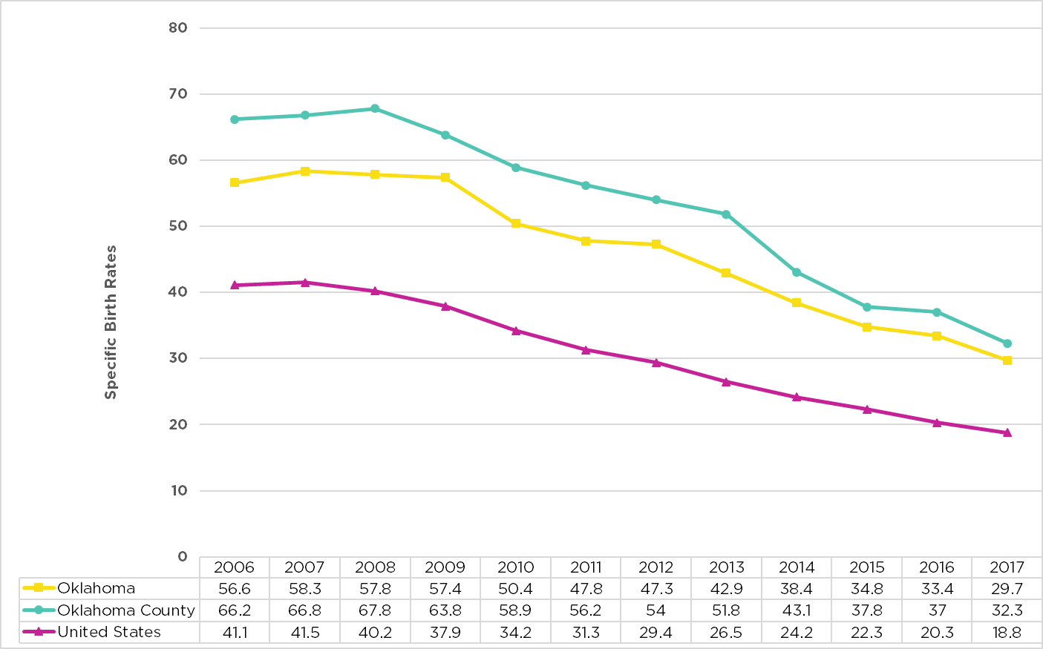
Source: Data is accurate as of report date and is subject to change. Thrive does not own this data.
Birth rates were pulled from Oklahoma State Department of Health's OK2Share website: http://www.health.state.ok.us/ok2share/ and the National Vital Statistics Reports from the Centers for Disease Control and Prevention website: https://www.cdc.gov/nchs/data/nvsr/nvsr67/nvsr67_08-508.pdf
Specific Rate = 1000 x Number of Resident Live Births / Total Female Resident Population

Among teen pregnancy, a recent article from The Oklahoman, “State of Oklahoma: Why Are We Failing?” (2018) cites other challenges Oklahomans face:
- Oklahoma imprisons more women than any other state
- Prenatal care among Oklahoma women continues to decline
- Oklahoma has the fourth worst rate of children dying between the ages of one and 14
- Oklahoma ranks among the five worst states for heart disease, diabetes, and deaths from drugs and cancer
- Oklahomans die younger (3 years earlier) than the national average
- The state ranks last in the US in physician to patient ratio
- Oklahoma ranks second to last in percentage of uninsured citizens
- Oklahoma has the fourth highest percentage of students qualifying for the free and reduced-price meal program
- A majority of students score below proficient in nearly every state-required test
- Oklahoma has one of the highest rates of young children with adverse childhood experiences (ACEs)
All of these challenges culminate together to create barriers for the youth in our communities to achieve success. Although teen pregnancy is just one of these hurdles, research shows that teen pregnancy also influences many other negative outcomes such as generational poverty, health, low graduation rates, mental health issues, economy of the state and many more (Hoffman & Maynard, 2008; The National Campaign to Prevent Teen and Unplanned Pregnancy, 2013).

Population Density
Although Oklahoma has many rural areas in the state, the attention of the collaboration focuses on Oklahoma County, which is one of the most highly urbanized counties with a population estimate of 792,582 (United States Census Bureau, 2018). While this helps separate Oklahoma County from some of the other hardships Oklahoma as a state faces, such as less access to medical care and lower educational scores, Oklahoma County is not immune to the state’s hardship of low child health ratings, death rates, infant mortality, and high teen births.
Oklahoma Counties by Population Density, 2013 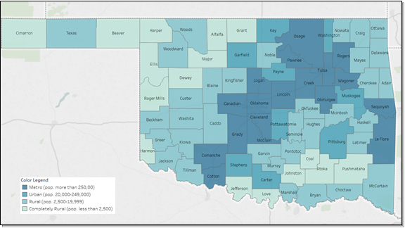
Source: United States Department of Agriculture (USDA) 2013 Rural-Urban Continuum Codes. https://www.ers.usda.gov/data-products/rural-urban-continuum-codes/

Race and Ethnicity
Oklahoma County is a collection of community members with a diverse background of religion and cultures. Approximately 17.5% of Oklahoma County identifies as being Hispanic or Latino, 4.3% identified as being American Indian, and 15.8% identify as Black or African American (United States Census Bureau, 2018).

Age and Gender
Oklahoma county has approximately one-fourth (25.7%) of the population under the age of 18 with an even split of females and males. This is on trend with other similarly populated cities.

Our Project
Although all three pillars work concurrently to reduce teen pregnancy, the focus of this project was to help engage the community pillar by assessing their needs and barriers for all sexual health topics. The community is a pivotal piece in any public health issue when wanting to create meaningful and sustainable change. When it comes to approaching community-wide concerns, such as high pregnancy and birth rates, community partnerships present communities with the chance to reach their full potential while utilizing all the available resources and generating and maintaining new effective tactics (Kramer et al., 2005). Engaging the entire community leads to an increase in long-term beneficial effects when it comes to reducing risky behaviors in children and adolescents and in turn affects adolescent health as a whole (Fagan et al.,2012).
Although there are many arenas in the community that influence sexual health, Thrive decided to focus on three areas that, according to research, have strong ties to the success of preventing unplanned pregnancies: parents/caregivers, faith leaders and members and community-based organizations staff.
Studies have shown that parents/caregivers have a direct influence on their child’s sexual health specifically on their teen avoiding unwanted pregnancy (Miller, 2002). Parents and caregivers help shape the narrative as well as help instill values around sex whether that includes abstaining or practicing safe sex.
Oklahoma has a unique contextual factor of being deeply associated with religion often being nicknamed the “buckle of the Bible belt.” Because it is such an important part of our community, Thrive wanted to engage faith leaders and members as one of the target populations of this community assessment. Houses of worship foster connections among community members and trusted adults. Studies have shown that “…teens with higher levels of religiosity tend to delay sexual involvement more than those with lower levels of religiosity” (Hardy & Raffaelli, 2003). This gives the collaboration a unique opportunity to tap into the community’s already present protective factors by reaching out to houses of worship and their congregants.
Finally, the last target population from which Thrive wanted to gather feedback was community-based organization (CBO) staff. These organizations have a dramatic impact and strong connections to young people. By partnering with these organizations and sharing resources, it maximizes the impact of teen pregnancy prevention efforts beyond anything that Thrive or the collaboration could do even if the focus of the CBO is not solely focused on teen pregnancy prevention efforts.
By looking at these three target populations (CBO staff, faith members and parents) in the community Thrive felt they would be able to have a representative picture of what the community at large thought about teen pregnancy prevention and their related barriers and needs. The goal of this project was not only to collect data to inform the collaboration, but to report that data back to the community to give them an opportunity to problem-solve with the collaboration members to create sustainable community interventions. In order to accomplish all this, Thrive based on a collective impact Community Engagement toolkit split the project into five levels (Collective Impact Forum, 2017).
Level 1:  Informing | Level 2:  Consulting | Level 3:  Involving | Level 4:  Collaborating | Level 5:  Empowering

Level 1: Informing
The first step in this process was making connections within the community not only to raise awareness of the collaboration’s efforts, but also establish relationships that would later give feedback into the interview and survey question paths and eventually feed into the final levels of the project by inviting the community into the Community Working Group. Additionally, the goal was to identify individuals who had a deep passion for the collaboration’s mission that would become community champions and drive the next levels of the project.
This initial level was accomplished with the implementation of a workshop called More than Just “The Talk.” The workshop was initially developed while Dr. LaNita Wright was an employee at the Oklahoma City-County Health Department, and has been updated over the last several years. Dr. Wright obtained permission to implement this workshop during this community engagement project.
More than Just “The Talk” is an interactive workshop designed for trusted adults in young people’s lives. The workshop focused on parents and non-parental role models communication with child(ren) regarding sexual health topics, included relevant statistics, and application of concepts. This workshop was selected for several reasons: 1) the workshop was readily available to the project consultant; 2) the project consultant was already trained in implementing the workshop and obtained permission to do so; 3) the workshop was brief enough to be implemented in one session, which negated retention issues associated with multiple sessions; and 4) the workshop was specifically designed to engage community members in teen pregnancy prevention efforts (and had been implemented with parents, staff members of community-based organizations, and with congregants of local faith-based organizations).
More than Just “The Talk” workshops were conducted from October 2018 to December 2018 with local churches and community-based organizations. Dr. Wright conducted the trainings in the Oklahoma City area, which helped establish relationships in the community as well as provide names for potential interview participants.
In an effort to get community feedback at each step of this project, Dr. Wright provided a brief assessment (Addendum 1) to participants after the training. These assessments asked participants to rate the workshop based on a Likert scale, describe the most and least valuable portion, provide names of key informants (names redacted from report for anonymity), and recommendations for future topics/programs.
Thrive’s original goal was to provide three sessions per target area, nine total. Dr. Wright facilitated five total sessions (3 faith, 2 community-based organization) by December 2018. Due to the reach of the sessions implemented, the similarity of the information presented for staff, parents, and faith leaders, and the desire to not oversaturate the community with these workshops prior to the needs assessment Level, Thrive Staff and Dr. Wright decided collectively to forgo the remaining workshops in order to prepare for Level 2 of the project.
These sessions served as a launching point for this project by informing participants of services offered by partner agencies and/or members of working groups, providing fact sheets and other feedback for discussing plans for future program delivery. Additionally, they were used for collecting recruitment information needed for the needs assessment in each target area.

Level 2: Consulting
The next step was the “Consulting” level, which included three steps:
- Creating survey (quantitative) and interview (qualitative) question paths.
- Obtaining feedback on the survey and interview question paths from the community through the collaboration’s Community Working Group.
- Administering the survey and conducting interviews in the community to collect data.
Thrive and Dr. Wright worked collaboratively to utilize best practices to create questions that were both relevant and accessible to the community. Both interview and survey questions paths were reviewed internally before they were released for review by the public. Only the survey was translated into the Spanish due to the reach of the survey and the inability to translate and analyze interview data in another language.
Thrive, in order to ensure that the community voice was heard, presented questions paths to the Community Working Group. This meeting was held to update community members of the status of the community engagement project as well allow them an opportunity to provide feedback into the process, next steps and the question paths for the survey and interview. This was a very successful meeting with 28 community members in attendance. One of the suggestions from the Community Working Group that Thrive incorporated was to ensure that the survey was available in Spanish since the Hispanic ethnicity represented a considerable portion of the Oklahoma County population, and is one of the most at-risk for teen pregnancy. For additional recommendations from the Community Working Group, see Appendix 2.
At the time of this report, Level 2 has been completed. We are transitioning to Level 3 (explained below). The project results have been presented back to the Community Working Group. Due to time restraints, the entire report was not given to the group during the meeting; rather a PowerPoint presentation summarizing this information was provided. In addition, a one-pager with information on how to access this full report on Thrive’s public website was given to all Community Working Group members.

Level 3 - Involving
The next phase in this project is in progress. The focus of level 3 is to involve the community at a deeper level. Thrive and Dr. Wright will present the data to the community through multiple meetings through the Community Working Group, and hear their direct feedback and thoughts regarding the findings. The first of these meetings occurred on June 13, 2019.
Additionally, the community, who are context experts on the subject of their community will work with sexual health content experts to problem-solve appropriate and sustainable solutions for their community in a future setting. Thrive will continue to facilitate these discussions as well as facilitate relationships to connect the working group members with the resources they need.

Level 4 - Collaborating
Level 4 focuses on enabling community members to participate in every aspect of planning and decision-making for the new program and/or services. Key champions identified in the community-working group will be incorporated more heavily to help lead advisory groups for each identified area. Members of the working groups and the advisory boards will be trained and/or assist with developing resources for other community members.

Level 5 - Empowering
Level 5 involves key champions taking the lead over new programs, services or resources, and lead work to implement solutions in community settings, while professionals serve in consultative and supportive roles. During the final stage, members of the community-working group and advisory groups will take the lead in implementing and intervening in the community, with support from the collaboration and Thrive.
The last two phases will be an iterative process that will involve continual support and collaboration among the community, Thrive and the collaboration. Although two of the most difficult levels are complete, these final steps are imperative to ensure true community engagement, appropriate community fit and sustainability.

Methodology
Researchers used a mixed-methods approach by conducting interviews (n=25) and surveys (n=350). Prior to contacting any of the recommended participants (based on Level 1 efforts noted above), the research team worked alongside Thrive staff to create the final question paths, secure recording materials, and incentives.
Interviews were conducted with information-rich (based on community members’s recommendations) key informants and surveys were sent more broadly (with advertisement specifically via flyers, social media, and email blasts). By designing a mixed method type of study, this allows researchers and readers to understand a more complete picture of the results. This study was deemed by the University of Central Oklahoma Institutional Review Board as non-human subjects research (Addendum 6).

Question Path Development
Significant efforts were made to create both survey and interview question paths that would promote meaningful responses. Creation of both survey and interview paths was the primary focus of the research team led by Dr. Wright and Thrive’s director of data and evaluation; the initial question paths were developed based on previously conducted interviews with local pastors and parents, a literature search of previously conducted sexual health interventions, and informal interviews with local leaders. These question path steps also involved multiple rounds of reviews by the Thrive staff, with multiple reviewers providing feedback on question format and content. This was an iterative process lasting for two months and led to the development of question paths all researchers and staff deemed appropriate.
Moreover, once draft versions of the three survey question paths were developed, these surveys were shared with Thrive’s Community Working Group, in order to allow for additional review and feedback. Due to the specific order and wording of content on the interview question path, the research team decided not to send the interview question path to the Community Working Group; however, the research team pilot tested the interview question path with three local community members: one faith leader, one parent of a young adolescent, and one staff member of a local youth serving community-based organization. The local community leaders did not recommend major changes to the interview question paths.

Qualitative Data Collection & Analysis
A combination of purposive and snowball sampling techniques were utilized to recruit participants who would provide information-rich responses to the interview questions. Initially, most of the original list of key informants were contacted by email or phone, if contact information was either provided or located. A recruitment flyer was also shared with each initial contact electronically. In addition, participants were asked to recommend additional, information-rich potential participants; the interview team also attempted to contact them with the provided contact information.
Additional recruitment efforts (multiple follow-up calls and emails) occurred during the last few weeks of data collection in attempt to reach the 10 per sector threshold. In order to meet grant deadlines and to allow enough time for data analysis, interviewing ceased on April 26, 2019.
Structured interviews were conducted in-person by a four-person team. Participants were interviewed at a public location of their choice where they felt they could talk privately, most commonly a local restaurant/coffee shop or place of employment. Participants were identified by code number only. Prior to the interview, participants completed the informed consent form and demographic questionnaire. The demographic questionnaire collected demographic information about the community-based organization staff member, faith leader, or parent prior to the interview. Interviews were audio-recorded, lasting on average 30 minutes. At the end of the interview, participants completed the recruitment questionnaire and received a $15 store gift card. The recruitment questionnaire collected information about the participant’s interest in being more involved with Thrive programming in the future and allowed participants a chance to be entered into a drawing for additional prizes. See Addendum 4 for final interview question paths for each sector.
Due to the need to meet a May 15, 2019 preliminary report deadline, the time frame for data collection shifted from a four-month to a two-month window. The target number of interviewees had to be reduced in order to meet this hard deadline. Therefore, recruitment ended based on predetermined timelines, rather than saturation (i.e. continuing interviews until no new ideas were heard). Interviews were conducted in March and April of 2019.
Interviews were transcribed verbatim and checked for accuracy. Two members of the research team were involved in the data analysis process. The researchers used an in-depth, inductive data analysis process, using a five-step analysis process (Tolley, Ulin, Mack, Robinson, & Succop, 2016).
First, researchers reviewed all transcripts for content, quality, and initial patterns. Second, the researchers identified emerging themes, by developing a codebook and utilizing the codebook to organize data and identify themes. Transcriptions were uploaded to NVIVO 12 Pro software. NVIVO 12 Pro, a qualitative coding and analysis software package, was utilized for coding and theme development (QRR International, 2019). The two researchers coded all transcripts together to promote triangulation (analyzing the data from two different standpoints and experience levels) and ultimately promote the trustworthiness of the data.
Third, the researchers utilized thematic analysis to identify emerging patterns across codes and participants (Ulin et al., 2005). To increase transparency in theme identification, 25% of participants in each sector discussing a concept was set as an a priori threshold for including a concept as a final theme. However, because this report is intended to assist practitioners, associated with a larger mixed methods study, and data was not collected solely for the purposes of research, subthemes that did not meet the threshold were still shared to provide a clearer of the bulk of the data collected.
Fourth, the researchers used tables and graphics to further organize themes and identify central themes. Fifth, transcripts were reviewed for disconfirming evidence and transferability by describing results in enough context (including finding representative quotes of each them) and detailing credible conclusions (Tolley et al., 2016).

Quantitative Data Collection & Analysis
The survey was created using Survey Monkey software from questions paths that had been reviewed by Dr. Wright, Thrive staff, Community Working Group co-chairs and the Community Working Group (See addendum 2 for recommend changes from the community and 3 for final survey question path). The survey was designed using current best practices, but also with the goal of ensuring the survey was accessible to the community Thrive serves. Great care was taken with the number of questions and the question reading level to avoid survey fatigue or confusion by participants. Skip logic was used throughout the survey to ensure that participants were only answering relevant questions. In order to be more inclusive, the survey was created with English and Spanish language options.
On average, the survey took 7 minutes to complete, using the time of the respondents who completed the survey. Thrive is unable to know a completely accurate response rate due to the fact that individuals were encouraged to forward the survey on to other participants in the community as well as the fact that there was anonymous onsite surveying conducted. The survey was originally sent to approximately 150 people. However, Thrive is able to calculate the completion or retention rate (number of people who completed the survey/number of people who started the survey) of the survey. The completion rate of the survey was 67%; it should be noted that completion rates for surveys are generally between 20-50% (Bhat, 2019).
The survey was distributed throughout the collaboration including the Community Working Group and partnering organizations. Members of the collaboration and partners were asked to distribute the survey to persons in their spheres of influence or send it to any organization or group that fit into the three target populations. Additionally, the members of the Community Working Group were called to action to also take and distribute the survey. A flyer was made specifically for the survey and was distributed to Thrive’s close partner agencies as well as distributed through tabling events.
Finally, onsite surveying was conducted with target populations and demographics that were monitored by a bi-weekly report that showed aggregated counts to see the areas that higher responses were needed. Onsite surveying was done at three different partnering organizations. Since there was an adequate number of parent responses, participants were asked to take it as a CBO staff or as a faith member if applicable first. Additionally, by looking at the bi-weekly status report, it was noted that there was a low Hispanic response rate in comparison to the Oklahoma County census number. In order to try to engage more members from this key demographic, Thrive registered to participate at the Integris Hispanic Health Fair in order to conduct onsite surveying to try to bolster these responses.
Thrive also provided incentives to increase response rates. Any respondent who completed the survey was allowed to enter into a random drawing to win a prize. Due to the grant funding and generous community donations, over 100 incentives of various amounts were distributed for participation (across survey & interview participants). Prizes included gift cards to local restaurants and entertainment venues, Target, Walmart and Starbucks gifts cards, and a grand prize of a $150 Amazon gift card. All prizes were distributed after the last interview was conducted.
After closing the survey, data was downloaded from Survey Monkey to an excel sheet to be cleaned. Thrive’s director of data and evaluation kept a cleaning log for all data points altered, added or removed. Each line in this log was confirmed by at least one other member on the Thrive team to ensure accuracy. Although over 500 responses were received, after removing responses that did not consent to take the survey (survey had two consent points, one at the beginning and one for the parent questions), removing incomplete answers and removing responses that were entered during the testing phase, the total number of analyzed responses was 350.
After the data was cleaned, the final responses were downloaded into SPSS to be analyzed. Descriptive statistics and some light statistical testing was done on the data by each target population and with all target populations combined. One other Thrive team member reviewed data output to ensure accuracy.

Participants

Demographics
The interview and survey participant demographics were not strictly limited to any race or geographical location, however in order to hear our specific community clearly, Thrive did try to engage Oklahoma County, but did not limit responses if they fell outside of that area. Additionally, since the survey contained sensitive topics, the participants had to be 18 years of age or older to consent to take the survey or participate in the interviews.

Map of Interview and Survey Respondent Zip Code
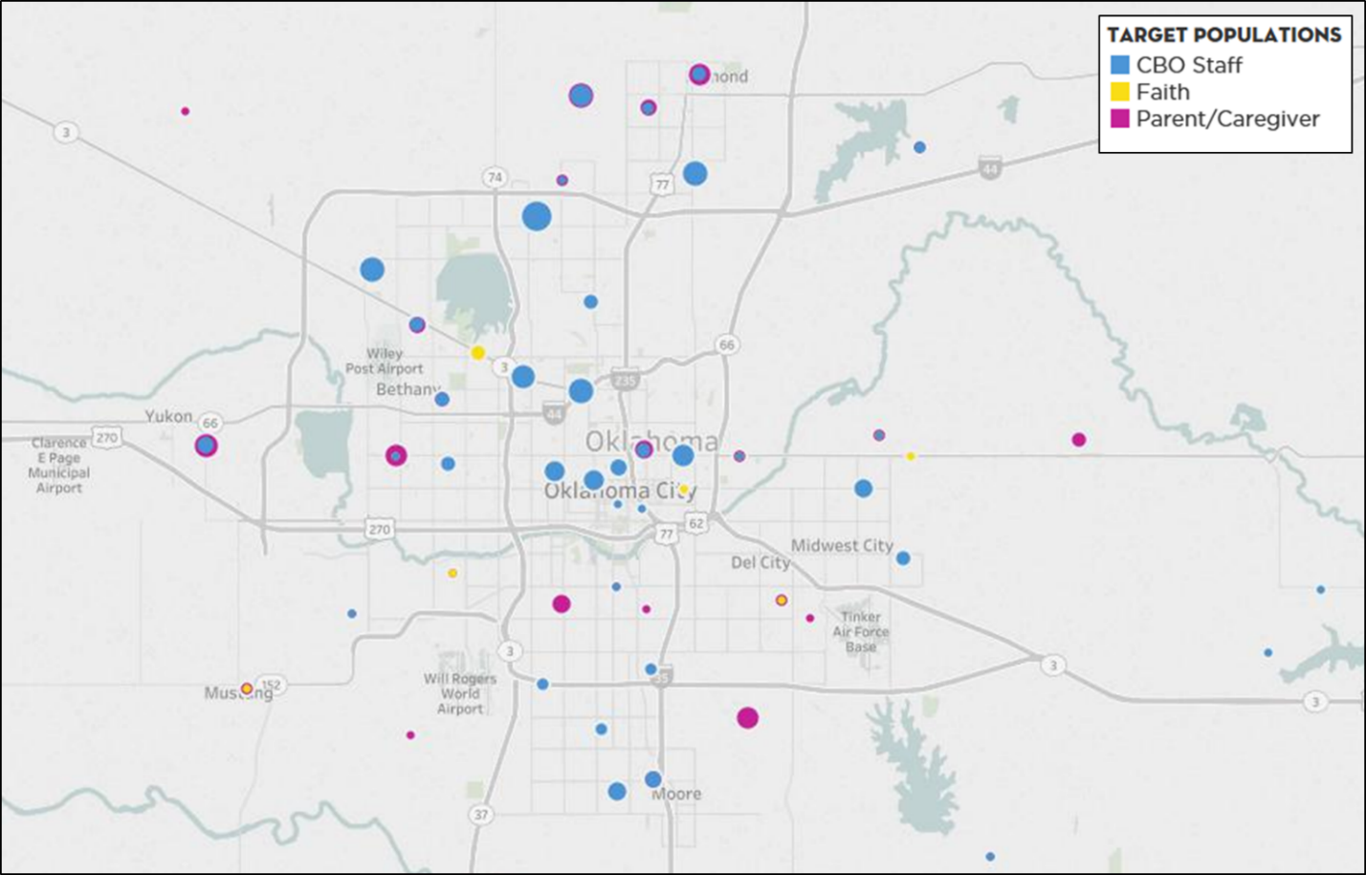
Source: CEP survey data. Data is accurate as of report date and is subject to change.

Due to the fact that there were fewer interviews, and Thrive has gone to great length to ensure that the responses and information of these interviewees remain anonymous, demographic breakdowns will only be given for the survey respondents. However, it should be noted there were no outstanding differences between interview and survey demographic information.
Survey Demographic Breakdowns 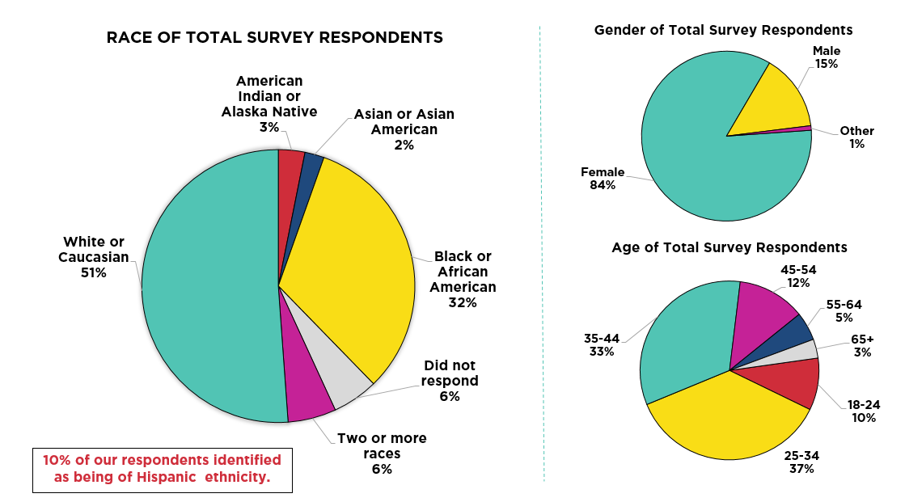
Source: CEP survey data. Data is accurate as of report date and is subject to change.

Although Thrive specifically tried to engage key populations that experience higher rates of teen births than other demographics, the majority of responses were from middle-aged Caucasian women.
Employment and Relationship Status of Survey Respondents
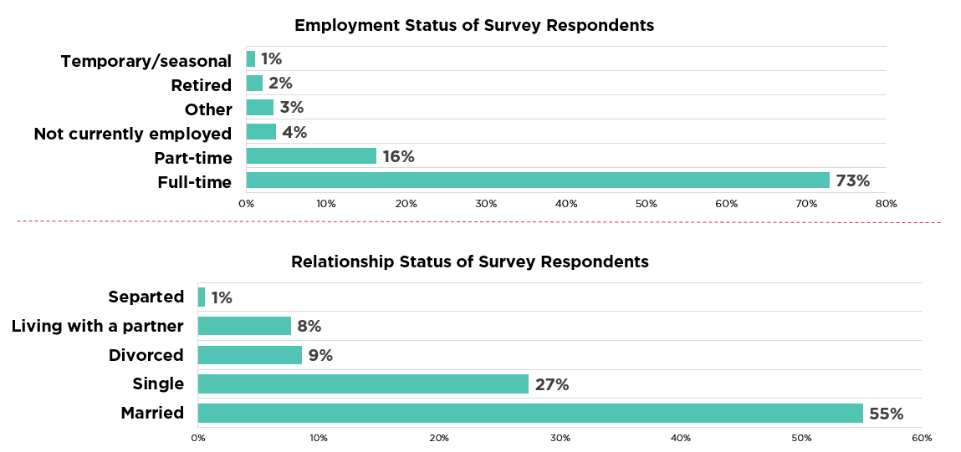
Source: CEP survey data. Data is accurate as of report date and is subject to change.
Because this survey contained questions regarding sensitive information about sexual health, family conversations and personal beliefs, Thrive wanted to eliminate unnecessary personal questions that may cause a participant to feel uncomfortable or limit the amount of disclosure from a participant. Therefore, Thrive did not ask participants about their income but rather asked about the employment type and relationship status.
CBO Staff Demographic Breakdowns
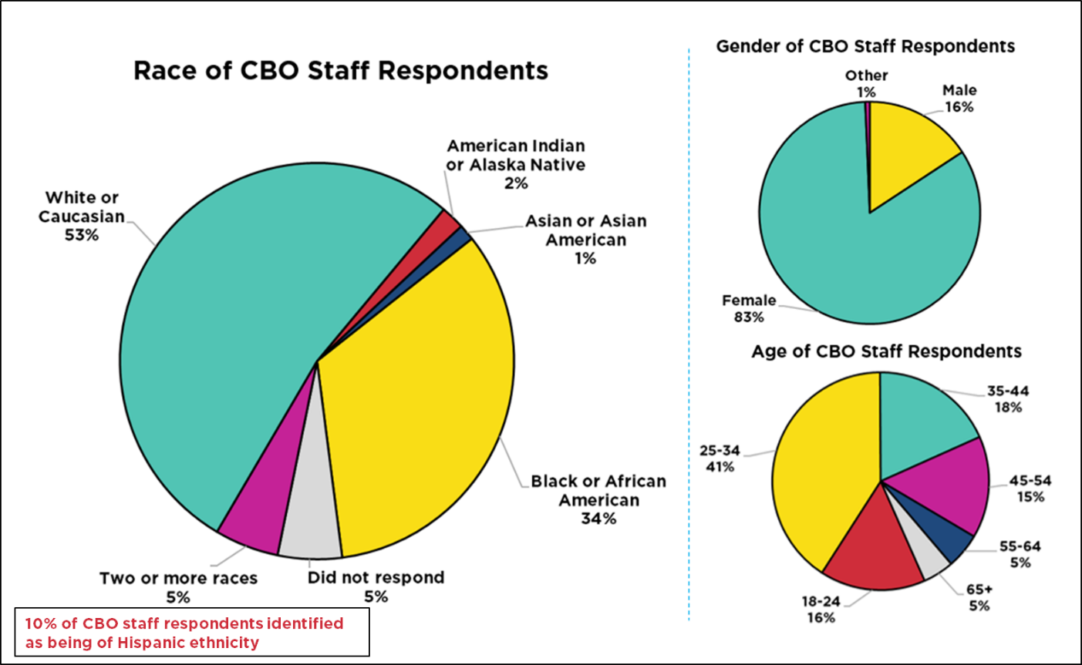 Source: CEP survey data. Data is accurate as of report date and is subject to change.

CBO Staff Personal Role in Organization

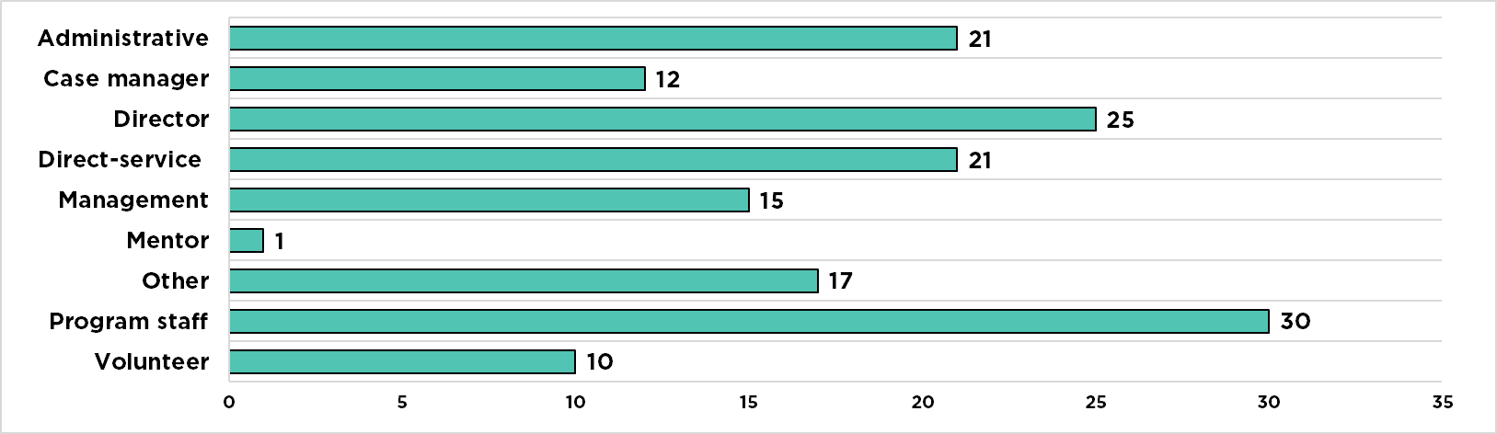
Source: CEP survey data. Data is accurate as of report date and is subject to change.
Faith Members Demographic Breakdowns
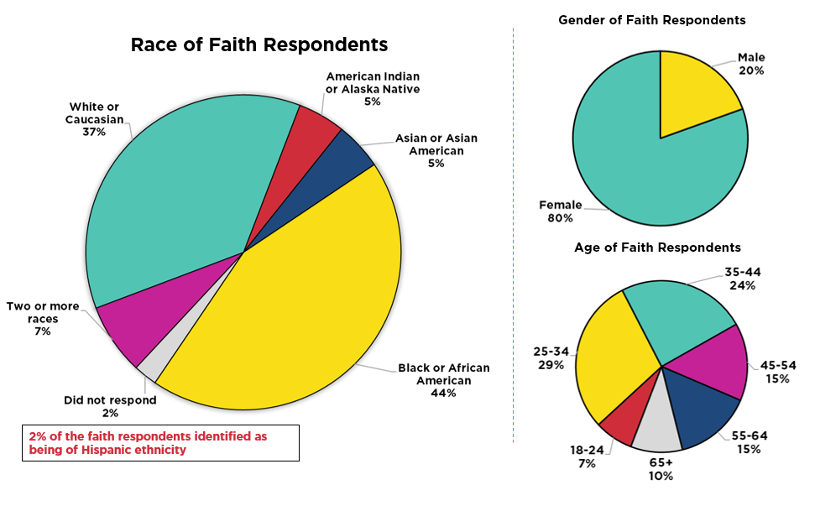 Source: CEP survey data. Data is accurate as of report date and is subject to change.

Religious affiliation of Faith Member Survey Respondents

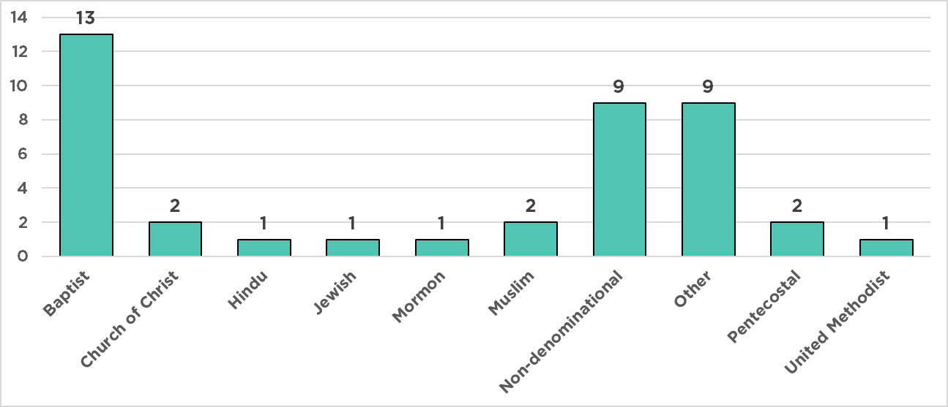 Source: CEP survey data. Data is accurate as of report date and is subject to change.

Parent Demographic Breakdowns
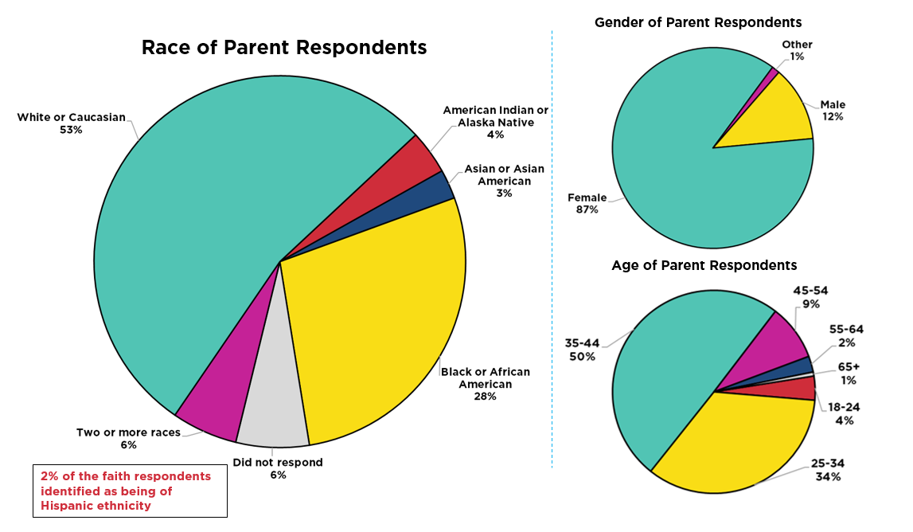 Source: CEP survey data. Data is accurate as of report date and is subject to change.

Parent Respondents Marital Status
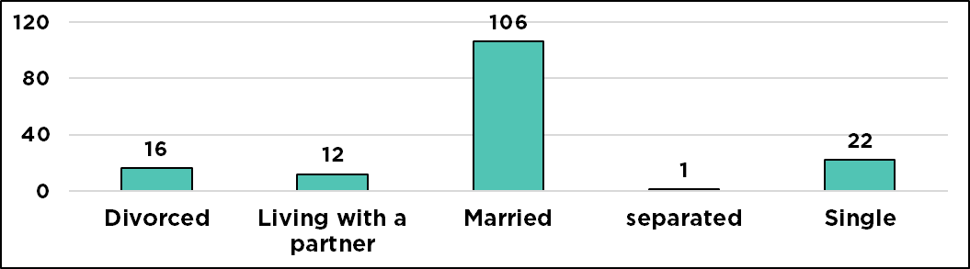
Source: CEP survey data. Data is accurate as of report date and is subject to change.

Parent Respondents Reported Number of Children
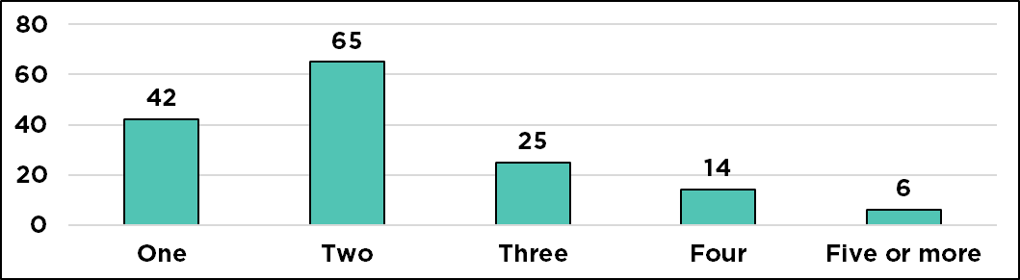
Source: CEP survey data. Data is accurate as of report date and is subject to change. Some respondents did not currently have children living in
their house.

Findings
The survey was open from 2/26/2019 to 4/15/2019 and received over 500 responses; however, after cleaning the data and eliminating incomplete responses, the total responses used were 350 with 41 being from the faith community, 157 being from parents/caregivers and 152 being from community-based organizations.
Interview recruitment began on 3/12/2019 and concluded on 4/26/2019. Of the 43 potential interviewees contacted, 25 (13 parents, 6 community-based organization staff members, and 6 faith-based organization congregants) total community members participated in interviews. Interviews lasted on average 30 minutes.
Although the interview and survey questions were not identical, researchers ensured they followed the same progression of information. Thrive wanted to know what previous experience the participants had with teen pregnancy prevention and sexual health education. Additionally, a list of teen pregnancy prevention and sexual health topics for the survey and interview were rated on a Likert scale of importance and the participants’ level of comfort talking about the topics. Topics included:
- Abstinence
- Access to affordable reproductive healthcare (ARHC)
- Birth control and condoms
- Communication skills with partner
- Healthy relationships and consent
- LGBTQ+ information
- Parent-child communication
- Peer pressure
- Puberty and reproduction
- STIs/STDs
Next, Thrive wanted to understand the barriers that the community faced talking to their youth about teen pregnancy prevention. Finally, Thrive wanted to know what resources the community felt they needed in order to have these conversations with young people and how they wanted to receive those resources.

Community-Based Organization (CBO) Staff
Previous experience
The majority of the surveyed CBO staff identified their organization as either direct-service providers (45%) or dealing with training/education (38%). The majority of the respondents self-reported being in some sort of leadership role in their organization (34%) or as program staff (20%).
Breakdown of CBOs by Types of Organization
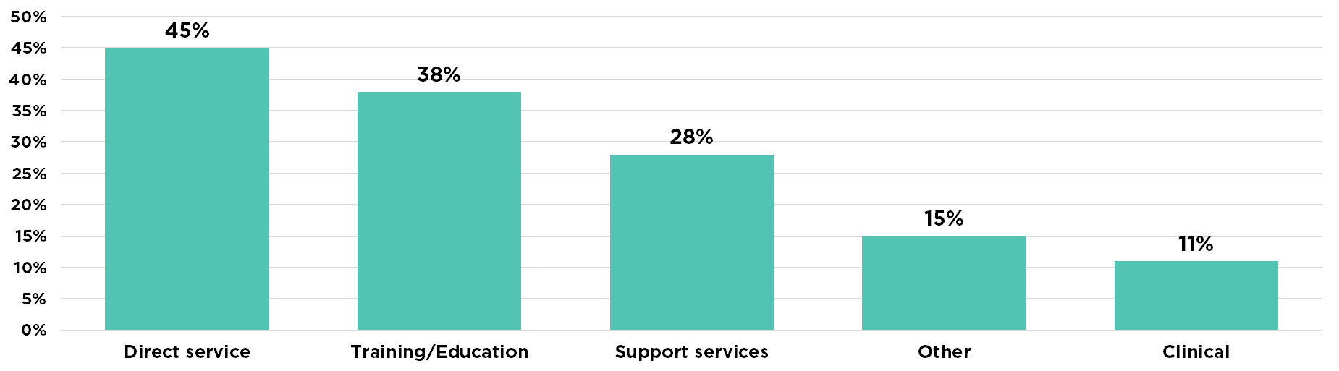
Source: CEP survey data. Data is accurate as of report date and is subject to change.

The majority of surveyed CBO staff members shared that their organizations offer program(s) that included teen pregnancy prevention related topics (71%). When asked what teen pregnancy prevention topics they covered with adolescents they served, the majority of CBO staff reported they covered healthy relationships and consent (72%) and birth control and condoms (68%). CBO staff reported that the information was provided in majority by in-house staff (65%) with the most common delivery methods being educational programs, group settings and handout/brochures.
Two interviewed CBO staff members mentioned organization-specific programs by name; one discussed sexual activity, drugs and alcohol while the other focused mostly on puberty. Additional topics shared by other interviewed CBO staff included access to health care, access to birth control, STIs/STDs, and whatever the adolescents wanted to discuss.
…and in the program puberty is talked about. That's a heavy topic. Sex is talked about. How babies are created, where they come from. Um the only thing that's not talked about in that is consent and um uh anything outside of like abstinence. So, resources are provided for kids that are abstinent, but no other resources.
– C5
So, taking them to the doctor, taking them to get checked out regularly. Um, we have a communication with like [local clinic]. And so, we try to include that into their service delivery plan, getting them access to healthcare. Whatever level they're on, getting them checked, getting them, um, access to condoms and birth control.
-C1
Over half of the interviewed CBO staff members shared that they have had some experience discussing teen pregnancy related topics in their organization. Most discussed their open relationship with the youth; many staff reported that the youth will discuss most things with them. They did not often share specific topics but shared they would answer any questions asked by the adolescents.
I'm fortunate to have, usually the youth I work ...I have a really good relationship with them. So, that conversation is usually part of our ... interactions. So, it usually stems from a youth, like, bringing it up, or talking about it, or having a situation come up.
-C1
Uh I think I've talked about just about every topic there is with kids. And, like I said, my only... complaint is that we can't offer the resources that I would like to offer. Or kind of touch on certain topics because it will lead in a direction, you know, as an adult you can kind of see where a conversation is kind of leading with a child. So just kind of having those limitations has really held back a lot of what I feel we could have done, and a lot that I feel we could have, you know, a lot of situations we could have helped in.
-C5
Um, I mean it's pretty much in the class. If it's not one on one, if they come to me with an issue, it's in our […] class. Uh, and it, it's pretty much those kids that I have a relationship with, you know, on a different level than other kids. So, it's probably somebody that I got that's always in my office or something like that.
–C6
Topics
Without the ability to ask in-depth follow-up questions during the survey (compared to the interview), the topics comfort and importance survey questions were eliminated in order to separate CBO staff member’s personal perceptions regarding sexual health topics from the organization’s (or leadership’s) perceptions. However, interviewed staff members were still asked questions regarding comfort and importance, due to the ability to ask clarifying questions.
All interviewed CBO staff shared their level of comfort in discussing each of the listed topics (See Addendum 5). All topics received the highest ranking of comfort (rating of 5) from at least half of the CBO staff. Overall, staff shared they were comfortable sharing any topic with adolescents they serve.
In addition, the topics with the highest level of importance (rating of 5) from at least half of the interviewed CBO staff were access to affordable reproductive health care, communication with a partner, birth control and condoms, healthy relationships and consent, LGBTQ+, parent-child communication, and puberty and reproduction. Parent-child communication had the highest level of importance for the most participants. LGBTQ+ was the only topic with the mid-level importance (rating 3) from at least half of the CBO participants. No topics had a rating of 1 or 2 from at least half of the CBO staff.
Barriers
When asked why their organizations did not provide teen pregnancy prevention information, nearly half of surveyed CBO staff cited the information being outside their organizations scope or mission (44%) and nearly a third saying that it was due to limited resources such as materials or funding (28%)

What are some barriers in receiving the resources you feel are important (check all that apply)?
Outside of organization’s scope or mission | 44%
Limited resources such as materials or funding | 28%
Outside of organization's culture | 22%
Lack of expertise or training | 22%
Already full workload | 9%
Limited time to do the program | 6%
Source: CEP survey data. Data is accurate as of report date and is subject to change

Most of the interviewed CBO staff mentioned a different barrier to implementing teen pregnancy prevention efforts. These barriers included funding, lack of transportation for the adolescents, parents, lack of management approval, restrictions regarding passing out condoms to adolescents.
And if we do then we're looking at some liability for the agency so our barriers are the parents and what they want the kids to, to be exposed to.
-C3
Um it's within the curriculum. I think the curriculum is something that I would need to get approval um for our upper management and also know the guidelines, I'm not sure when it comes to the guidelines what our agreement with Oklahoma City Public Schools is. I don't know what that is.
-C4
Resources and Delivery
Surveyed CBO staff most often reported wanting to learn more about LGBTQ+ information (51%), parent-child communication (45%) and access to affordable reproductive healthcare (45%). A little more than half (52%) of CBO staff said they wanted to learn these topics through websites. The next requested delivery system for CBO staff to learn more about these teen pregnancy prevention topics was educational programs (46%).
What topic(s) would you like to learn more about (check all that apply)?

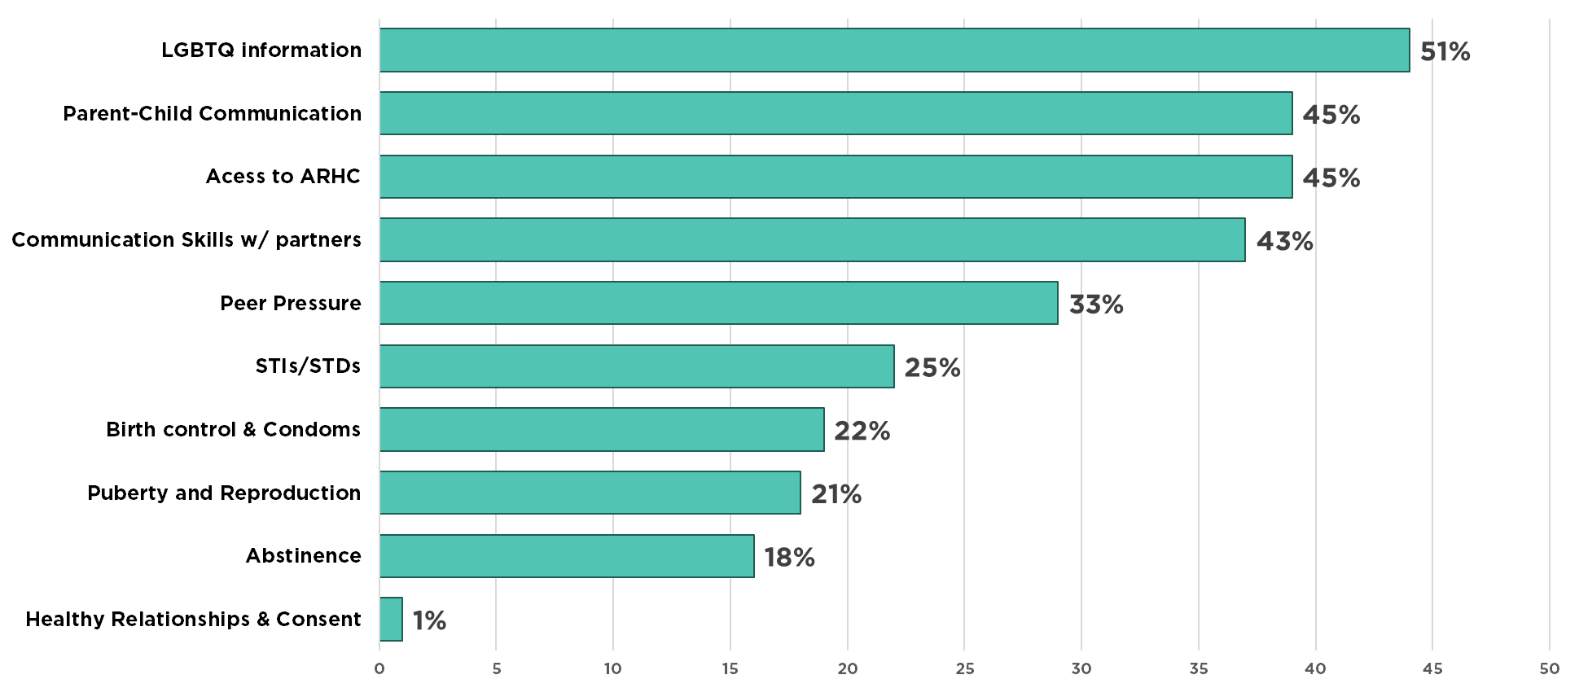
Source: CEP survey data. Data is accurate as of report date and is subject to change

All interviewed CBO staff mentioned a specific delivery method for teen pregnancy prevention efforts for the adolescents they serve. Half shared that any effort should be fun and engaging for the young person.
So, having forums that are engaging and enlightening to talk about different sexual scenarios, to where youth can kind of elaborate from their perspective and allow them to understand the decision-making process and along with the consequences that come along with that decision.
-C1
In a fun way […] In a way that they'll be able to retain information and wanna come back again.
-C6
Staff also mentioned a variety of specific topics they would be interested in learning themselves. Topics included motivational interviewing, building relationships with adolescents, most current statistics, access to health care and free clinics, LGBTQ+ training, and rape. There was not a clear consensus across staff members. Most interviewed CBO staff mentioned they would like to learn additional teen pregnancy prevention topics in a group setting from guest speakers or staff already trained in this topic.
I think it's important to ... motivational interviewing, learning how to build relationships, learning different strategies of how to discuss preventative measures, um, learning statistics.
-C1
Well I mean obviously the access to health care um, has, you know can be a barrier. Um, and then just the educational piece, having the right, equipped knowledge folks um, to come in and talk about those things.
-C2
… Having those hard conversations with kids like um rape is also a part of sexual health. Some, some of our young people that have been molested or raped or sexually assaulted have never been seen by a physician, have never gone through that process. Getting our staff comfortable with having those hard conversations, and answering those tough questions and providing kind of a path for those young being would be beneficial as well. Just so our staff are more comfortable doing it.
-C5
Faith Members
Previous experience
Most interviewed faith respondents shared that there have not been any previous programs in their house of worship that included teen pregnancy prevention related topics, geared towards adolescents. In fact, according to the survey results, 98% said they felt that their house of worship should be providing teen pregnancy prevention (TPP) information to adults and/or youth; however only 20% of survey respondents said their house of worship had offered teen pregnancy prevention information in the past
Some of the interviewed congregants shared they have already discussed teen pregnancy prevention topics within their house of worship with adolescents. The topics they have discussed varied greatly from abstinence, to healthy relationships, to discussing a youth who identified as gay.
Oh, there's the teen camps. Um, worship studies. Things like a lot of activities. To be honest with you, I kind of lost track since I have no more teens any more than to participate in them […] basically it was a church program, or a group. They met up with the teens, they kind of just talked about the trials of life and, you know, and what to expect growing up.
– F3
Topics
Most surveyed and interviewed faith respondents reported themselves and other identified leaders as being comfortable with discussing teen pregnancy prevention topics in their house of worship. Faith survey respondents reported a variety of people in their house of worship as being comfortable talking to youth regarding teen pregnancy prevention topics.
How comfortable are the following people discussing TPP topics with youth in your house of worship?

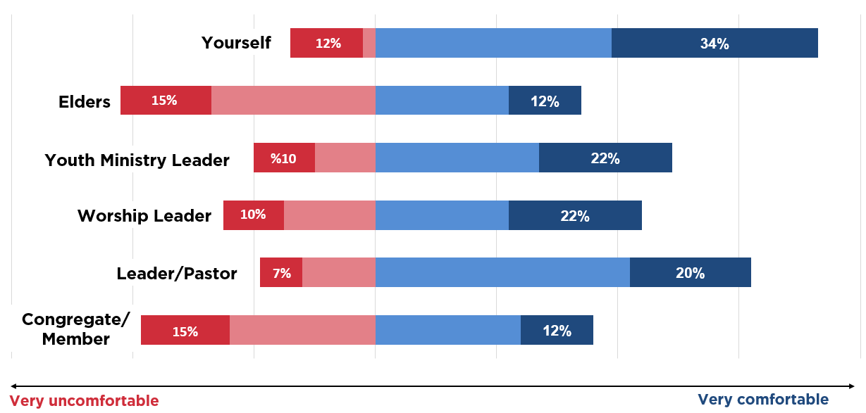 Source: CEP survey data. Data is accurate as of report date and is subject to change.

Nearly three-fourths (73%) of faith survey respondents said they personally were comfortable or very comfortable discussing teen pregnancy prevention related topics with youth in their house of worship.
In addition, survey respondents most often identified the lead pastor (62%) and/or youth ministry leader (49%) as comfortable or very comfortable discussing teen pregnancy prevention-related topics with youth. Interviewed respondents also said that the youth ministry leader or youth minister would be comfortable discussing topics with youth. Respondents most often identified elders (42%) and other congregants/members (39%) as being uncomfortable or very uncomfortable discussing teen pregnancy prevention-related topics with youth.
In addition to general comfort, when presented with specific teen pregnancy prevention-related topics, all interview respondents rated themselves as highly comfortable discussing each topic with youth; two topics did not receive the highly comfortable rating from participants: LGBTQ+ and puberty and reproduction (See Addendum 5).
Uh, because that's such a controversial topic especially in the Christian community. Um, personally, myself, I don't have anything against anyone of the LGBTQ community, but me and my beliefs, it would probably conflict. And I would have a conviction to speak against it. Um, I don't know if I would feel as comfortable talking about it.
-F1
Um, there again, I put a three. It's kind of an awkward conversation to begin, again, um, and maybe I don't have as much, um, knowledge or understanding as I should in order to properly communicate that.
-F6
Importance
After identifying their comfort with discussing teen pregnancy prevention-related topics, survey and interview respondents were asked to rate specific topics based on importance using a Likert scale.

How important do you feel the following topics are for your youth to learn?
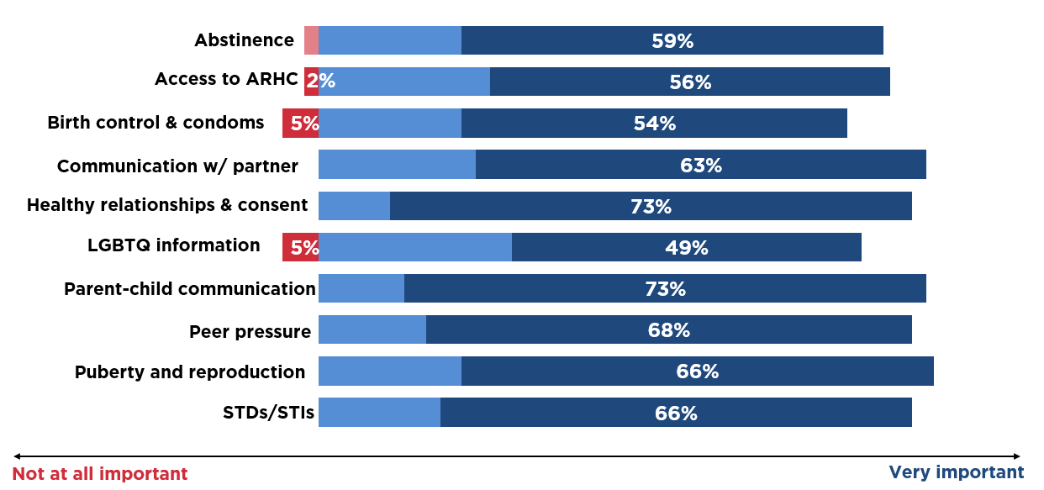
Source: CEP survey data. Data is accurate as of report date and is subject to change.

Nearly all survey and interview respondents rated all topics as very important to discuss with youth in their house of worship. Only 5% of survey respondents rated LGBTQ+ and birth control and condoms as not important at all to discuss with youth in their house of worship. Similarly, some interview respondents also rated LGBTQ+ information as least important to discuss with youth in their house of worship (See Addendum 5).
Because I have mixed feelings about LGBTQ. I mean I don't have anything against anyone that's affiliated with that. Um, I just, I just have mixed views about it.
-F1
Well I'm gonna tell you, I'm not down with that. But, to each his own. So, I'm going to give that one a low score. I respect them. I give them the respect, and the space, but I'm going to have to say probably about a two.
-F4
Um, I would say that at the church level [LGBTQ+ topics] would not be on a high priority.
-F5
Barriers
All survey and interview respondents identified barriers to receiving teen pregnancy prevention-related information.
According to the survey responses, the greatest barrier they faced was needing additional training/information (54%) in order to communicate teen pregnancy prevention information with the youth in their house of worship. Other highly rated barriers included not knowing a trained educator/presenter (34%) and having limited time to implement a teen pregnancy prevention program (24%).
What are some barriers in receiving the resources you feel are important (check all that apply)?

Need additional training/information in order to communicate this information | 54%
Don't know a trained educator/presenter | 34%
Limited time to implement a TPP program | 24%
Youth would not show up for this information | 22%
Limited access to affordable healthcare | 20%
Other adults would not approve/allow | 20%
Pastor/clergy/house of worship leaders | 15%
No meeting space | 5%
Source: CEP survey data. Data is accurate as of report date and is subject to change.

Additionally, interview respondents identified a variety of specific barriers. A few mentioned there is too much focus on religion and abstinence. Other congregants mentioned parents, church members (specifically older church members), leadership, and adolescents not wanting to listen/participate.
Parents, church members, leadership, you know. So you have to get past all of those three barriers. And all of those, I think have to meet up. And I'm not saying for my church, but I'm just saying, in some churches that is a huge barrier, because I think they feel like if you teach them this, oh it's a pass for you to go out and have sex. No, it's not. It's not a pass. It's educating you what could happen if you do, instead of just lettin' stuff happen and then they don't know what to do. So, I think they would look at it as we're giving them a pass, and that's not the case.
-F2
Teens being teens. Yeah, I mean, um, I guess the point it is, I mean, I guess the thing is, you just, you teach it and preach it and just hope, you know, at least half or one will listen and we all know that, you know, out of ten teens, not all ten are going to get the message or to want to do it. So, the barrier I would say is just the teens and their own, um, peer pressure with each other.
-F3
Um, some of the older congregation might have reservations about talking to kids about using birth control, but like I said, most of our congregation, being as open and inclusive as- as we are, they're- they're fairly progressive in their thinking
-F6
Resources and Delivery
The faith survey respondents reported that they were intestered in receiving more informaiton regarding communication skills, specifically communication between parents and youths (54%) and healthy communication with partners (51%).
What topic(s) would you like to learn more about (check all that apply)?

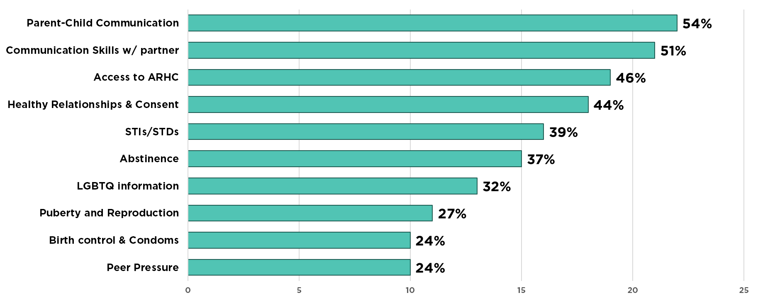
Source: CEP survey data. Data is accurate as of report date and is subject to change.

When asked how they wanted to receive additional information regarding teen pregnancy prevention related topics, survey respondents most often said they wanted educational programs (44%), access to websites/online sources (42%), and information presented in group settings (41%). In addition, interview respondents most often mentioned they would like to learn additional teen pregnancy prevention topics from pamphlets or brochures.
All interviewed participants also mentioned they wanted youth in their house of worship to receive information that was open and honest and preferred an outside presenter and access to a website/videos for the youth. Several also mentioned they would like to have a guest speaker to present not only to the youth, but also adult leaders/parents in the congregation.
Through trusted adults. I mean through, like different programming coming in. I believe they would be receptive to, uh, listening to Thrive or someone else that come in that's educated on, uh, teen pregnancy prevention. Just incorporate the program in our church.
-F1
I think it should be pretty open. I think that they should, you know, like know about accidents. Uh, I think that they should you know, know about contraceptives and um, you know, decisions that, you know, whenever you're, uh, entering into that arena, you know, what are, you know, what are some of the consequences? And you know, um, um, just being open and, and honest.
-F4

Parents
Previous Experiences
Most surveyed and interviewed parents shared their specific experience learning about teen pregnancy prevention topics as an adolescent themselves. Nearly three-fourths of surveyed parents said someone talked to them about sex when they were growing up, with half of them stating they learned from school (56%) and/or their parents (53%).
Nearly half of both surveyed and interviewed participants who learned directly from their parents found this information to be helpful and helped them to make better decisions as an adolescent and adult. All interviewed participants also reported learning about sex growing up, with most learning directly from their parents and friends.
I had a parent that was extremely open, mother ... any questions, nothing was off limits, very forthcoming so no problems whatsoever. It was very helpful and the fact that she never made it seem dirty, or wrong or off limits was extremely helpful.
-P6
Through my dad, which- what he taught me, but I knew to go even more in depth with it because I knew what- you know, he didn't do, so I knew to go more in depth with it.
-P4
Um, I also grew up in a household where my parents were fairly comfortable talking in a sex positive way. So, like I didn't grow up with like a lot of like shame or anxiety around and sexual health, which I think makes you much better at practicing consent… and speaking up and advocating for yourself in sexual relationships.
-P10
Half of the interviewed parents who learned in a school setting shared that it was helpful for them; one shared this was not helpful.
Um, I do remember maybe in middle school we did like a sex ed class maybe. Um, not helpful at all. Uh, only because like I said, it wasn't, it was very generalized. It covered very basic, basic information. Um, so just it was more so focused on the physical aspect when you talk about sexual health. There was really no conversation about healthy relationships, and things like that.
-P1
We had a mandatory course in ninth grade that was, from what I can remember it was a one semester course, and it was, uh, sex ed, drivers ed, and nutrition…so it was comprehensive in the sense that it included birth control methods, and, um, you know, it was more than just like, Don't have sex and STDs are bad." I do remember we had a similar mini-course in PE class in fifth, sixth, seventh and eighth, leading up to that. That was like a one-day thing too, but this was like a whole, in ninth grade it was like whole six or eight weeks out of that whole semester one course... so it was pretty good. Um, how helpful? So I mean really helpful, in the sense that I knew how to prevent pregnancy and I accessed birth control at a young age. I think 18 is when I started on the pill and didn't have my first child ‘til 31, when I planned it.
-P10
Half of those who learned from their peers found this information helpful to them.
Um, anything that I did learn was either from friends or um, I mean internet really wasn't ... I'm so old. Internet wasn't really um, a huge thing back then.
-P1
I don't know that much of [information from peers] was fact- fact based, you know, uh, so. I think it was more of a, um, experience type of, type of education. So helpful but not in a- a scientific way.
-P3
Um, friends. Um, like sometimes they weren't friends just in the classroom setting. You would just hear it from just people all around.
-P7
Over half of the parents considered information shared with them to be helpful. Many of them stated that this experience helped them to make better decisions. Very few (only two) shared that their experience with their peers was not helpful at all.
Um, well, as far as the different types of diseases, I say life, um, just by you know, conversation with individuals who may have contracted a disease and they may have just been open and shared it with me.
-P2
It was very helpful. Yes, because some of the stuff that you heard on the street, you know, from your friends were different from what your parents told you. So, yes.
-P11
I probably learned more from like, my older cousins than I did as, as far as like, you know, the details about it. Um, it was helpful in helping me make my decision as to whether I was, you know, whether it was something that I was gonna participate in or not. Um, and, like whether I should or should not do it. So, it was decently. I'd say on like a scale of one to 10, it was probably like maybe like a six.
-P13
The majority of the survey respondents who reported not receiving information about sex growing up said they wished they had (88%).
In addition to sharing about learning about sexual health topics, participants also shared if they were teen parents. Fifteen percent of surveyed parents reported being a teen parent (aged 19 or younger). Of those parents, less than half (42%) reported not receiving sexual health information as an adolescent. Of the reported teen parent respondents who did receive information, only a third reported the information they received as being helpful in making healthy decisions (36%). A few interviewed parents were teen parents as well; of those all reported having a trusted adult in their lives to assist them during this time.
In addition to their experience learning about sexual health topics as an adolescent, parents also shared their experience talking with their own child/children. Most (74%) of surveyed parents shared they had conversations with their own child(ren), with over half (62%) perceiving those conversations as successful. However, less than half (47%) agree/strongly agreed that these conversations influenced their child(ren)’s decision making. Half (56%) felt prepared to have these conversations with their child(ren).
Moreover, the majority of interviewed parents had conversations with their own child(ren) about sexual health topics. Over half of the interviewed parents perceived that those conversations were open and meaningful. Most of these parents stated that they shared information related to puberty and knowing one’s body, safer sex practices (some specifically mentioned condoms), respect and boundaries.
So, I have a really good relationship with my boys when it comes to being transparent and being honest. And so it's really easy for me to talk to them about that stuff. […] One thing that I am clear to them about, I'm really adamant about, "If you have a question come ask me. Don't ask your friends.” Because nine times out of 10, they're telling you the wrong thing.
-P1
So he's eight, so he does, like, he's asked before how babies are made and we've given him what, at this point, I think is a pretty biological explanation. And we had a lot of talk about like these are things that are adult things that adults do. You know
-P10
I haven't really jumped too much into sex, um, too fully because she's still young, even though I know they do things at a young age. So I'm just doing little steps by little. Basically, we just, right now we talking about, like, periods and stuff. Just get to know her body, basically.
-P11
All right. He's eight. And so, uh, as far as sexual health we talk about, um, safety, a- about his own body, persons, you know, uh, feeling comfortable, uh, knowing what's his private parts, what's his own personal parts. Um, having permission, having to give people permission to kiss him or something. He doesn't... he has the right to not be touched and, um, have his space. Um, I will call it just child appropriate.
-P3
Surveyed parents who reported not yet having a conversation with their child(ren) felt that the topics were not age-appropriate for their child(ren) (74%). Similarly, interviewed parents most often mentioned the age of their own child as a reason they had not engaged in conversation regarding sexual health. However, interviewed parents also noted the child(ren) themselves were not comfortable discussing sexual health topics with them as the parent.
The full details of having sex and what comes about with it. I don't think I'm ready for it and I don't really- I guess as a first-time parent and he's my oldest, I don't know when exactly is the right time to make that decision. Um, so, I think that's more so it. Just haven't, haven't decided that it's a good time for that.
-P13
I don’t know, maybe to the point that if they do start dating at some point when they get in their teenage to tell them about the risk that comes along with that…because my eldest is 10 years old so, I really have not even started to talk about h-since he has not even reached puberty yet. So, I-you know, I really don't know what is the appropriate age that I should start talking about that.
-P9
Topics
All surveyed and interviewed parents shared their level of comfort discussing each of the listed topics. Topics receiving the highest level of comfort (rating of 5) from at least half of the surveyed parents were healthy relationships and consent, peer pressure, and parent-child communication. Overall, all parents rated themselves as very comfortable or comfortable discussing all topics with their child(ren). Those topics that were rated with as very uncomfortable by parents to discuss with their child(ren) were abstinence (6%) and LGBTQ+ information (5%).

What is your level of comfort talking to your child(ren) about the following topics?

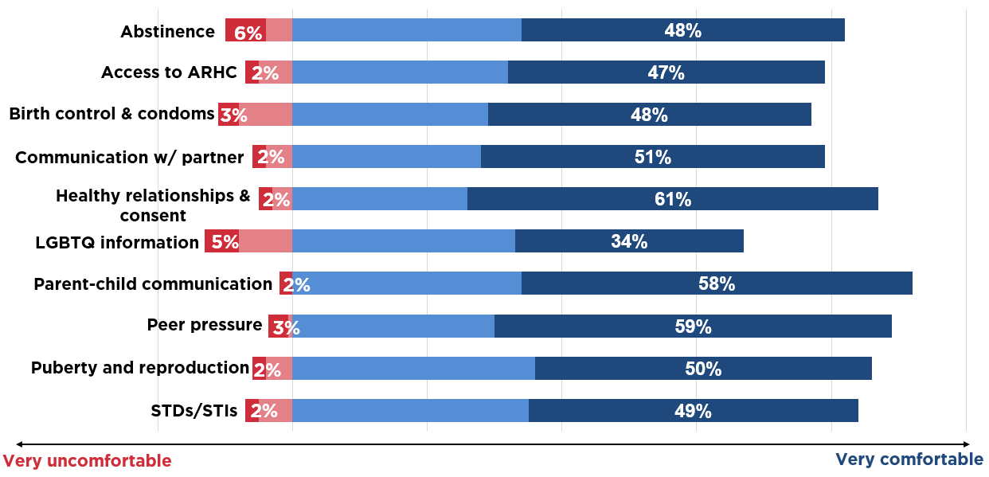
Source: CEP survey data. Data is accurate as of report date and is subject to change.

Topics receiving the highest level of comfort (rating of 5) from at least half of the interviewed parents were abstinence, access to affordable reproductive health care, communicating with partner, healthy relationships and consent, parent-child communication, and puberty and reproduction (See Addendum 5). Nearly a quarter also shared they were very comfortable discussing birth control and condoms and LGBTQ+.
Very comfortable because again, [healthy relationships and consent] so important, when it comes to rape situations and things like that. I need you to understand that if she says no, no means no. I don't care what her body is saying, anything. You have to understand, until she tells you yes, it's no. Vice versa, with you as well. With him being a male because sometimes we feel like males are just supposed to just go in there. I don't like the double standard and I'm not- I don't agree with the double standard, even when it comes to "oh well, it's okay for a guy to ask that but not a girl."
-P7
Yeah. So, I encourage her to do this, not only on a basic level with her brother, and with her parents and with her friends, but if she has some romantic interest where she's like, "I like this guy, but it's special." Like he's a different kind of like and my son the same way. I say, "All right well the conversation's going to look a little bit differently." So, I definitely encourage them to communicate, with everyone. But specifically knowing what that communication, how it looks differently with someone that you're giving a special title to.
-P8
In addition to comfort, interviewed parents were also asked to rate specific sexual health topics based on importance using a Likert scale (See Addendum 5). Approximately half of the parents rated access to abstinence, affordable reproductive health care, communicating with partner, birth control and condoms, healthy relationships and consent, LGBTQ+, parent-child communication, and puberty and reproduction as highly important (a rating of 5).
Collectively, no topics were rated at the lowest level of importance.
Yeah. [Communicating with a partner] just seems so obvious to me, because you, almost everything that can go wrong in any sexual relationship is about poor communication.
-P10
Uh, I think that [birth control and condoms], that's definitely good to […] discuss just because if, you know, they may not use the condoms all the time or they may not use the birth control all the time so then basically teach them about, you know, preventing pregnancies or the diseases. 'Cause that's what I was telling my daughter it seem like condoms don't only, I mean, like, birth control don't only protect against pregnancy, we have to worry about diseases as well. But, yeah, that's it.
-P11
Barriers
When asked what barriers were preventing them from accessing needed sexual health resources, surveyed parents most often reported having limited time (27%) and needing additional training/information in order to communicate this information (21%). Some parents also expressed concerns that their child(ren) would not engage in the conversation with them (19%).
What are some barriers in receiving the resources you feel are important (check all that apply)?

Limited time | 27%
Need additional training/information in order to communicate this information | 21%
Child(ren) would not engage | 19%
Don't know how to start the conversation | 13%
Limited access to ARHC | 10%
Partner or family member wouldn't approve | 4%
Source: CEP survey data. Data is accurate as of report date and is subject to change.

Interviewed parents most often mentioned the age of their own child and the child themselves not feeling comfortable discussing teen pregnancy prevention topics with them as the parent as the most significant barriers preventing conversations with their own child about these topics.
Comfortability. It's just not, not being comfortable, and then like I said, not knowing when the best time is based on age.
-P13
His age and my comfort level.
-P3
Age. Yeah, yeah, just making sure they're not... uh, I'm not creating interest in a... aren't creating curiosity for a topic that they're not interested in. And then being able to uh, provide answers for the areas they are interested in. So the only barrier is maybe interest uh, maturity and age.
-P8
In addition, interviewed parents were also asked how to reduce these barriers. In order to overcome barriers to conversations with their child(ren), several interviewed parents mentioned wanting to talk to other parents who already had conversations with their child(ren), having a trusted adult to talk to the child(ren) and let them know they can talk to their parent(s), and having their child participant in professional programs.
Yeah. Like I said, I think maybe talking to other parents, and maybe parents that have already gone through something. So, if you know, if there's parents that already have kids that are in their 30s, it's like, you know, "How did you approach the subject?" You know, "My kids are, you know, 16 or 17." You know. Like, "How do you approach the subject? How do you make them feel comfortable as you talk to them?" You know, just maybe talking to other parents who have already lived through that I think might be helpful.
-P12
I guess maybe the best resource would be other people that maybe have older kids and like talking to them. So, almost like a, not really a, a comfort group or anything like that, but like I said, just talking to other people who are similar and that have kids that are maybe a little older. So that might be a better, um, a best resource.
-P13
Resources and Delivery
When asked what topics they wanted to learn more about, surveyed parents wanted to learn more regarding parent-child communication (30%) as well as LGBTQ+ information (20%) and STIs/STDs information (20%). Parents reported wanting access to websites to deliver this information to them (39%); however around one-third of parents also reported wanting educational programs (30%) and handout/brochures (27%). Some interviewed parents expanded on this information by saying they wanted specific written, tangible information to read as a resource about sexual health related topics. These resources included books, pamphlets, and handouts. They rarely mentioned specific topics; rather they focused on their desire to learn from tangible resources.

What topic(s) would you like to learn more about (check all that apply)?

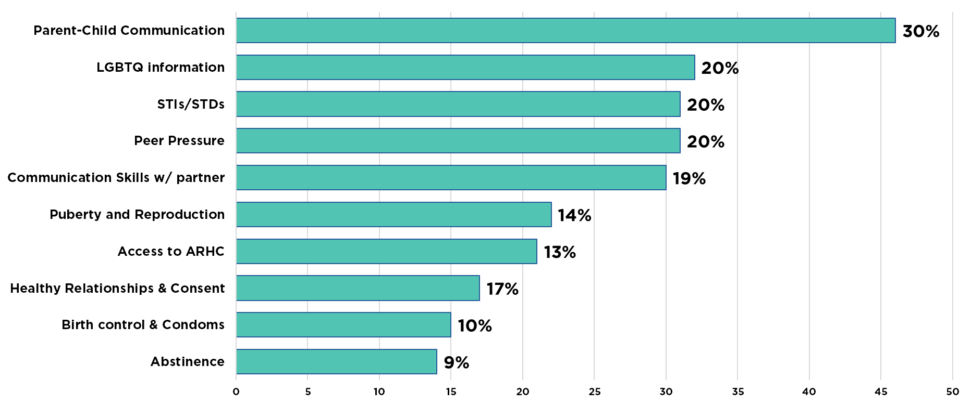
Source: CEP survey data. Data is accurate as of report date and is subject to change.

Interviewed parents also mentioned they would be interested in receiving emails and/or being linked directly to online sites. In addition to specific resources, parents also shared they would like to learn about sexual health related topics in group settings with other parents, including classes and/or support groups.
Um, for me I'm a reader, so I would probably do emails. I probably wouldn't see myself going to a school session and doing it like that mainly because of the timeframe. But like pamphlets, emails, books, different things like that, I would utilize.
-P2
Newsletters are great for me. If there was a Q&A site, um, a frequently asked questions site, you know, a blog, sounds funny, but something from social media that I can follow that has how-to guides and they're- that I can download or could read or could listen to. Uh, those are things that kind of would be interesting to me, to learn more about topics.
-P5
All interviewed parents also shared specific settings in which they would be comfortable allowing their child(ren) to learn about sexual health topics. Nearly half of the parents shared they would be comfortable with their child(ren) learning in school or their own home. A quarter of participants shared that a community/workshop setting, with an adult who the parent and child(ren) trust, church, or anywhere with a professional would be appropriate.
Small group settings. External organizations that are affiliated with, uh, extracurricular activities that they participate in. Uh, those are the things that I would feel comfortable my children having conversations with these topics outside of myself or a close family member.
-P5
I don't know, if they do offer programs at school, I'm comfortable with that. So, I don't know. I'm hoping the one where I tell them, but I mean if they can get a better type of education ... if the school at that time offers one, I mean it would be great.
-P9
I mean, I'd be fine with him doing school stuff, as long as it's not shame-based. So, I mean, I know there are some schools that do that, like dirty band aid thing, gross stuff, you're gonna be impure. I don't know if I'd let my child sit in that, or if I'd let him sit through it and then we talk about how crazy that is later.
-P10
I think that definitely, like I said, I would love for them to take a class at the university level. Um, because at that age, they're, they're a little more mature. I feel like it's, it's important for them to start learning about who they are at a young age. So like puberty and reproduction, you know, they probably get that around middle school, but then continuing to focus on the emotional, focusing on the psychological, focusing on the, the biological.
-P12
Nearly half of the interviewed parents also shared specific instances during which they would not be comfortable allowing their child(ren) to participate; a quarter of parents share that church (if the information is presented in a shameful manner) and if an unlicensed/unprofessional educator was leading the session they would not want their child(ren) to participate.
Um, but I would not want them going anywhere that, um, was being taught by someone who wasn't licensed or someone who wasn't, you know, well informed about those things. So, in other words, I'm not going to send them (laughs) with someone like me to teach them those things. Although I probably could give a lot of information, I would more so want them to learn it from a higher level than what I can offer.
-P2
…for example, in a church setting. I'm kinda cautious about that because of the way that it may be taught to them. If you're teaching it as a "this is wrong, this is wrong, this is wrong" then I don't want it to be taught there. If you're teaching it as "hey, this is something that happens." Yeah, the Bible would prefer if you wait until now, but we also have to look at reality too, so.
-P7

Summary

CBO Staff
The majority of CBO staff were direct service providers and reported their organization was already presenting teen pregnancy prevention information by in-house staff. Those who said their organization had not presented this information yet, reported that this type of information was outside of their organization’s mission.
CBO staff most often reported wanting to know more about LGBTQ+ information. Moreover, staff reported wanting to learn more about teen pregnancy prevention topics through websites and educational programs.

Faith Members
Faith respondents seemed open and willing to have teen pregnancy prevention topics presented in their house of worship to their youth, most often identifying the leader/pastor or youth leader/pastor as being the best internal fit to present that information; however, most reported this type of information was not currently being discussed in their house of worship.
Furthermore, participants also noted they were willing to have a trusted, professional outside organization come into present teen pregnancy information to their youth if they were able to find one. They reported wanting to know more about parent-child communication and would most like to receive that information through an educational program. Their most reported barrier was needing additional training and information to present these topics themselves.

Parents
Parents reported learning about sexual health topics as an adolescent, most often from parents and friends; some also mentioned educational programs at school. All parents reported being comfortable discussing sexual health topics with their child(ren). In fact, the majority of parents reported already having conversations with their child(ren) about sexual health topics. Of the parents who had not had these conversations, many perceived that these sexual health topics were not age-appropriate for their child(ren) yet.
Parents also reported wanting to know more about parent-child communication. They preferred learning about this through websites and an educational program. Additional resources included parents wanting access to tangible resources (such as brochures) and connecting with other parents. However, parents reported that limited time was their most common barrier in talking with their child(ren) about sexual health topics.

All Target Populations
Looking across all three target populations, the most common topics that respondents want to learn more about were parent-child communication, communication skills with partners, STIs/STDs. They wanted these topics delivered through educational programs, handouts and/or brochures, group settings, and websites. The most common reported barriers that the combined group faced was needing additional training and information, limited time, and lack of approval (or support) from others discussing these topics with adolescents in their lives.

Future Implications
Based on the study, there are several future implications for not only the Thrive organization, but also for collaborating partners to consider. The following sections will provide recommendations for each target population.

CBO Staff
First, this study has shown that local CBO staff desire additional training opportunities and access to electronic resources. Thrive should coordinate trainings for CBO staff to receive educational information regarding requested teen pregnancy prevention topics. Ideally, Thrive would be able to coordinate with existing programs/organizations who are already offering training to alleviate duplicate efforts/trainings. If training is unavailable, Thrive should work to either develop or collaborate with local organizations to develop meaningful trainings.
Second, Thrive should develop (or link) a resource page(s) on the Thrive website in order to connect CBO staff to current and accurate teen pregnancy prevention information. Many staff expressed wanting access to current information, on-line. The Thrive website (and links to other resources) could help to supplement information gaps, especially when staff are unable to attend in-person training.
In addition, although many staff perceived teen pregnancy prevention as being outside of the scope of their organization, research shows that teen pregnancy prevention influences overall health outcomes of teens as well as the local economics of the community (Hoffman & Marynard, 2008). In order to overcome this perceived barrier, Thrive should work to provide factual, easy to obtain information (on-line) regarding how teen pregnancy prevention is relevant to multiple health and economic outcomes. Thrive should also ensure that all staff are knowledgeable or know how to obtain this information as well.

Faith Members
First, this study has shown that trust is an important component in the faith community. Therefore, Thrive should continue to foster relationships with local faith leaders and members. Since the faith community in the Oklahoma City metropolitan area is such a large part of the community, it is vitally important to develop meaningful, trusting relationships with leaders and members. This is important especially since faith respondents reported wanting to partner with trusted partners. Moreover, any organizations who plan to partner with houses of worship to implement teen pregnancy prevention programming (or provide any sort of resources) should consider fostering meaningful relationships with the leader(s) first.
Second, once relationships are established, Thrive should connect faith leaders and members with sexual health professionals/educators who can facilitate or co-facilitate with an in-house leader/member to conduct educational programs. As the backbone organization, Thrive’s role is not to provide direct services. Thrive should be a connector of resources and facilitator of conversations between the community and partnering organizations.
Third, since faith respondents reported wanting more information about parent-child communication and additional training opportunities, Thrive should research curricula or training programs that focus on developing parents’ skill sets to have meaningful parent-child conversations about difficult topics, such as sexual health. If curricula or programs already exist, Thrive should consider offering training(s) for their collaboration members and for members of local houses of worship to promote sustainable programming/access to resources in the community. If curricula or programs are an inappropriate fit (or unavailable), Thrive should consider partnering with local organizations to facilitate the development of meaningful workshops/trainings.

Parents
First, this study has shown that parents reported being comfortable discussing sexual health with their child(ren); but many report their child(ren) being too young to engage in these sorts of conversations. Thrive should determine how to communicate research regarding age-appropriate topics to parents, while also assessing their readiness to learn more about these topics and share with their child(ren). One recommendation would be to review the Advocates for Youth website which organizes sexual health information by age for the parent. Thrive should focus on providing concise, information-rich resources tailored to parents on the Thrive website, such as downloadable brochures/fact sheets.
Second, although parents reported wanting educational programs (in-person), they also mentioned time as a major barrier. Therefore, when connecting parents with training programs, Thrive should be cognizant of the time commitment and training times. Although in-person meetings present their own barriers (time, retention, cost, etc.), parents reported wanting to connect to other parents who were experiencing similar situations. By fostering these connections through education programs, Thrive could help to nurture a network of connected parents.

Limitations
Although meaningful, this community needs assessment faced several challenges. First, there was a lower than expected survey and interview response rate from the faith community. Many additional efforts were made to engage the faith community (such as on-site surveying, posting of flyers, tabling, and additional emails to engaged faith leaders). However, even with the additional outreach, the response rate did not reach the response goal for surveys nor interviews. This could either be indicative of the sensitive nature of discussing sexual health in the community and/or the need for longer data collection timeframes (when possible).
Second, there was a low response rate from key populations in our community. For example, Hispanic ethnicity and American Indian race have higher teen birth rates; however, their response-rate was lower than other races and ethnicities. The highest number of responses were from middle-aged, White females, even after additional outreach efforts (as mentioned above).
Lastly, the majority of the recruitment occurred within the collaboration, although some on-site surveying was conducted and interview recruitment was conducted mostly outside of collaboration. For future projects, it would be important to engage populations outside of Thrive’s sphere of influence to ensure a diverse community voice is captured.

Conclusion
This community needs assessment provided a plethora of valuable information regarding the needs of CBO staff, faith members, and parents. Communities are continuously adapting and growing. Therefore, it is important that Thrive continue to gain insight from the local community about their evolving needs. This consulting process is iterative and should not end with this needs assessment. Moreover, Thrive should not attempt to engage the community alone. It is vitally important to engage and work alongside parents, faith members, and community-based organizations (both current and potential partners) in order to see continued, impactful changes in sexual health.

References
Bhat, A. (2019). What is survey dropout analysis and why is it needed?
Retrieved
June 6, 2019 from https://www.questionpro.com/blog/what-is-survey-dropout-analysis/
Catalano, R.F., Fagan, A.A., Gavin, L.E., Greenberg, M.T., Irwin, C.E., Ross, D.A.,
& Shek, D.T.L. (2012). Worldwide application of prevention science in adolescent health. Lancet, 379(9826), 1653–1664. doi:10.1016/S0140-6736(12)60238-4.
Collective Impact Forum. (2017). Community Engagement Toolkit
Version 2.2. Retrieved from https://www.collectiveimpactforum.org/sites/default/files/Community Engagement Toolkit.pdf
Hardy, S., & Raffaelli, M. (2003). Adolescent religiosity and sexuality: An
investigation of reciprocal influences. Journal of Adolescence, 26(6), 731-739.
Hoffman, S. D., & Maynard, R. A. (Eds.). (2008). Kids having kids: Economic
costs and social consequences of teen pregnancy (2nd ed.). Washington, DC: Urban Institute Press.
Kramer J.S., Philliber S., Brindis, C.D., Kamin, S.L., Chadwick, A.E., Revels, M.L.,
Valderrama, L.T. (2005). Coalition models: Lessons learned from the CDC’s Community Coalition Partnership Programs for the Prevention of Teen Pregnancy. Journal of Adolescent Health, 37, S20–S30. doi:10.1016/j.jadohealth.2005.05.010
Miller, B. C. (2002). Family influences on adolescent sexual and
contraceptive behavior. The Journal of Sex Research, 39(1), 22-26.
Power to Decide (2019). National data. Retrieved from
https://powertodecide.org/what-we-
do/information/national-state-data/national
The National Campaign to Prevent Teen and Unplanned Pregnancy. (2013).
Counting it up: The public costs of teen childbearing: Key data. Washington, DC: The National Campaign to Prevent Teen and Unplanned Pregnancy. Retrieved from https://powertodecide.org/what-we-do/information/resource-library/counting-it-key-data .
Tolley, E. E., Ulin, P. R., Mack, N., Robinson, E. T., & Succop, S. M. (2016)
Qualitative methods in public health: A field guide for applied research (2nd ed.). San Francisco, CA: Wiley.
Ulin, P. R., Robinson, E. T., & Tolley, E. E. (2005). Qualitative methods in
public health: A field
guide for applied research. San Francisco, CA: Jossey-Bass.
United States Census Bureau (2018). QuickFacts: Oklahoma City, Oklahoma.
Retrieved from
https://www.census.gov/quickfacts/fact/table/oklahomacitycityoklahoma/PST045218
United States Census Bureau (2018). QuickFacts: Oklahoma County,
Oklahoma. Retrieved from
https://www.census.gov/quickfacts/fact/table/oklahomacountyoklahoma/PST045218

Addendum 1 – More than Just a Talk Feedback Form
Level 1: More than Just “The Talk” Workshops
Faith Settings and Dates
United Methodist Church | 4/18/18 | 6 adults
Baptist Church | 5/9/18 | 42 adults
Congregational United Church of Christ | 11/1/18 | 12 adults
Faith Settings- Aggregate Brief Assessment Data
On a scale of 1 to 10, please circle how you would rate this workshop (1= not worthwhile, 10= very worthwhile) | 9.633
The most valuable part of the workshop was… | How to answer sensitive questions (34), How to have truthful convos with adolescents (9), Candid Information/Open Conversation as a group (5), Facts/Stats (4), All valuable (3), Door openers (2), Videos (1), Open discussion about consent (1), condoms expire (1)
The least helpful part of the workshop was… | None/N/A (56), Videos (3;1video was removed after the first workshop based on feedback), PowerPoint (1), Want information presented on the back of one of the handouts (1), Reviewing the 5 types of questions (1)
We are preparing for key informant interviews. Key informants are people who know what is going on in the community. Do you have any recommendations of faith leaders (clergy, lay leader, or other adult) who you would recommend for these interviews?
15 names provided
Recommendations for future topics or programs that should be held in faith settings?
Drugs & alcohol (4), more emphasis on boy’s role in sex (3), HIV/AIDS (2), physical and emotional abuse/abuse (2), how to use social media appropriately (2), preventing communicable diseases/STDs (2), abstaining from sex (2), self-esteem/self-love (2), information about programs for churches wanting to implement comprehensive sex ed (1), consent training (1), contraceptive methods (1), porn (1), goals/dreams (1), peer pressure (2), emotional attachment (1), how to get to know your sexual partner (1), teen suicide (1), divorce (1), how to mentor youth who are pregnant or had a child so they will not have another child (1), homosexuality (1), abortion (1), Biblical view of sex, effect of child support (1), Christian dating (1), oral sex (1), skits of consequences (1), know how/why to discipline (1), trust issues (1), how kids can talk to parents (1), kids not trusting everything they hear from everyone (1)
Community-Based Organization (CBO) Settings and Dates
Pivot | 5/14/18 | 9 adults
Boys & Girls’ Club of Oklahoma City | 5/30/18 | 14 adults
CBO Settings- Aggregate Brief Assessment Data
On a scale of 1 to 10, please circle how you would rate this workshop (1= not worthwhile, 10= very worthwhile) | 9.478
The most valuable part of the workshop was… | How to answer sensitive questions (10), How to talk to about sex with adolescents (7), All valuable (4), Door openers/closers (2),
The least helpful part of the workshop was… | None or N/A (16), want more time for the workshop (2), other participants over-talking (2), PowerPoint (2), having a conversation about sex at all (1)
We are preparing for key informant interviews. Key informants are people who know what is going on in the community. Do you have any recommendations of community-based organization staff members who you would recommend for these interviews?
7 names provided
Recommendations for future topics or programs that should be held in community settings?
STD/STI prevention (3), Sexual trauma or abuse, relationship building/ healthy relationships (2), sex before marriage (1), provide more reasons and solutions for teen pregnancy problem in OK (1), life after teen pregnancy (1), programs longer than 1 year

Addendum 2 - Suggestions for Survey Changes from Community Working Group Meeting
Overall |  | Front page |  | Parent |  | Faith |  | CBO Staff
Have drop down menu or allow them to hover to explain terms they may not know |  | Intro is too long, condense it to need-to-know info. | 2 | Where did yo receive this info: "Add friends, parent, siblings, internet" | 2 | Group agrees that we shouldn’t use church but rather "place of worship" to be inclusive |  | What type of organization do you work at? "Add Community, mental healthy/substance abuse and Other"
Add a contact person with email for questions/comments/concerns |  | Link to Thrive website in intro (maybe to grant page info?) |  | What is your level of comfort talking to your child(ren) about the following SH topics: "Communicating with partner…about what? Add more detail" |  | Has your church offered TPP education serv: Question is unclear, clarify what you're wanting from this question |  | What type of organization do you work at? "Add Domestic violence/sexual assault, higher ed, mental health counseling, healthcare"
Have a in-person or by phone option in case people don't have a computer |  | On the first EOS after intro some people may still want information - link to Thrive? |  | What topics would you like to learn more about: "Communicating with partner…about what? Add more detail" |  | Has your church offered TPP education serv: |  | Which of the following topics would you like to lean more about: Add "Sexual Violence prevention" to the list | 3
Have the option for the questions to be read out loud | 3 | Include a "why are you getting this" in intro | 2 | .Change EOS message to: "EOS: Thank you for your time! Would you like to give us your contact information to be entered to win a prize? Don't worry, this will not be linked to your survey answers! No one will know what you answered |  | Has your church offered TPP education serv: Not inclusive of a dynamic church structure - needs to be more specific | 2 | Please rate how effective your organization sexual health services are: "What is this based on?" | 3
 |  | Ages: consider breaking down into smaller groups | 3 | Spell "sex ed" out |  | Use birth control not contraceptives | 2 | Which of the following topics does your organization address: "Add Sexual violence prevention on the list" | 2
 |  | Employment type: add "Temporary" | 2 | If you don't need or want to talk to your child(ren): Add "not acceptable in my culture and my partner has those conversations" | 2 | How important do you feel the following topics are for you/and or your teens - should change to "Teens within your church" |  | What resources would help your organization by more effective in deliver SH info: "Add surveys"
 |  | Intro: Thrive is a non-profit organization that is committed (delete "that is") |  | What topics would you like to learn more about: Add "other" option |  | How would you and/or your teen - change to "Teens within your church" |  | Which of the following topics would you like to learn more about "Add some sort of prioritization" | 2
 |  | Intro: "the bst chance to meet your needs and the needs of your community" |  | How would yo and/or your teen - say "child" instead of "teen" |  | Click this link to be contacted with more information - "you answer" is hard to read |  | How would you like to receive information on these topics: "Training add 'classroom or web-based'"
 |  | Gender: Change to "Sex" |  | What are other settings you would like to see sex ed. Taught in? "Add online and peer-to-peer" |  | Communicating with partner is vague - needs more detail. Seems too close to healthy relationships | 2
 |  | Parenting Adult: Change to "Caregiver" |  | Include a list of TPP list of resources at the EOS for parents who don’t want to talk to their kids. Resources could include: Thrive, other organizations, CDC SIECUS, advocates for youth, etc. |  | How important do you feel the following topics are for you/and or your teens: add peer pressure/social norms/perceptions from media
 |  | Do you currently have children under the age of 18: Some parents share custody or don't have them full-time. Reword the question to include them |  | If you don't need or want to talk to your child(ren) about these topics: Add "Would you like someone to talk w/ your child for you?" | 3 | You and your teens don't seem inclusive of all respondents. Say child instead of teen
 |  | Say birth control instead of contraceptives. Some people won't know what contraceptives are. | 2 | What is your level of comfort talking to your child(ren): Contraceptives listed twice in sentence is redundant. |  | What are some barriers: Add "Don't know where to find info and spouse has different views"
 |  | Many people who speak spanish don't necessarily read spanish. |  |  |  | Would it be helpful to ask parents what their plan is to educate their child on these topics?

Addendum 3- Survey Question Path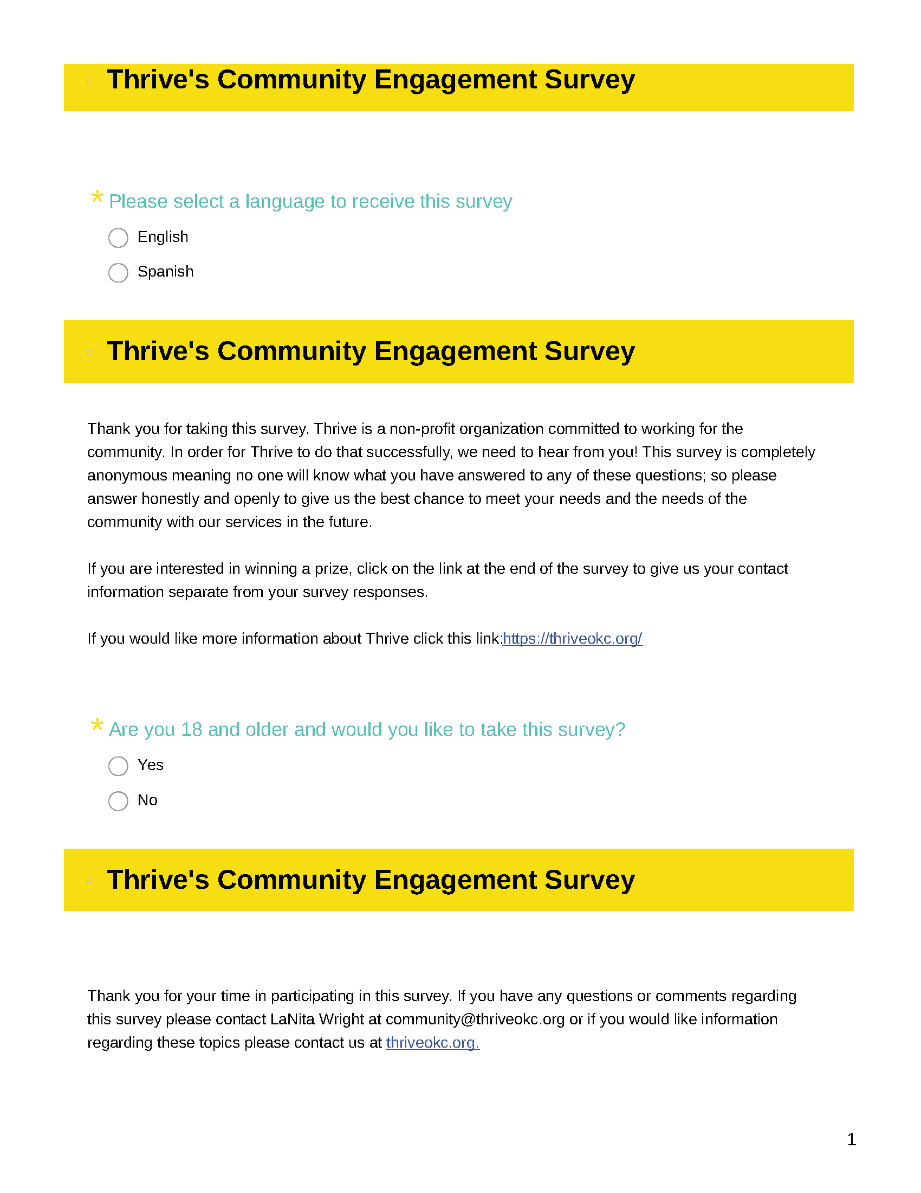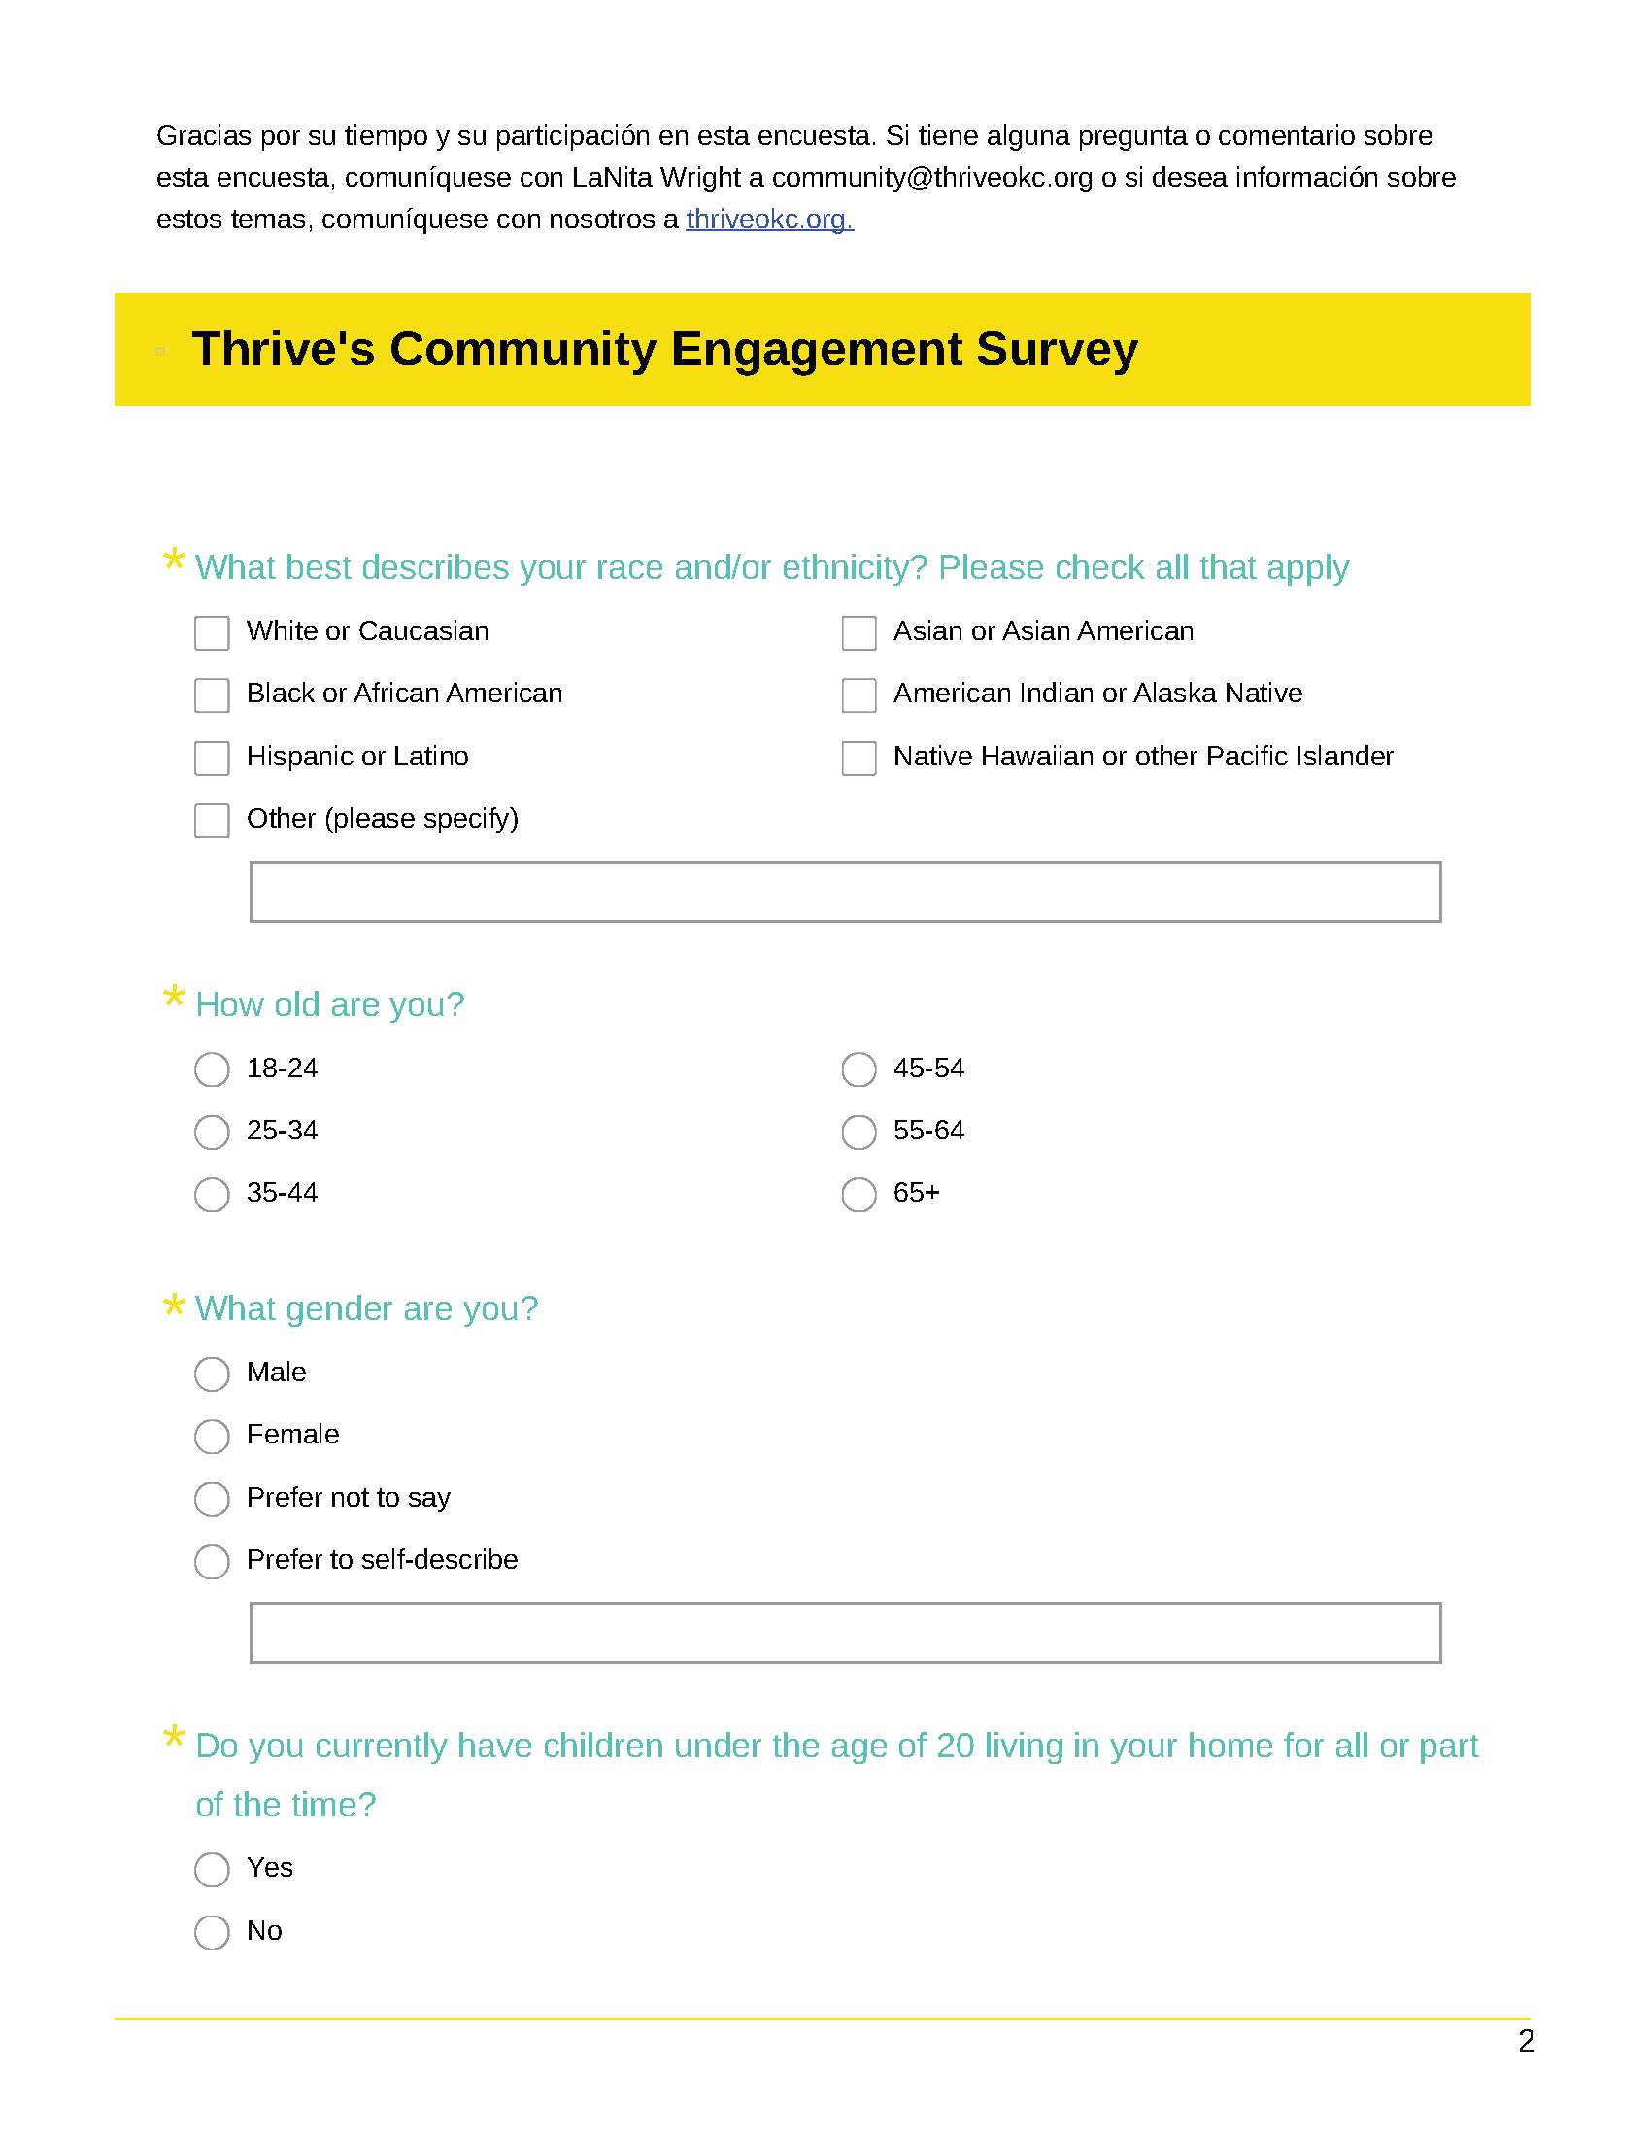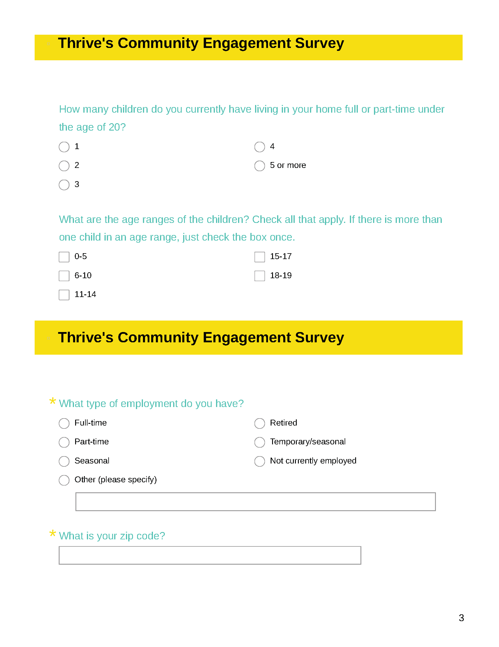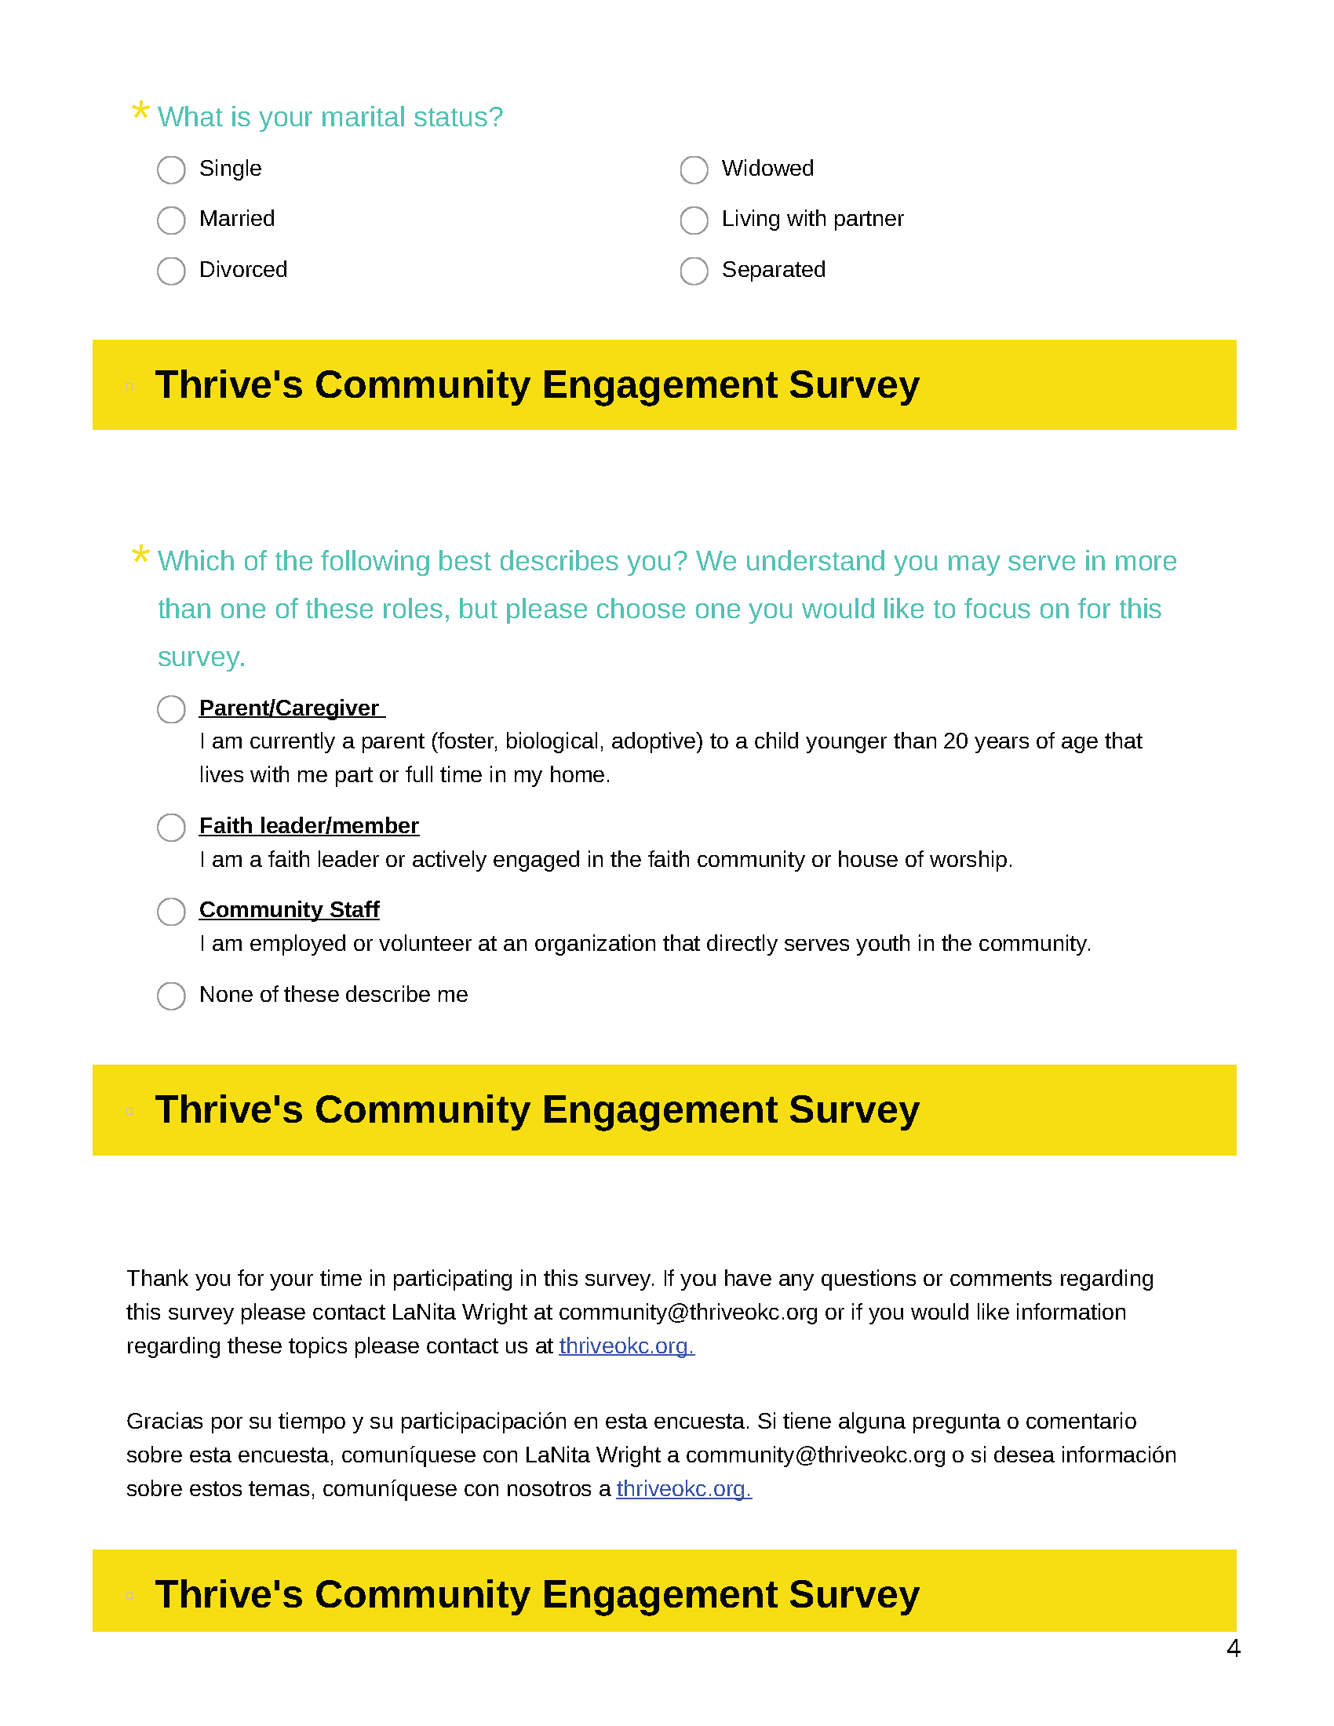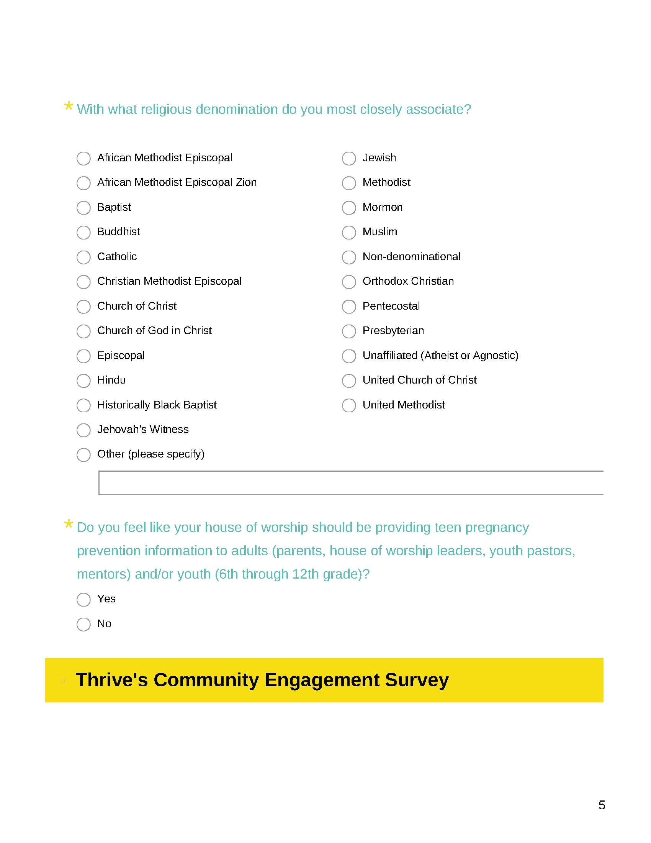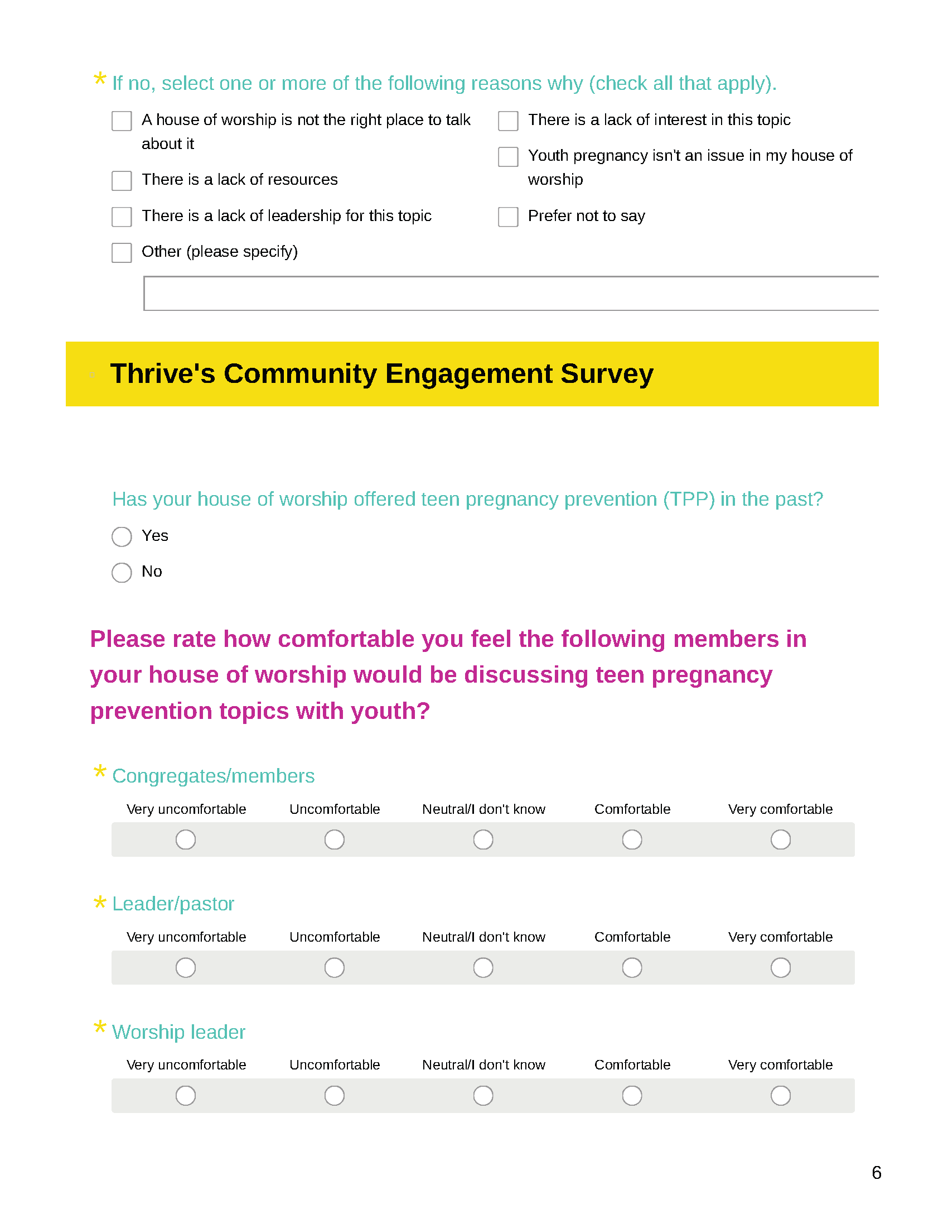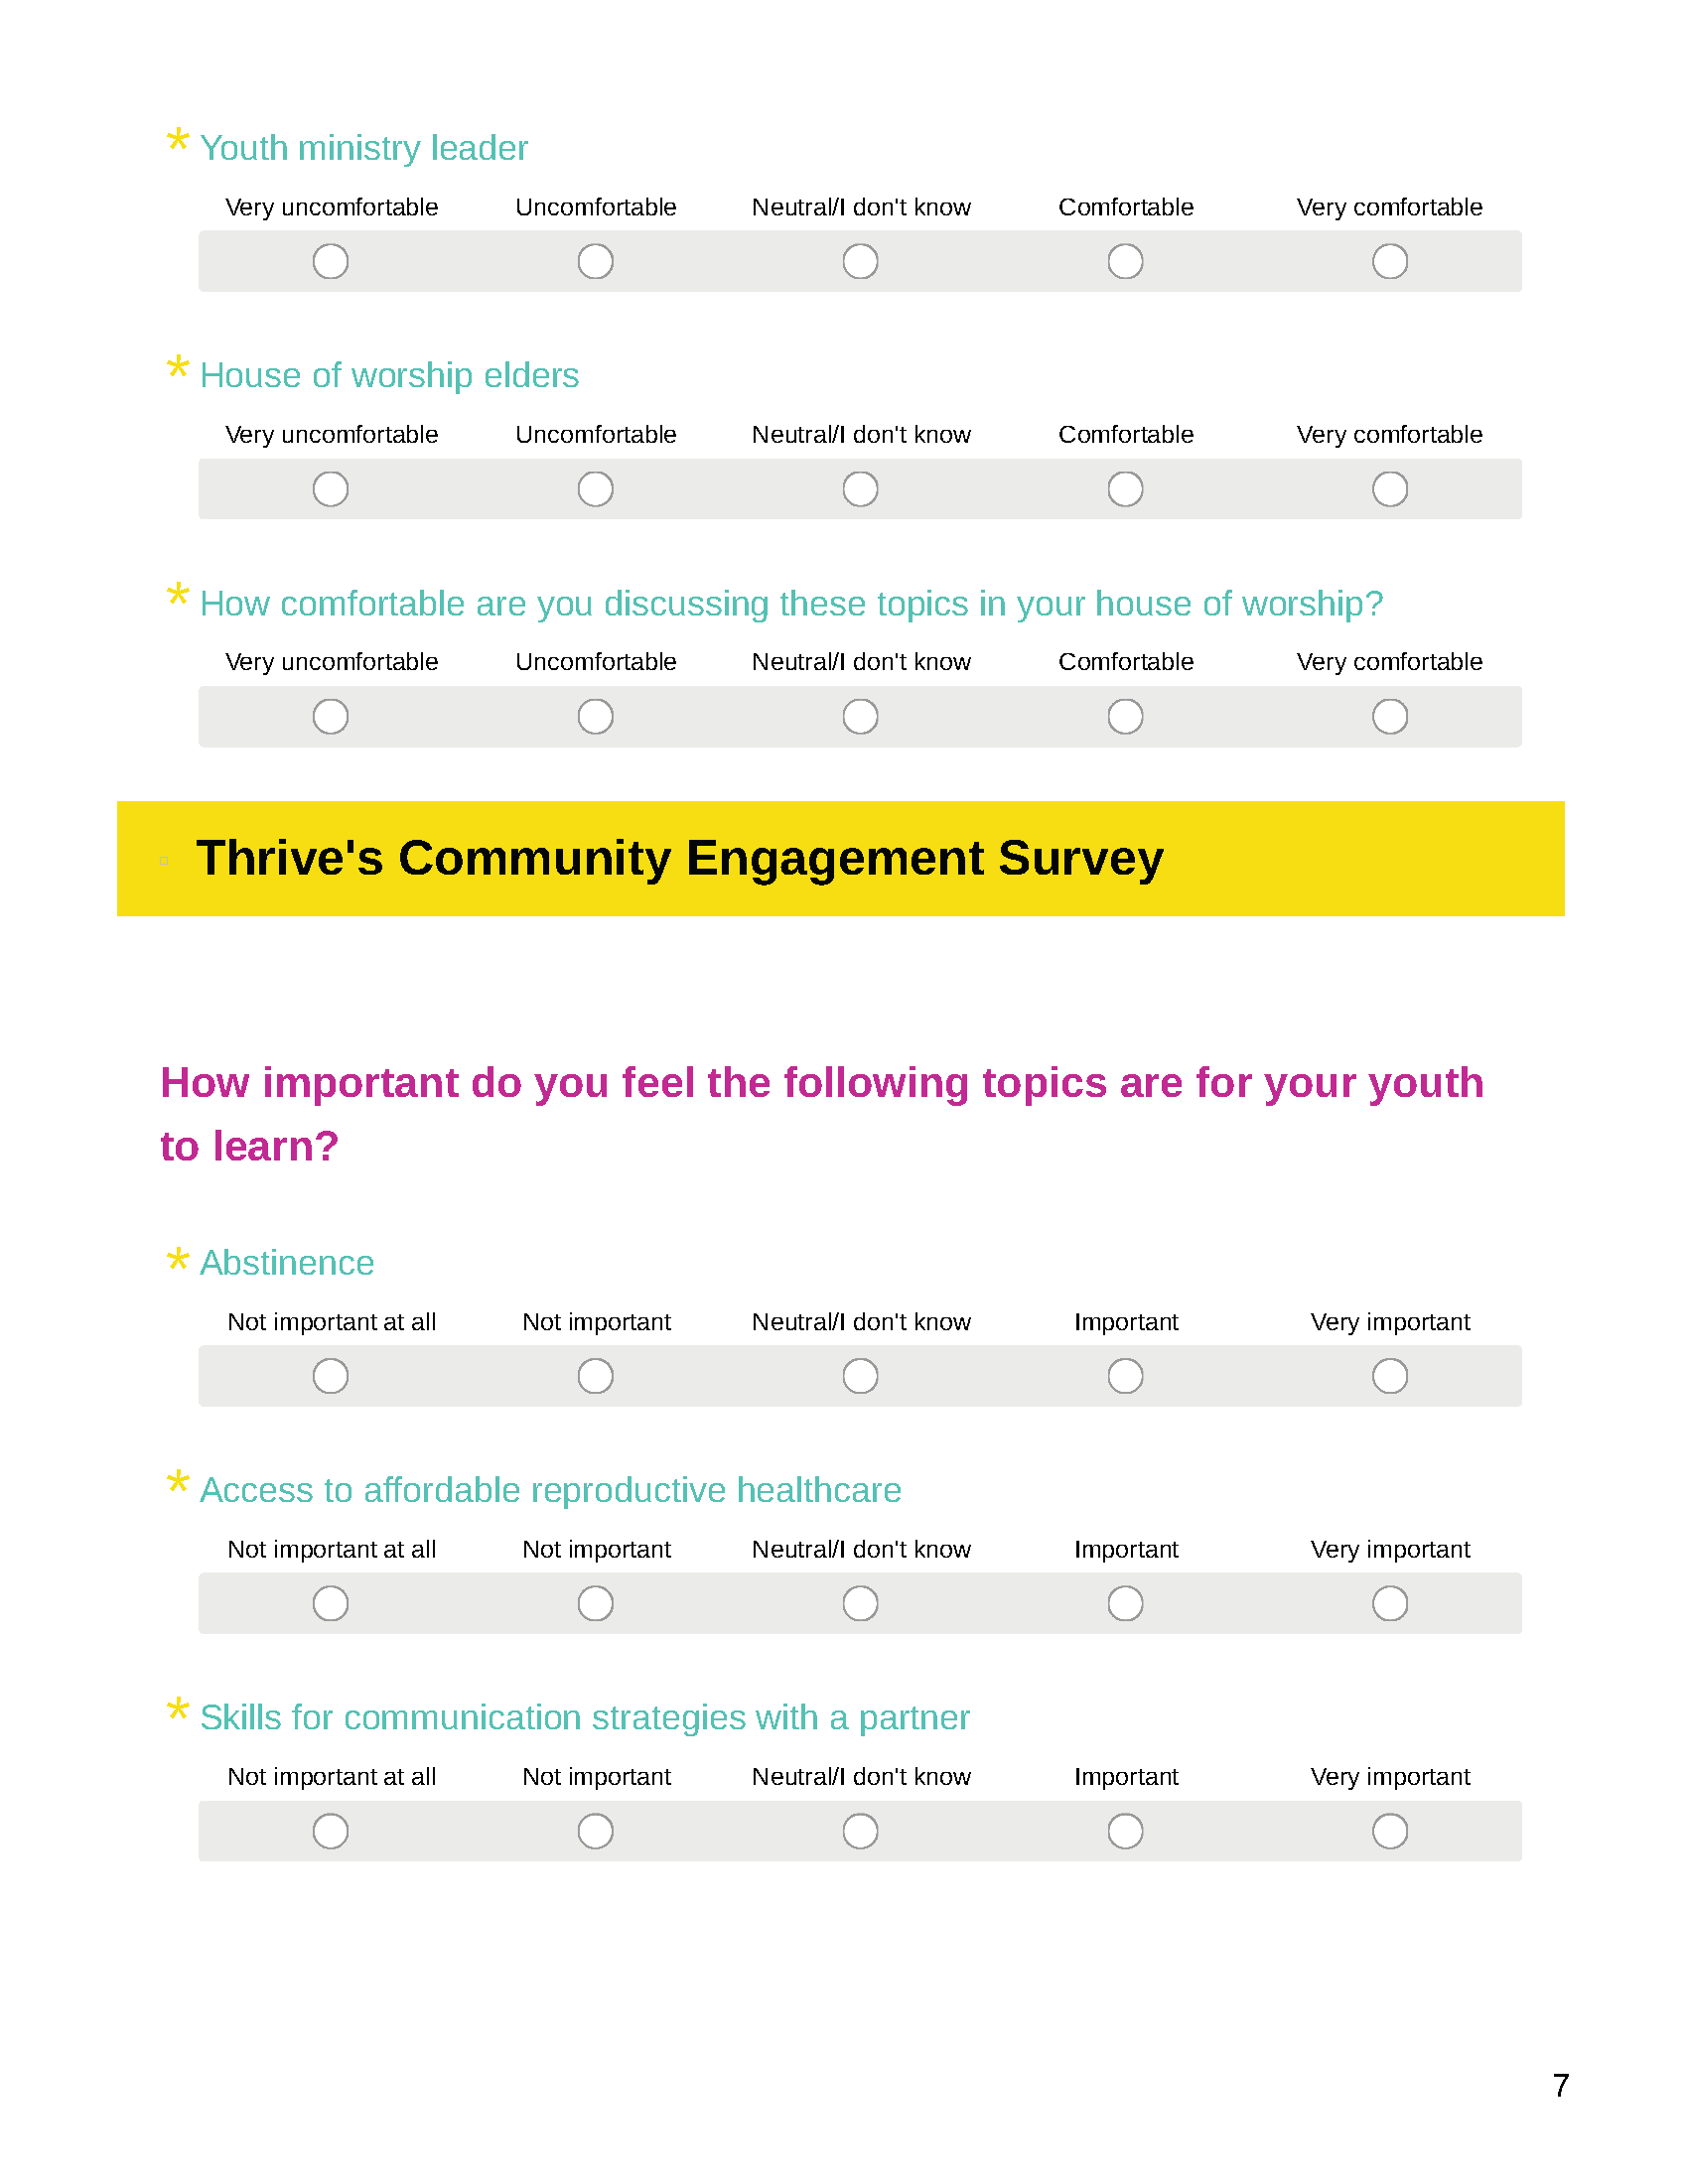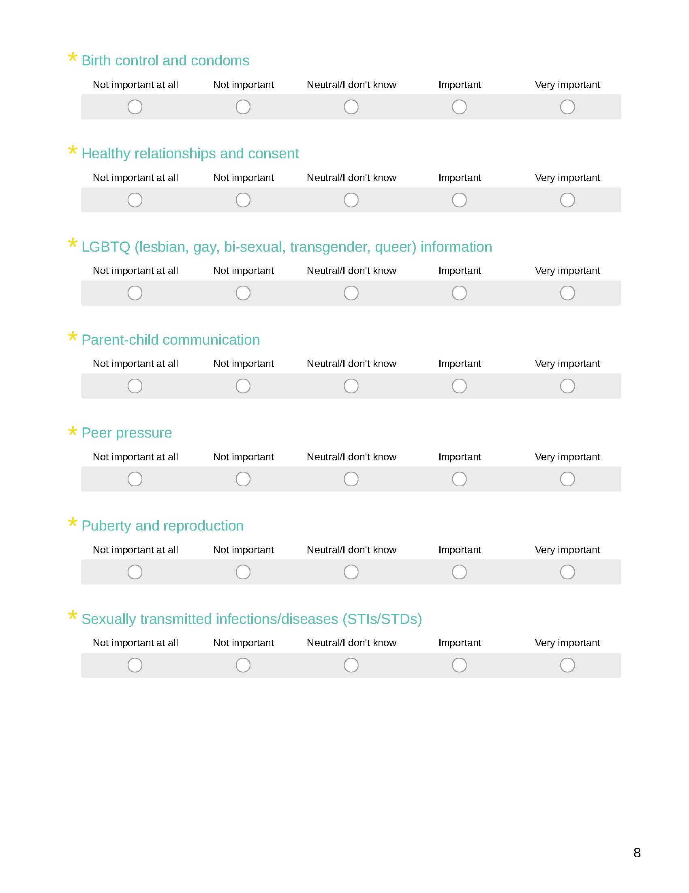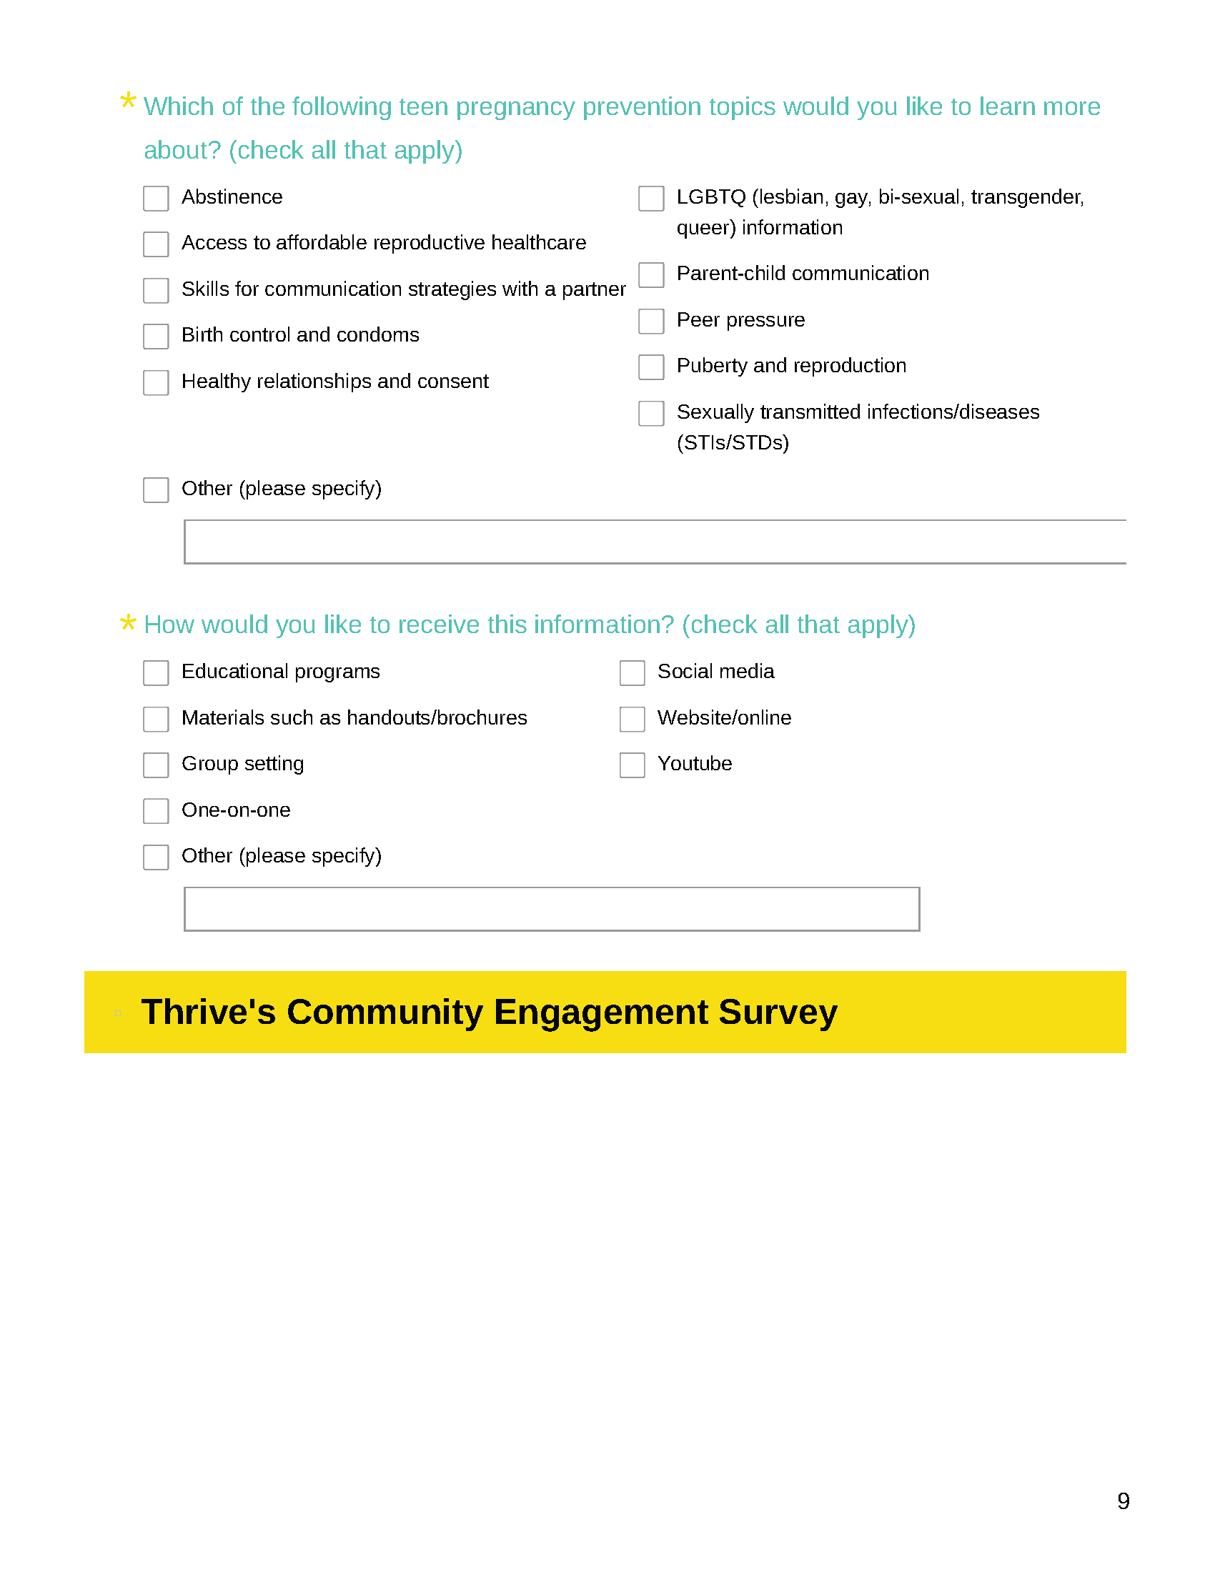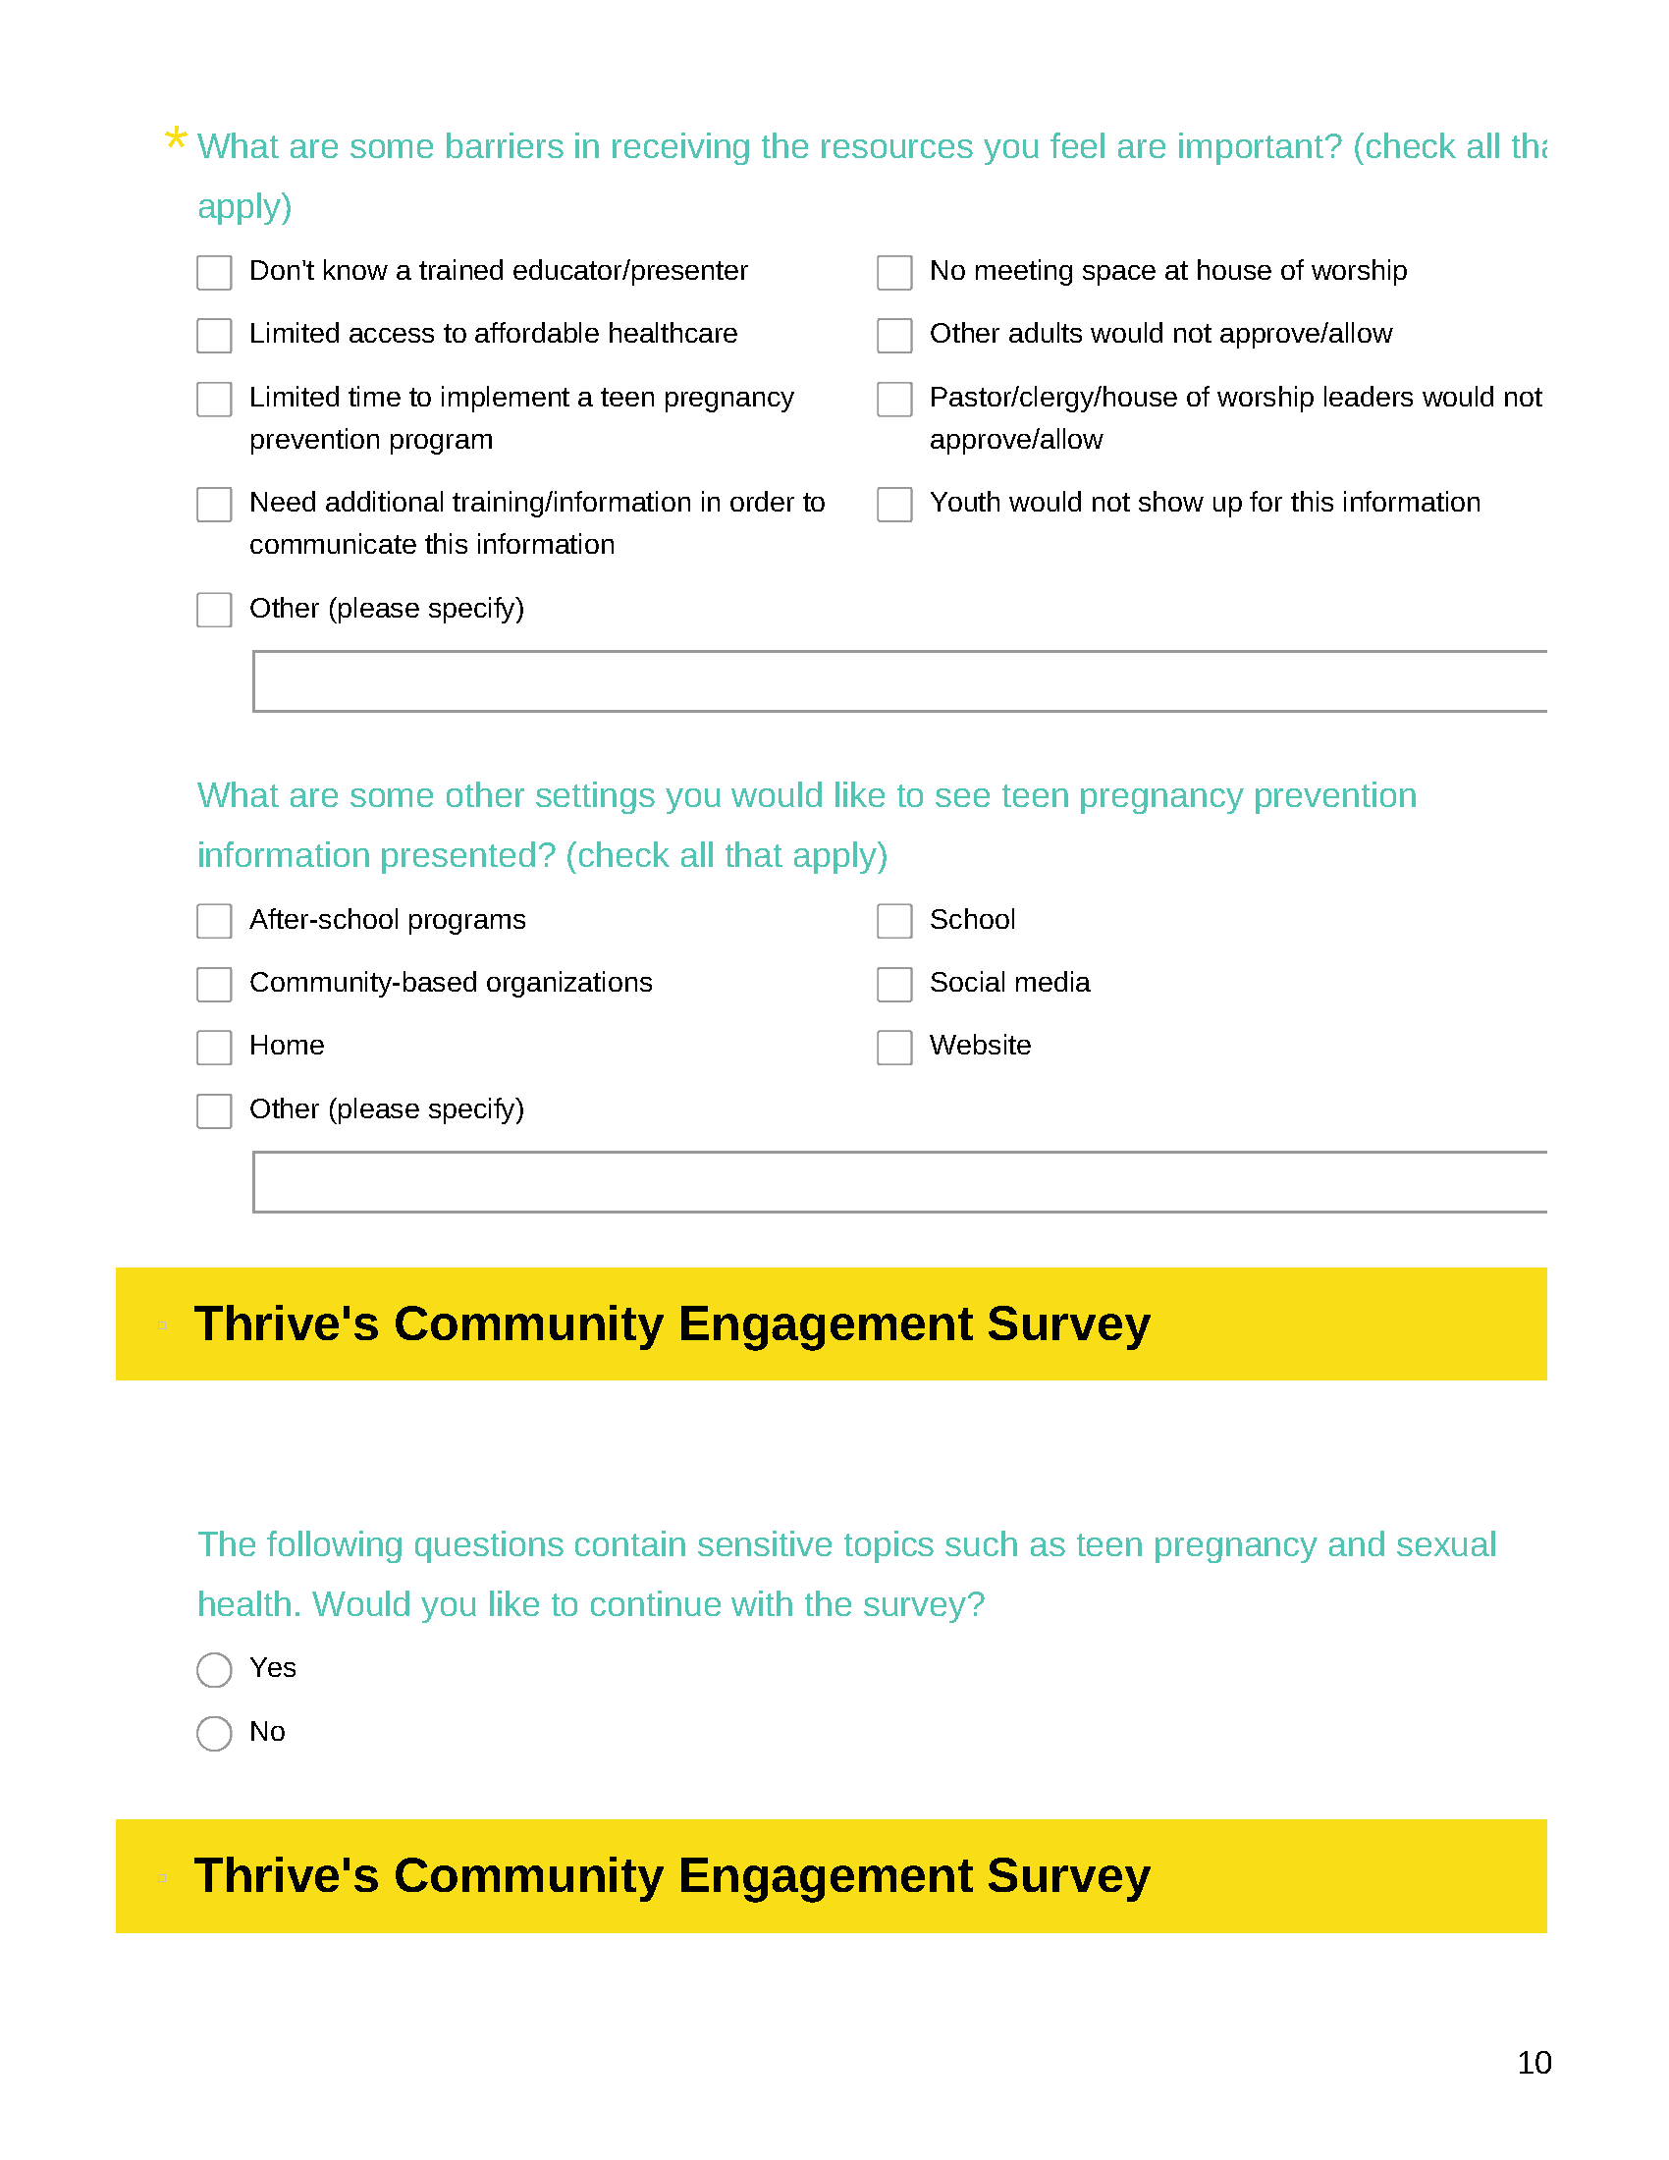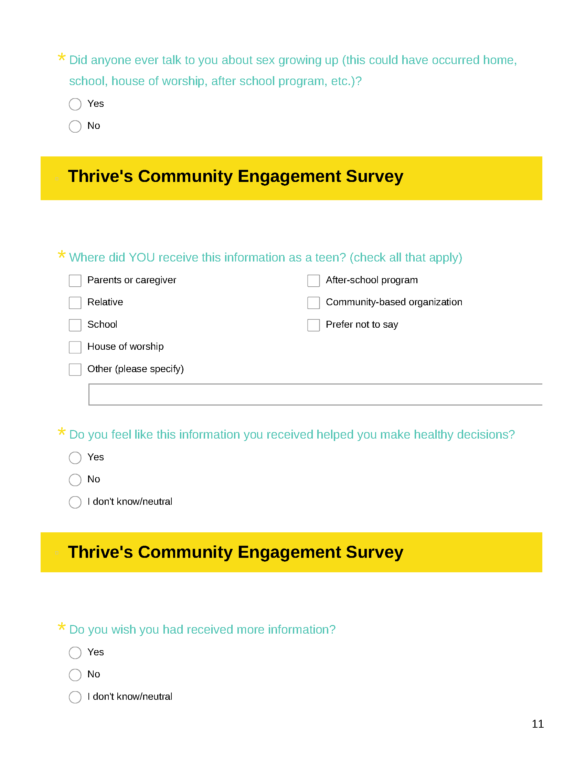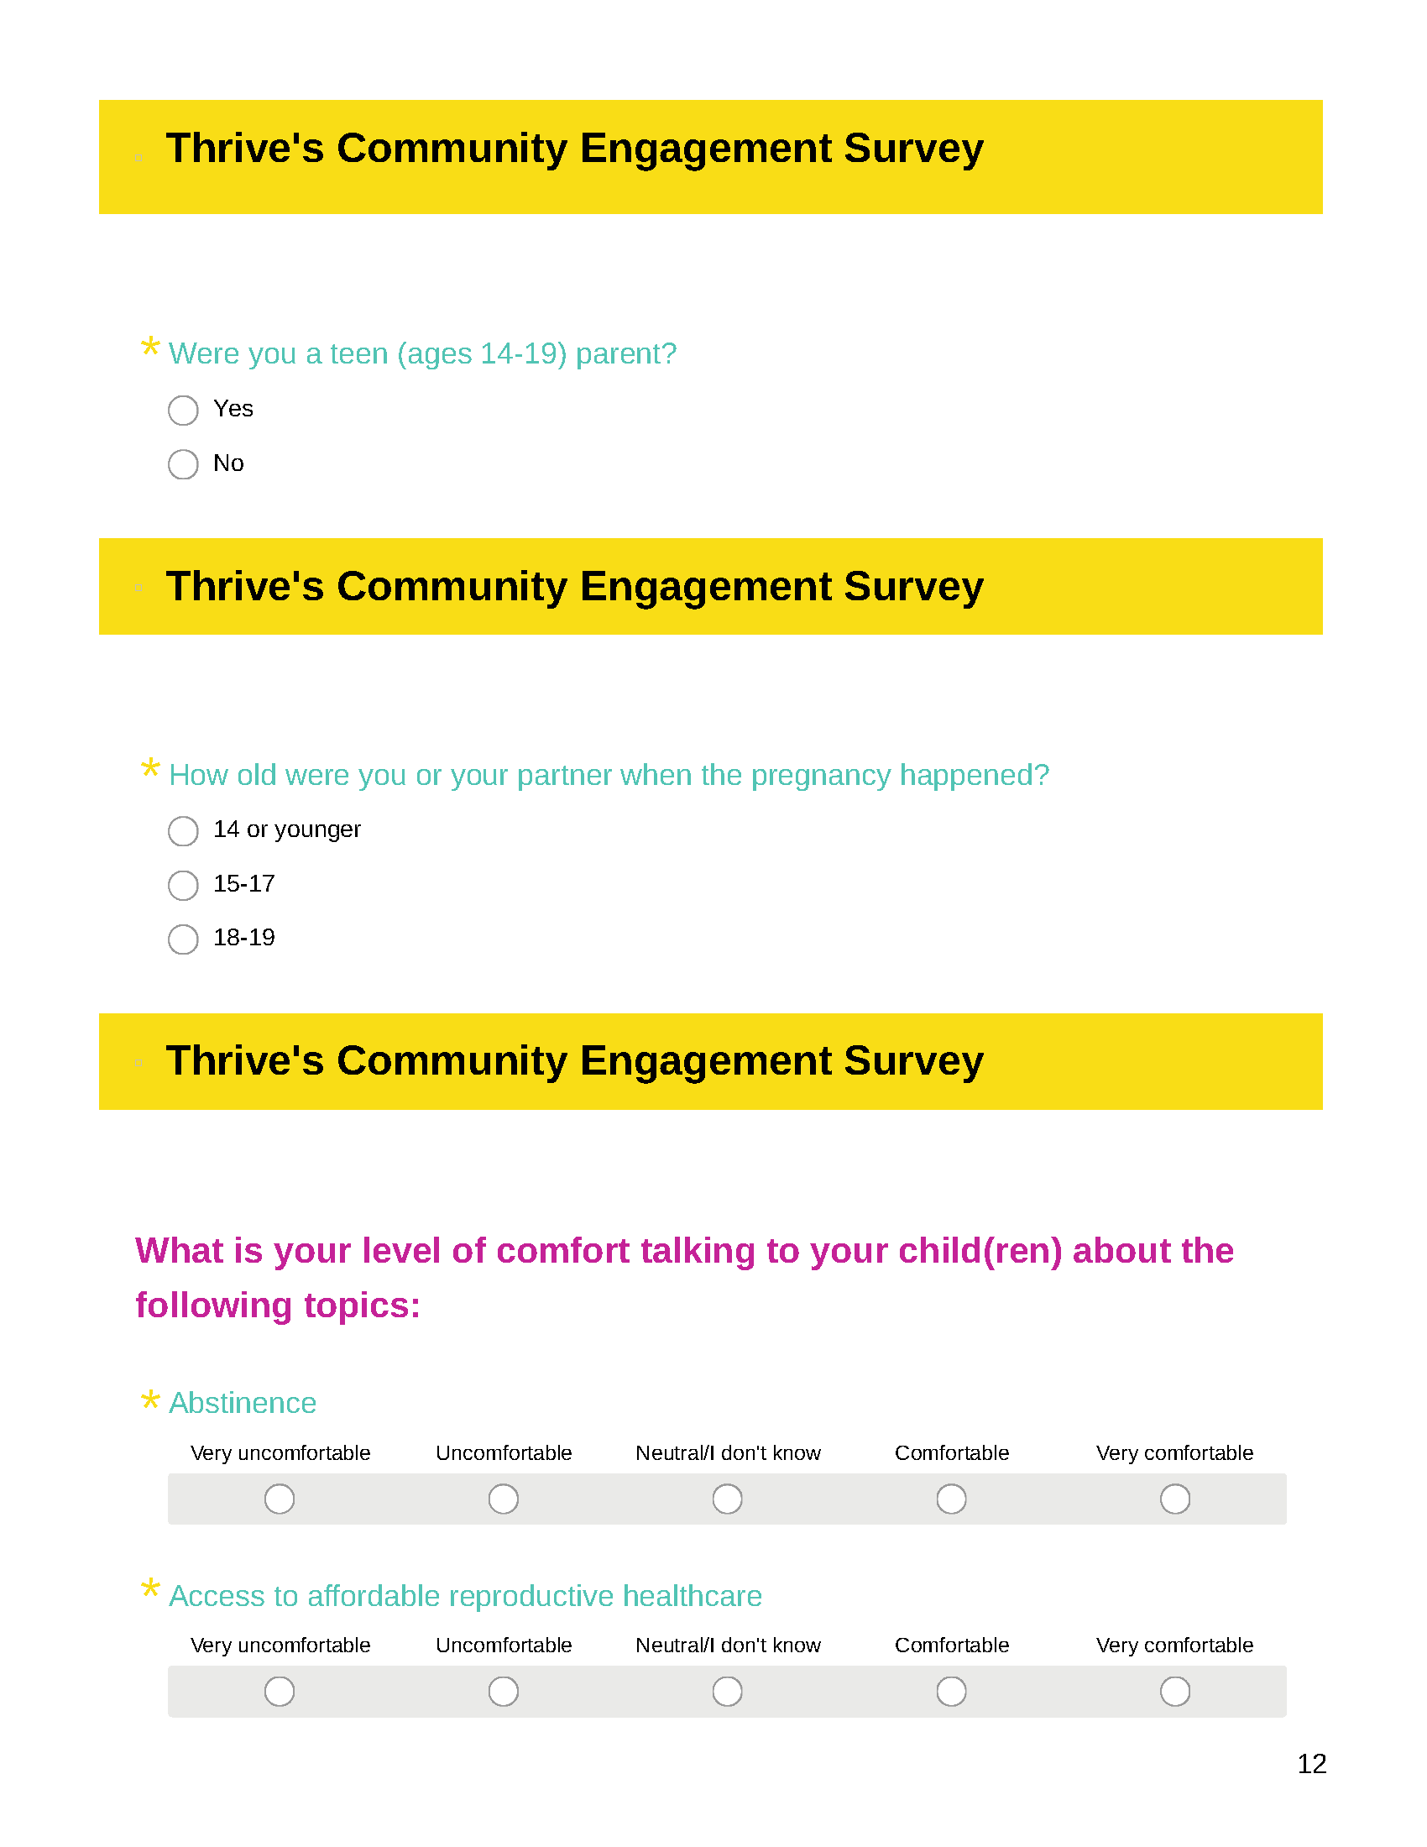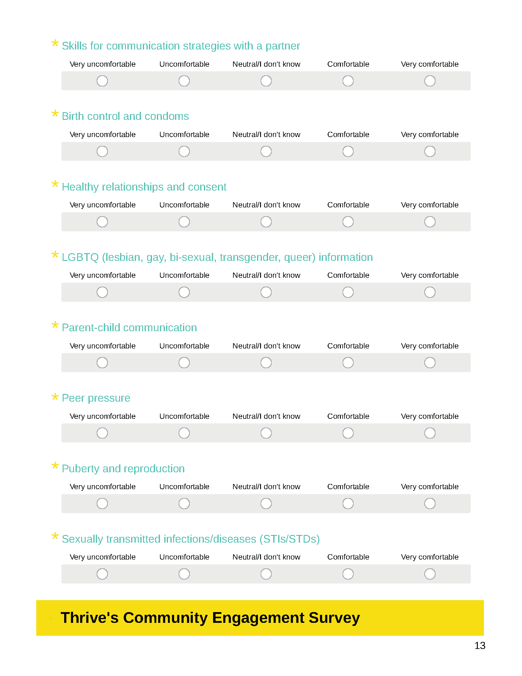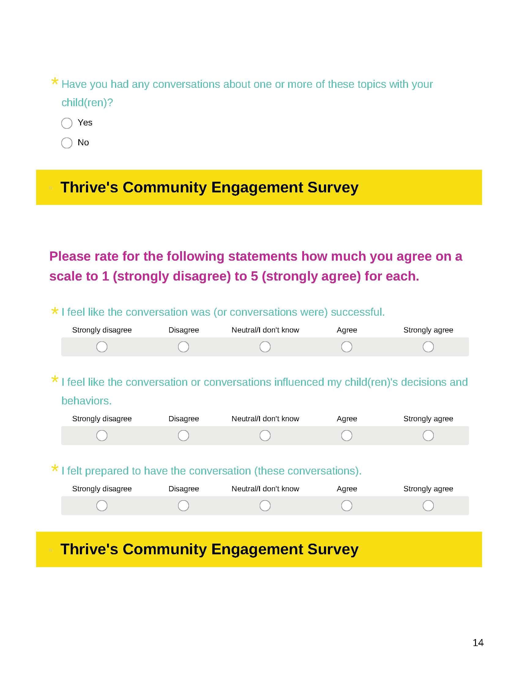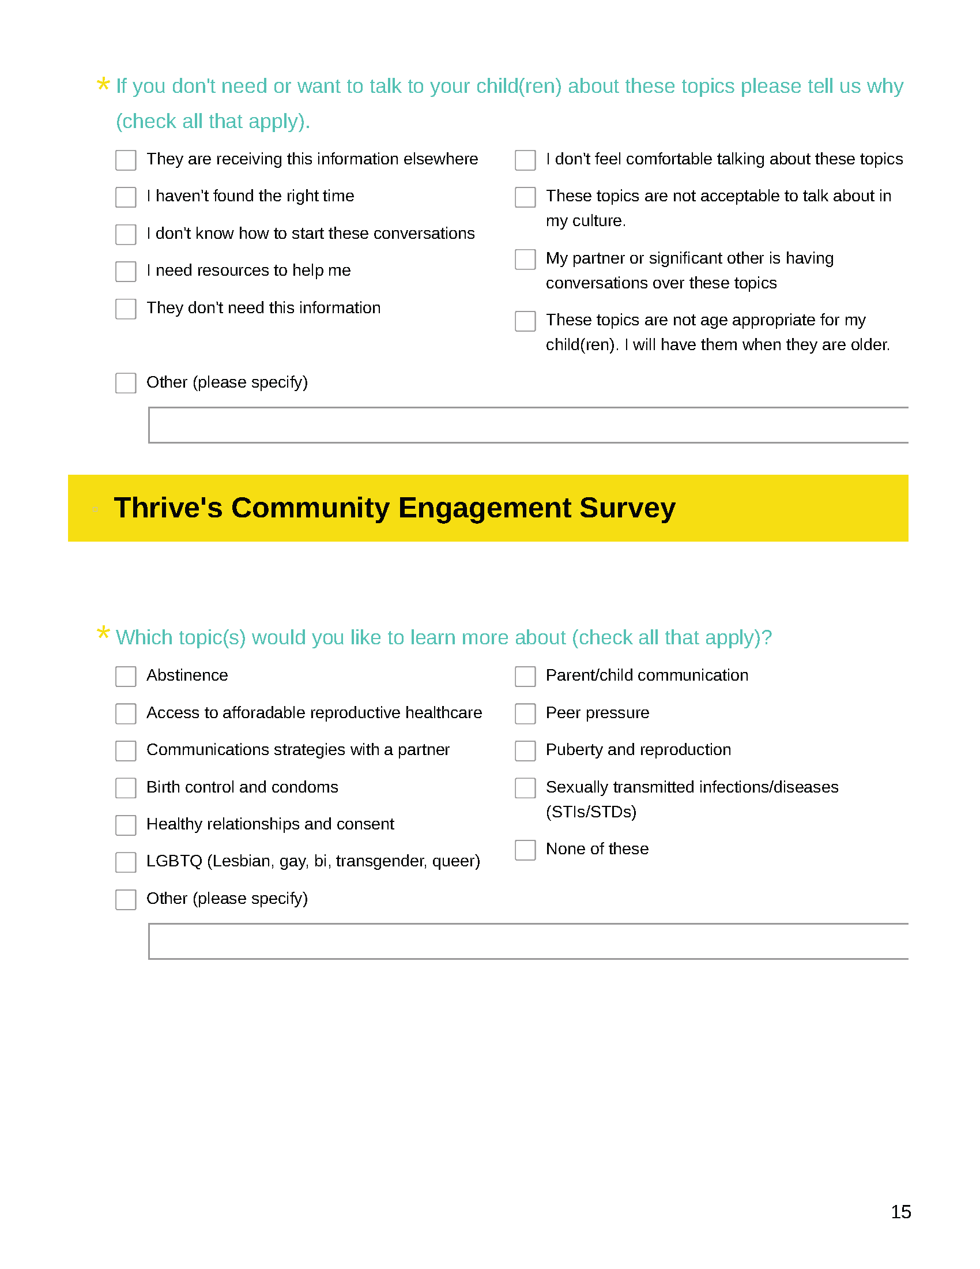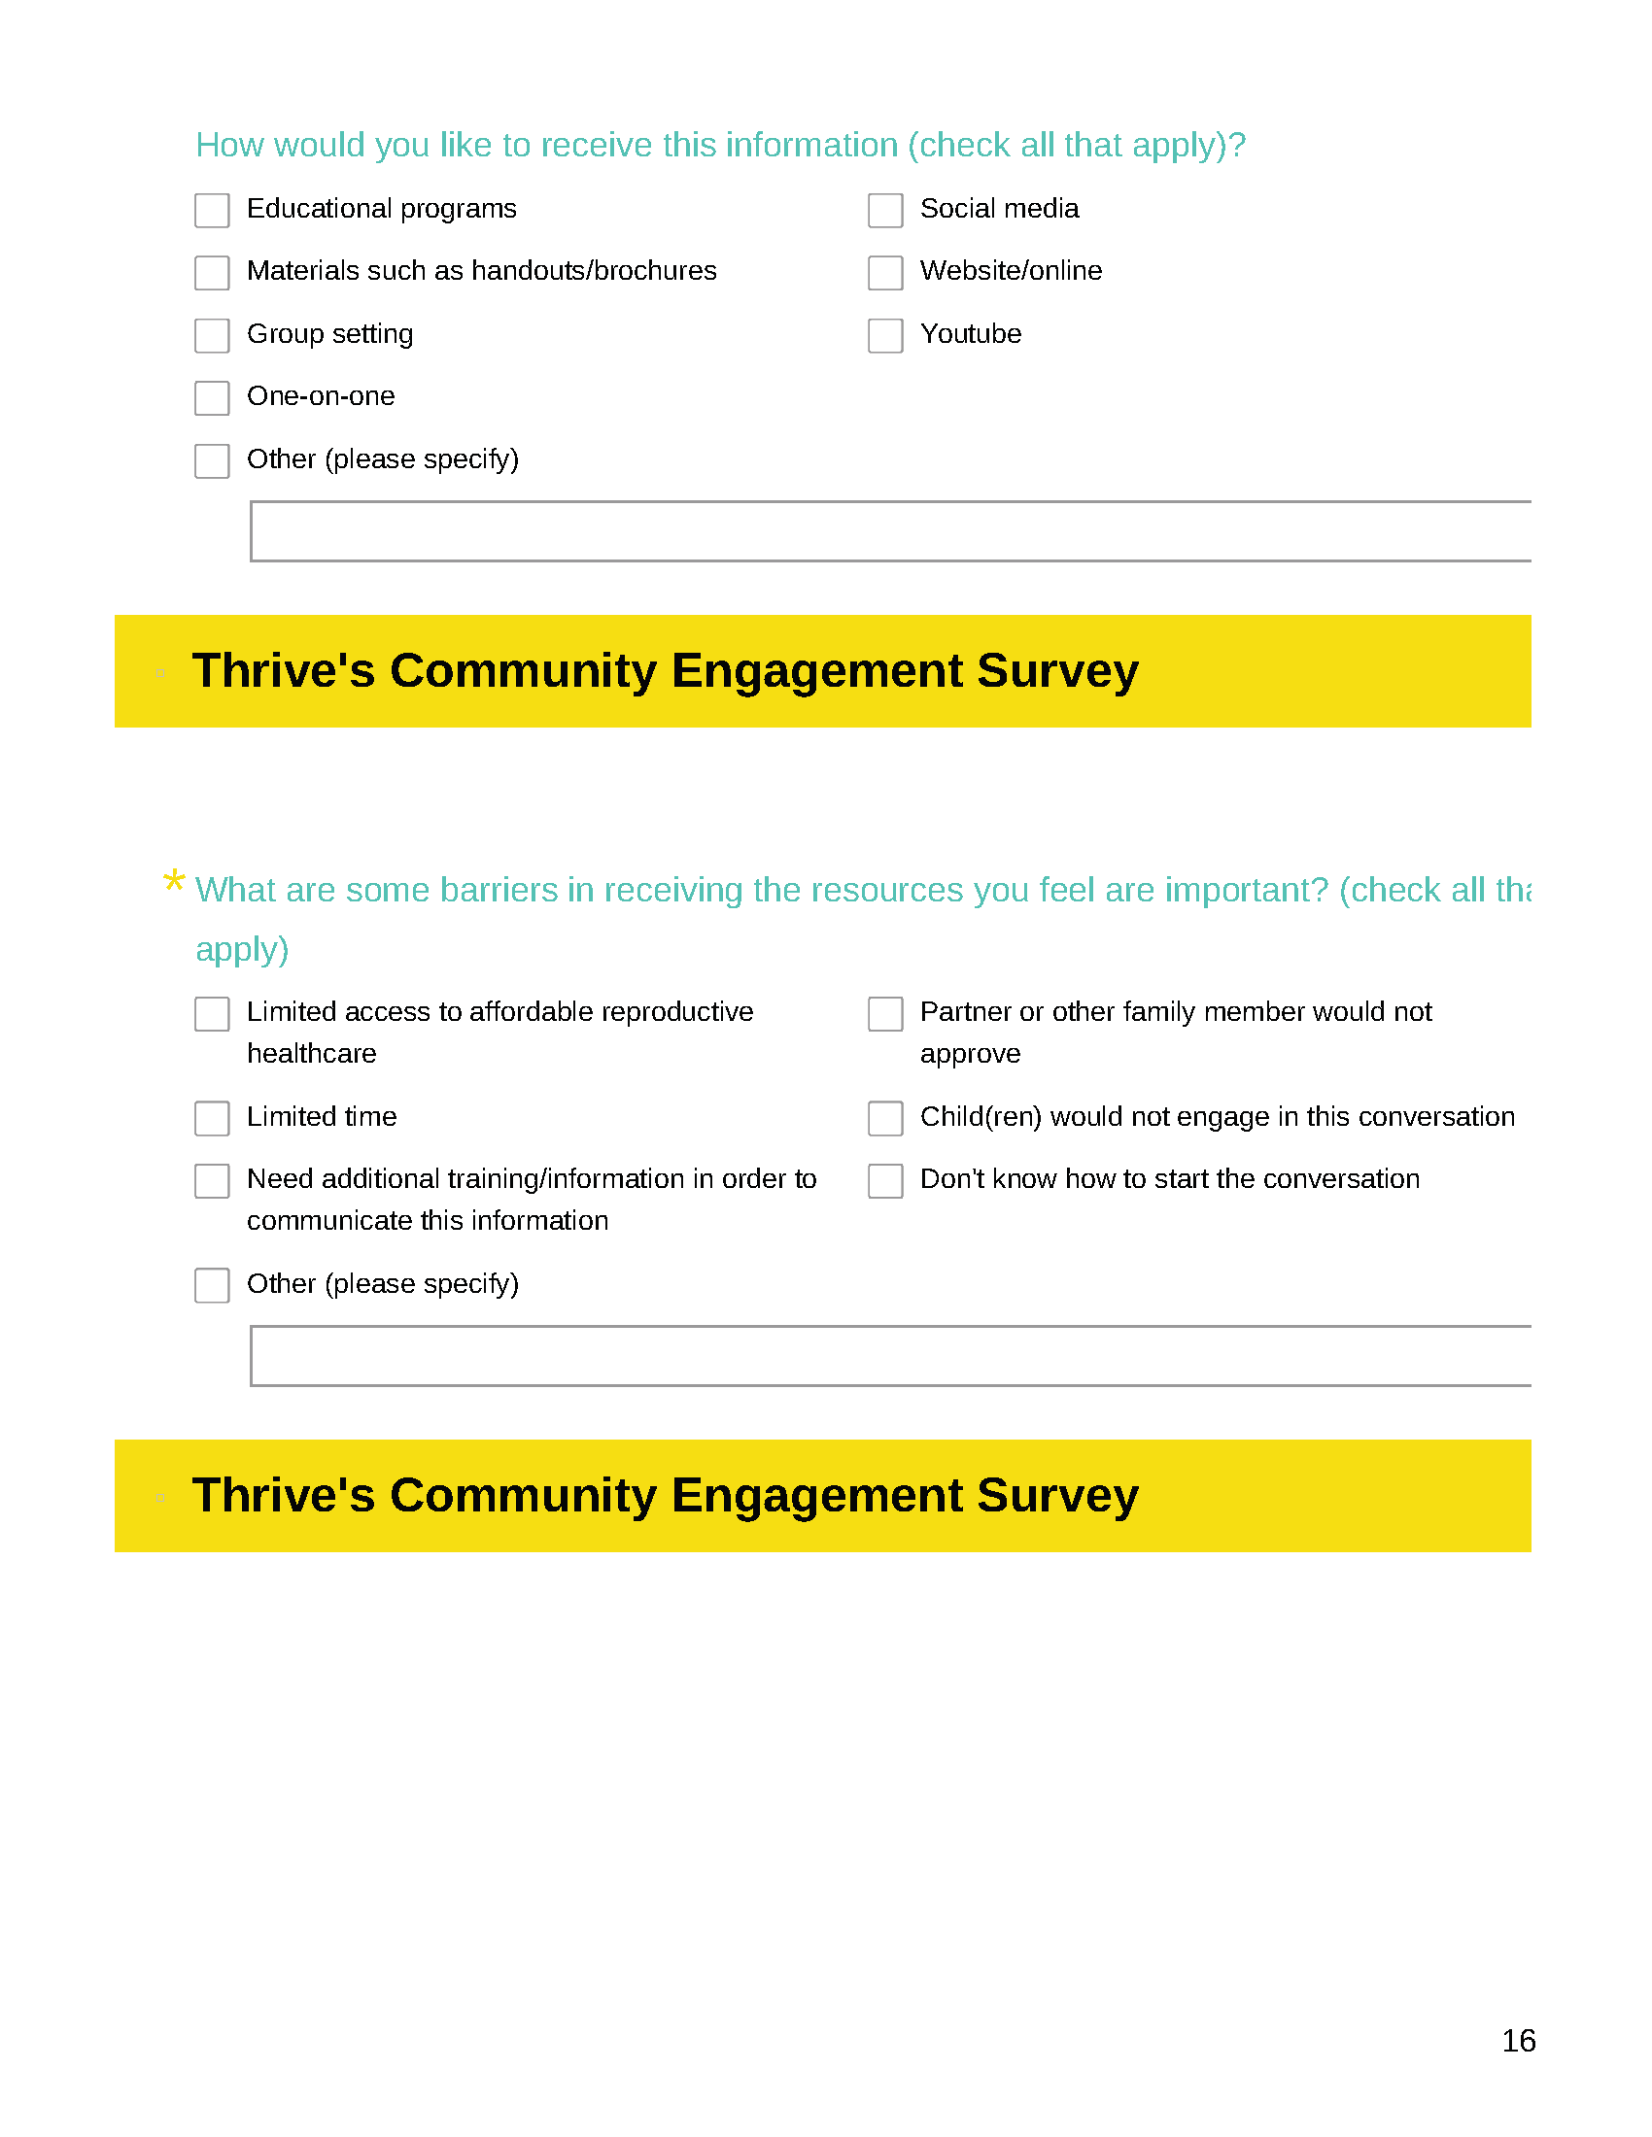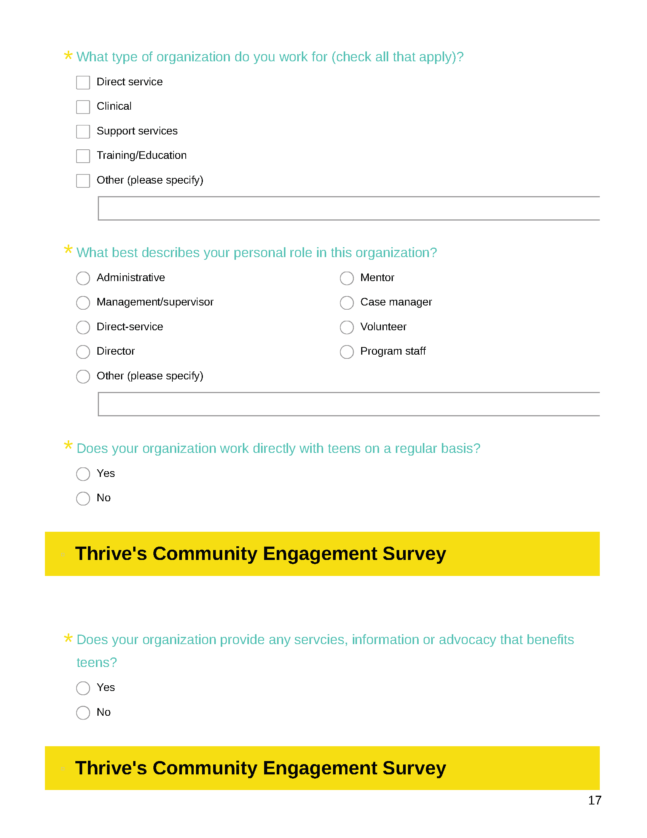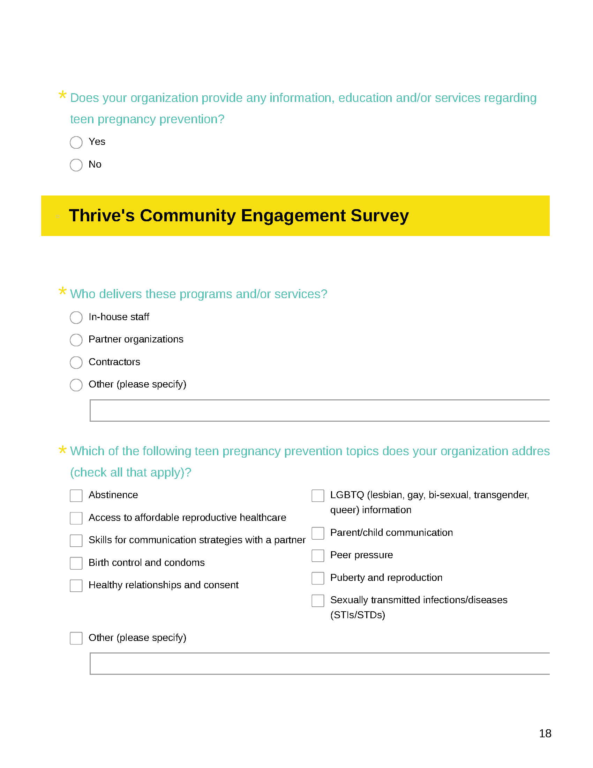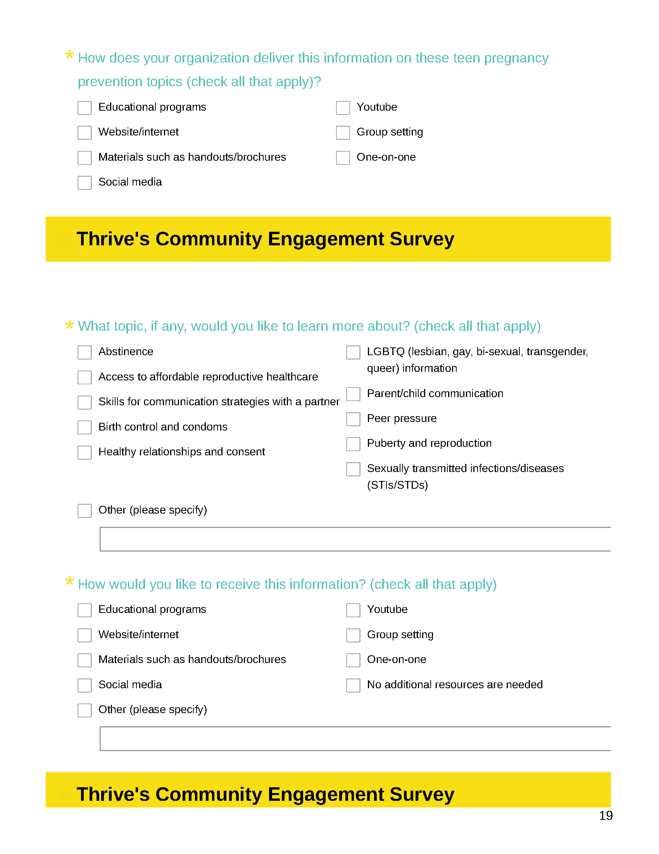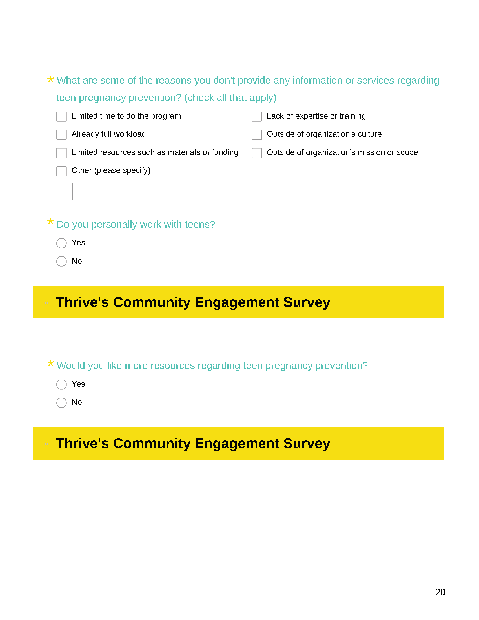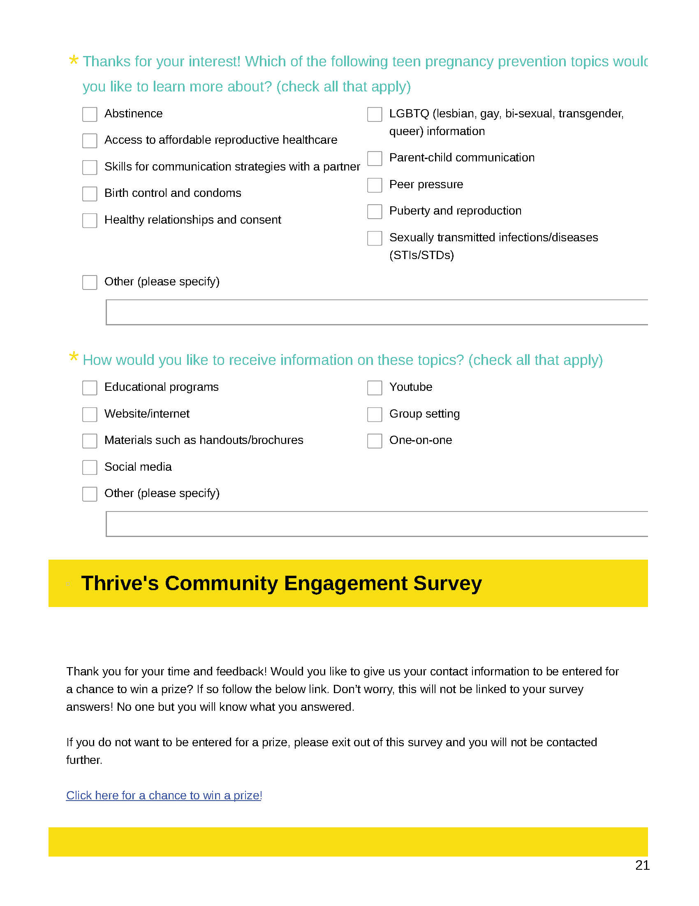

Addendum 4- Interview Question Paths
Community Engagement Project
Community-Based Organization Staff Member Interview Question Path

Thank you for agreeing to take part in this discussion regarding sexual health education efforts in Central Oklahoma.
My name is _______________ and I work with ______________.
(If necessary) With me today is ______________, who will be assisting me during the session.
I am (If two people: We are) apart of a project called the Community Engagement Project, sponsored by Thrive, which is an organization that focuses on teen pregnancy prevention and overall sexual health for youth and young adults.
We would like to learn more about your organization’s interest and needs in teen pregnancy prevention.
We’ve asked you to participate today because as a staff member, you have an influential role in the lives of the youth your organization serves; so we want to understand your role in this effort.
Everything you say will remain confidential. When publishing this information, I will not say your name nor the name of your organization. I am interviewing at least 20 other staff members of community-based organizations so no one will know who I interviewed and who I did not.
I will report aggregate or collective data across participants (such as the number of youth served, years of service across staff members), not personal data. I realize that this may be sensitive material. So, I appreciate your honesty and willingness to share.
I’m here today to ask questions and listen to you. There are no right or wrong answers. I simply want to hear your point of view. If there are any questions you prefer not to answer, let me know and we can move to the next question.
I would like to record the discussion today because it would be impossible to listen and effectively take notes. I want to be sure I don’t miss anything you say. Again, no names or personal information will be shared when publishing this data, and the recordings will be deleted after the interview is transcribed. Is this ok with you?
At this time I’d like to ask that you keep your phone on silent and not answer phone calls or text messages during this discussion. This interview should take no more than an hour of your time.
Are you ready to begin?
Let’s get started with a few demographic questions.
https://www.surveymonkey.com/r/DemoInterviews

Questions:
- What do you think your community based-organization should be doing to prevent teen pregnancy?
  - Probe: Does your organization address teen pregnancy prevention? Tell me more about that.
  - Probe: What topics do you typically discuss?
  - Probe: How has teen pregnancy affected the adolescents your organization serves?
- What sort of topics do you think should be included for teen pregnancy prevention program held at your organization?
Note to interviewer: remember to pause here to allow their response.
- Take a look at the sheet in front of you. On a scale of 1 to 5, with 1 being not at all important, 3 being neutral, and 5 being very important, how important do you feel each of these topics are for youth to know? Take some time to mark your response on the sheet in front of you.
Note to interviewer: Give them time to answer the first. Then ask about each one individually. Be sure to pause after each topic.
  - Abstinence
  - Access to affordable reproductive health care
  - Communicating with a partner
  - Birth control and condoms
  - Healthy relationships and consent
  - LGBTQ
  - Parent-child communication
  - Puberty and reproduction
  - Are there any additional topics you feel are important to include? Please add any additional topics to this list.
    - Tell me more about that.
  - On a scale of 1 to 5, with 1 being not at all comfortable, 3 being neutral, and 5 being very comfortable, what is your level of comfort with discussing these topics with youth your organization serves? Let’s discuss them one by one.
Note to interviewer: state each topic one by one and pause for their answer and explanation.
- What values would you say are important to your organization? Please explain.
  - Probe: How does teen pregnancy prevention align with your organization’s values?
- What values are important to you personally?
  - Probe: How does teen pregnancy prevention align with your personal values?
- Tell me about any programs geared towards youth implemented by your organization.
  - Probe: Do any of those programs include teen pregnancy prevention information?
- Within your organization, who is considered a trusted adult, a person in your organization who young people feel comfortable talking to about teen pregnancy prevention topics?
  - Probe: What information would you want the youth served by your organization to receive about teen pregnancy prevention?
- What barriers do you see with your organization providing teen pregnancy prevention information to the youth you serve?
- What kind of training would you like individuals serving youth within your organization to receive to support youth’s teen pregnancy prevention concerns?
  - Probe: How do you want youth in your organization to learn about teen pregnancy prevention topics?
- Tell me about your own experience talking with youth your organization serves about teen pregnancy prevention topics.
Note to interviewer: if they say they have not had this experience ask this- Have these types of conversations happened in your organization with other staff?
- Tell me about any resources you would be interested in receiving related to teen pregnancy prevention.
- What programs do you know of that are currently providing teen pregnancy prevention programs with youth?
  - What do you know about this agency/these agencies?
  - What is your perception of this agency/these agencies?
- Is there anything else you would like to share with me today?

Thank you for your time today.

Here is a link if you’re interested to be entered in our contest to win an additional prize. It also has the opportunity to get involved with our efforts.

Post-interview link to grand prize entrance:
https://www.surveymonkey.com/r/CEScontactsheet

Thrive Community Engagement Project
Faith Leader Interview Question Path

Thank you for agreeing to take part in this discussion regarding sexuality education efforts in Central Oklahoma.
My name is _______________ and I work with ______________.
(If necessary) With me today is ______________, who will be assisting me during the session.
I am (If two people: We are) apart of a project called the Community Engagement Project, sponsored by Thrive, which is an organization that focuses on teen pregnancy prevention and overall sexual health for youth and young adults. We would like to learn more about your house of worship’s interest and needs in teen pregnancy prevention. We’ve asked you to participate today because as a member of a house of worship, you may have an influential role in the lives of the youth there; so, we want to understand your role in this effort.
Everything you say will remain confidential. When publishing this information, I will not say your name nor the house of worship. I am interviewing at least 20 other faith leaders so no one will know who I interviewed and who I did not.
I will report aggregate or collective data across participants (such number of youth served, years of membership across faith leaders), not personal data. I realize that this may be sensitive material. So, I appreciate your honesty and willingness to share.
I’m here today to ask questions and listen to you. There are no right or wrong answers. I simply want to hear your point of view. If there are any questions you prefer not to answer, let me know and we can move to the next question.
I would like to record the discussion today because it would be impossible to listen and effectively take notes. I want to be sure I don’t miss anything you say. Again, no names or personal information will be shared when publishing data, and the recordings will be deleted after the interview is transcribed. Is this ok with you?
At this time I’d like to ask that you keep your phone on silent and not answer phone calls or text messages during this discussion.
Are you ready to begin?
Let’s get started with a few demographic questions.
https://www.surveymonkey.com/r/DemoInterviews

Questions:
- What do you think your house of worship should be doing to prevent teen pregnancy?
  - How has teen pregnancy affected your house of worship?
  - If yes to teen pregnancy: What was your house of worship’s response to a teen pregnancy?
- Tell me about programs geared towards the youth in your house of worship.
  - Tell me about any program that also includes teen pregnancy prevention information.
- What sort of topics do you think should be included in a teen pregnancy prevention program held at your house of worship?
Note to interviewer: remember to pause here to allow their response.

- Take a look at the sheet in front of you. On a scale of 1 to 5, with 1 being not at all important, 3 being neutral, and 5 being very important, how important do you feel each of these sexual health topics are for youth to know? Take some time to mark your response on the sheet in front of you.
Note to interviewer: Give them time to answer the first. Then ask about each one individually. Be sure to pause after each topic.
  - Abstinence
  - Access to affordable reproductive health care
  - Communicating with a partner
  - Birth control and condoms
  - Healthy relationships and consent
  - LGBTQ
  - Parent-child communication
  - Puberty and reproduction
  - Are there any additional topics you feel are important to include in a teen pregnancy prevention program? Please add any additional topics to this list.
    - Tell me more about that.
  - On a scale of 1 to 5, with 1 being not at all comfortable, 3 being neutral, and 5 being very comfortable, what is your level of comfort with discussing these topics with youth in your church? Let’s discuss them one by one.
Note to interviewer: state each topic one by one and pause for their answer and explanation.

- What values are important to your house of worship? Please explain.
  - How does teen pregnancy prevention align with your institutions’ values?
- What values are important to you personally?
  - How does teen pregnancy prevention align with your personal values?
- Within your house of worship, who can serve as a trusted adult, a person in your organization who young people feel comfortable talking to about teen pregnancy prevention topics?
  - What do you think is the level of comfort for these leaders for discussing these topics and messages with youth in your house of worship?
  - What information would you want youth within your house of worship to receive about preventing teen pregnancy?
- What barriers do you see with providing teen pregnancy prevention within your house of worship?
- What kind of resources would you like individuals serving youth within your house of worship to receive to support their teen pregnancy prevention concerns?
  - How do you want youth in your house of worship to learn about these topics?
- Tell me about your own experience talking to youth in your house of worship about these topics.
- Tell me about any resources you would be interested in receiving related to teen pregnancy prevention.
- What programs do you know of that are currently providing teen pregnancy prevention programs with youth?
  - What do you know about this agency/these agencies?
  - What is your perception of this agency/these agencies?
- Is there anything else you would like to share with me today?

Thank you for your time today.

Here is a link if you’re interested to be entered in our contest to win an additional prize. It also has the opportunity to get involved with our efforts.

Post-interview link to grand prize entrance:
https://www.surveymonkey.com/r/CEScontactsheet

Community Engagement Project
Parent Interview Question Path

Thank you for agreeing to take part in this interview.
My name is _______________ and I work with ______________.
(If necessary) With me today is ______________, who will be assisting me during the session.
I am (If two people: We are) apart of a project called the Community Engagement Project, sponsored by Thrive, which is an organization that focuses on teen pregnancy prevention and overall sexual health for youth and young adults. We would like to learn more about your interest and needs in teen pregnancy prevention. We’ve asked you to participate today because as a parent, you have an influential role in the life of your child or children; so we want to understand your role in this effort.
Everything you say will remain confidential. When publishing this information, I will not say your name, your child’s name (or children’s name) or any personal identifiers. I am interviewing at least 20 other local parents so no one will know who I interviewed and who I did not.
I will report aggregate or collective data across participants (such as number of children), not personal identifiable data. I realize that this may be sensitive material. So I appreciate your honesty and willingness to share.
I’m here today to ask questions and listen to you. There are no right or wrong answers. I simply want to hear your point of view. If there are any questions you prefer not to answer, let me know and we can move to the next question.
I would like to record the discussion today because it would be impossible to listen and effectively take notes. I want to be sure I don’t miss anything you say. Again, no names or personal information will be shared when publishing this data, and the recordings will be deleted after the interview is transcribed. Is this ok with you?
At this time I’d like to ask that you keep your phone on silent and not answer phone calls or text messages during this discussion.
Are you ready to begin?
Let’s get started with a few demographic questions.
https://www.surveymonkey.com/r/DemoInterviews

Questions:
- Tell me about your experience learning about sexual health topics as an adolescent yourself.
  - What sort of topics come to mind when you think of sexual health?
  - From whom did you learn information?
  - Tell me how helpful that information was.
  - Do you feel like the information helped you make better decisions?
- Were you a teen parent?
  - Who was the most helpful trusted adult in your life when you were dealing with the pregnancy?
  - Who was the least helpful trusted adult in your life when you were dealing with the pregnancy?
  - How did that experience influence your parenting?
- What sort of topics do you want your child(ren) to know about sexual health?
- Tell me about your experience talking to your child(ren) about sexual health topics.
  - What sort of information have you shared?
  - What sort of information would you like to share but have not?
    - Tell me more about why you haven’t discussed that yet.
  - How did you learn how to talk to your child(ren) about this?
- Who would your child(ren) identify as a trusted adult, a person in who your child feels comfortable talking to about sexual health topics?
  - Would you feel comfortable with that person talking to your child(ren) about sexual health topics?
- What sort of topics do you feel should be included in a teen pregnancy prevention program? Note to interviewer: remember to pause here.
- Take a look at the sheet in front of you. On a scale of 1 to 5, with 1 being not at all important, 3 being neutral, and 5 being very important, how important do you feel each of these sexual health topics are for your child(ren) to learn during a teen pregnancy prevention program? Take some time to mark your response on the sheet in front of you.
Note to interviewer: Give them time to answer the first. Then ask about each one individually. Be sure to pause after each topic.
  - Abstinence
  - Access to affordable reproductive health care
  - Communicating with a partner
  - Birth control and condoms
  - Healthy relationships and consent
  - LGBTQ
  - Parent-child communication
  - Puberty and reproduction
  - Are there any additional topics you feel are important for your child(ren) to learn during a teen pregnancy prevention program? Please add any additional topics to this list.
    - Tell me more about that.
Note to interviewer: remember to ask about each additional topic separately.
  - On a scale of 1 to 5, with 1 being not at all comfortable, 3 being neutral, and 5 being very comfortable, what is your level of comfort with discussing these topics with your child or children? Let’s discuss them one by one.
Note to interviewer: state each topic one by one and pause for their answer and explanation.
- How would you like to learn more about talking to your child(ren) about sexual health topics?
- What are the barriers to talking to your child(ren) about these topics?
  - What resources could help you overcome these barriers?
- What programs do you know of that are currently providing teen pregnancy prevention programs with youth?
  - What do you know about this agency/these agencies?
  - What is your perception of this agency/these agencies?
- What other settings would you be comfortable allowing your child(ren) to learn about sexual health topics?
  - Note to interviewer: say “tell me more” if they provide very little information.
  - Note to interviewer: say “are there any other settings you want to mention?” if they only mention one.
  - Are there any settings and/or organizations you wouldn’t want to allow your child(ren) to learn sexual health topics from?

- Tell me about any resources you would be interested in receiving related to sexual health topics.
- Is there anything else you would like to share with me today?

Thank you for your time today.

Here is a link if you’re interested to be entered in our contest to win an additional prize. It also has the opportunity to get involved with our efforts.

Post-interview link to grand prize entrance:
https://www.surveymonkey.com/r/CEScontactsheet

Addendum 5- Interview Importance & Comfort Tables
Level of Importance for Adolescents to Learn about Sexual Health Topics During a Teen Pregnancy Prevention Program
 | Abstinence | Access to affordable reproductive healthcare | Communicating with a partner | Birth control & condoms | Healthy relationships & consent | LGBTQ | Parent/ child communication | Puberty & reproduction
C1 | 3 | 5 | 4 | 4 | 5 | 3 | 5 | 2
C2 | 1 | 5 | 5 | 5 | 5 | 5 | 5 | 5
C3 | 4 | 3 | 4 | N/A | 5 | 5 | 5 | 5
C4 | 5 | 4 | 5 | 4 | 5 | 3 | 5 | 3
C5 | 3 | 5 | 5 | 5 | 5 | 5 | 3 | 5
C6 | 5 | 5 | 5 | 5 | 3 | 3 | 5 | 1
F1 | 5 | 5 | 5 | 5 | 5 | 3 | 5 | 5
F2 | 5 | 5 | 4 | 5 | 4 | 5 | 5 | 4
F3 | 5 | 4 | 5 | 4 | 2 | 1 | 3 | 4
F4 | 5 | 5 | 5 | 4 | 5 | 2 | 5 | 5
F5 | 5 | 5 | 5 | 5 | 5 | 2 | 5 | 5
F6 | 5 | 5 | 5 | 5 | 5 | 5 | 5 | 5
P1 | 3 | 5 | 4 | 5 | 5 | 5 | 5 | 4
P2 | 5 | 5 | 5 | 5 | 5 | 5 | 5 | 5
P3 | 5 | 5 | 5 | 5 | 5 | 5 | 5 | 5
P4 | 5 | 5 | 5 | 5 | 5 | 5 | 5 | 5
P5 | 4 | 3 | 5 | 5 | 5 | 4 | 3 | 3
P6 | 3 | 5 | 5 | 5 | 5 | 4 | 3 | 5
P7 | 5 | 4 | 5 | 5 | 5 | 4 | 5 | 5
P8 | 4 | 4 | 5 | 5 | 5 | 5 | 5 | 4
P9 | 5 | 4 | 5 | 5 | 5 | 3 | 5 | 5
P10 | 1 | 3 | 5 | 5 | 5 | 5 | 3 | 5
P11 | 3 | 5 | 5 | 4 | 5 | 4 | 5 | 5
P12 | 3 | 5 | 5 | 5 | 5 | 3 | 4 | 4
P13 | 5 | 5 | 5 | 5 | 5 | 2 | 5 | 5
Totals | 5 = 14 | 5 = 17 | 5 = 21 | 5 = 19 | 5 = 22 | 5 = 11 | 5 = 19 | 5 = 16
 | 4 = 3 | 4 = 5 | 4 = 4 | 4 = 5 | 4 = 1 | 4 = 4 | 4 =1 | 4 = 5
 | 3 = 6 | 3 = 3 | 3 = 0 | 3 = 0 | 3 =1 | 3 = 6 | 3 = 5 | 3 = 2
 | 2 = 0 | 2 = 0 | 2 = 0 | 2 = 0 | 2 = 1 | 2 = 3 | 2 = 0 | 2 = 1
 | 1 = 2 | 1 = 0 | 1 = 0 | 1 = 0 | 1 = 0 | 1 = 1 | 1 = 0 | 1 = 1

Participant’s Level of Comfort Discussing Sexual Health Topics with Adolescents

 | Abstinence | Access to affordable reproductive healthcare | Communicating with a partner | Birth control & condoms | Healthy relationships & consent | LGBTQ | Parent/ child communication | Puberty & reproduction
C1 | 5 | 5 | 5 | 5 | 5 | 3 | 5 | 4
C2 | 5 | 5 | 5 | 5 | 5 | 5 | 5 | 5
C3 | 5 | 5 | 5 | 5 | 5 | 5 | 5 | 5
C4 | 5 | 2 | 4 | 2 | 4 | 2 | 4 | 2
C5 | 5 | 5 | 5 | 1 | 5 | 5 | 3 | 5
C6 | 5 | 3 | 5 | 5 | 5 | 3 | 5 | 5
F1 | 3 | 5 | 5 | 5 | 5 | 3 | 5 | 3
F2 | 5 | 5 | 5 | 5 | 5 | 5 | 5 | 3
F3 | 5 | 5 | 5 | 5 | 5 | 3 | 5 | 5
F4 | 5 | 5 | 5 | 5 | 5 | 3 | 4 | 5
F5 | 3 | 3 | 3 | 3 | 3 | 1 | 3 | 3
F6 | 5 | 3 | 5 | 3 | 5 | 4 | 5 | 3
P1 | 5 | 5 | 5 | 4 | 5 | 4 | 5 | 5
P2 | 5 | 5 | 5 | 5 | 5 | 5 | 5 | 5
P3 | 5 | 5 | 5 | 5 | 5 | 5 | 5 | 5
P4 | 5 | 5 | 5 | 4 | 5 | 3 | 5 | 5
P5 | 4 | 5 | 5 | 4 | 5 | 4 | 5 | 5
P6 | 5 | 5 | 5 | 5 | 5 | 3 | 5 | 5
P7 | 5 | 5 | 5 | 4 | 5 | 3 | 5 | 5
P8 | 5 | 5 | 5 | 5 | 5 | 5 | 5 | 5
P9 | 4 | 4 | 3 | 4 | 4 | 3 | 4 | 4
P10 | 3 | 5 | 5 | 4 | 5 | 5 | 5 | 4
P11 | 2 | 4 | 4 | 4 | 5 | 4 | 4 | 4
P12 | 5 | 5 | 5 | 5 | 5 | 4 | 5 | 5
P13 | 5 | 5 | 5 | 2 | 4 | 1 | 4 | 4
Totals | 5 = 19 | 5 = 19 | 5 = 21 | 5 = 13 | 5 = 21 | 5 = 8 | 5 = 18 | 5 = 15
 | 4 = 2 | 4 = 2 | 4 = 2 | 4 = 7 | 4 = 3 | 4 = 5 | 4 = 5 | 4 = 5
 | 3 = 3 | 3 = 3 | 3 = 2 | 3 = 2 | 3 = 1 | 3 = 9 | 3 = 2 | 3 = 4
 | 2 = 1 | 2 = 1 | 2 = 0 | 2 = 2 | 2 = 0 | 2 = 1 | 2 = 0 | 2 = 1
 | 1 = 0 | 1 = 0 | 1 = 0 | 1 = 1 | 1 = 0 | 1 = 2 | 1 = 0 | 1 = 0

Addendum 6 – University of Central Oklahoma IRB Approval
