Reporting Period: 2020-2021

Caregivers Community
Assessment

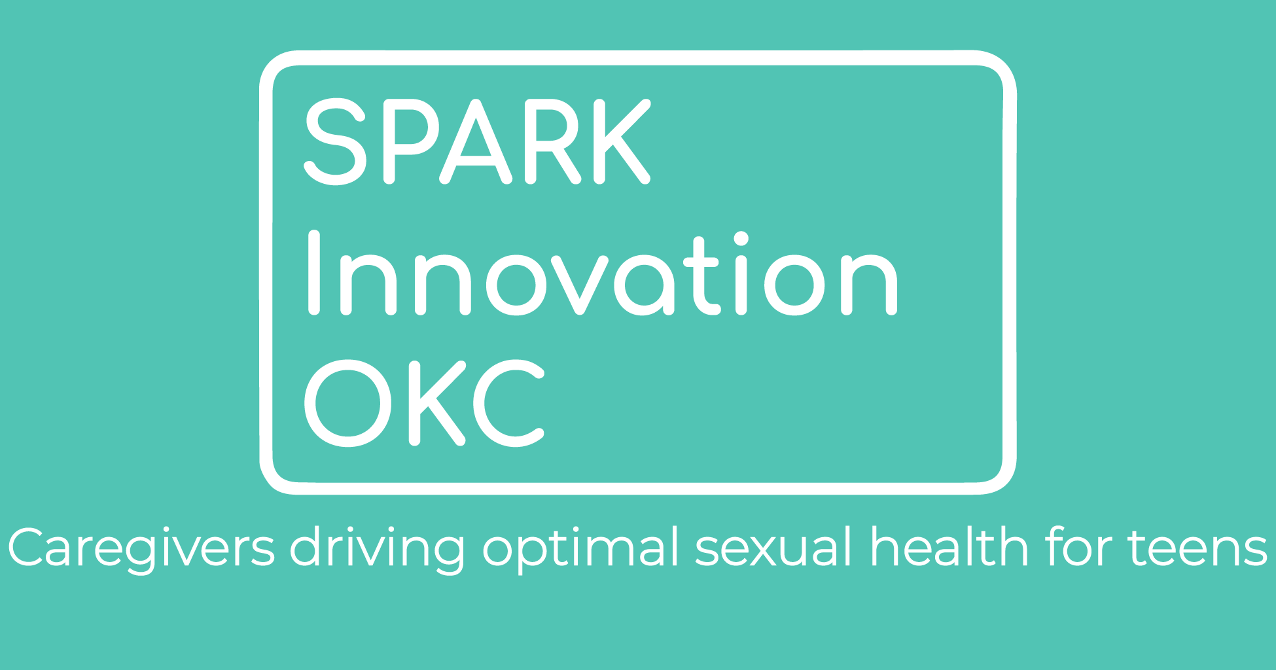
TABLE OF CONTENTS
Project Goals and Research Questions 3
Summary 5
Assessment Process 6
Age Appropriateness for Sexual Health Topics 10
Caregivers Requested Resources 13
Caregivers Reported Barriers 15
Limitations and Pivots 18
Recommendations 18

Project Goals and Research Questions
Oklahoma's teen birth rate is in the top five (highest) in the nation, and Oklahoma County has the highest number of teen births in the state. Pregnancy and parenting among teens result in greater risks of poverty, health issues, unstable housing and employment, and food insecurity. Teen pregnancy prevention is a key strategy in the reduction of generational poverty.

Thrive is the backbone organization leading a strong, successful effort to significantly reduce teen pregnancy in Oklahoma County. In this role, we convene and connect partners and change agents, engage and mobilize the community, evaluate and share data, and advocate for youth to have access to resources, services and medically accurate information about sexual health.

Today, 38 partner agencies, 3 action teams, and more than 90 individuals work together on a single issue. Our Collaboration is committed to reducing the teen birth rate in Oklahoma County by another 25% by 2025. Thrive has spent the last year investing in training and capacity-building infrastructure to support this goal by equipping more caregivers, professionals, and organizations with innovative opportunities and training that support young people and builds a culture where opportunities for youth to pursue education, careers, and well-being are not limited by teen pregnancy.

Thrive was awarded the SPARK Innovation OKC grant, a project funded by the Department of Health and Human Services’ Office of Population Affairs. Thrive is creating and supporting a network of trained, connected partner organizations and individuals in Oklahoma County. The goal is to develop innovative, equitable, and sustainable strategies that empower caregivers to increase protective factors, ultimately promoting adolescent optimal health and leading to a reduction in STIs and teen pregnancy.

This assessment was conducted through the SPARK Innovation OKC grant to help the organizations that were awarded the grant (Cohorts) to create effective, innovative, and person-centered interventions for the Oklahoma community as well as other sexual health organizations.

To better understand how Thrive, our Collaboration partners and grantees can serve our community, we must first understand what our community looks like. This is an essential component in making sustainable interventions in tandem with the community. By being aware of the unique needs, barriers, cultures and beliefs in our community, interventions can be created with best practices as the framework but tailored to the community's direct needs instead of an intervention that may not be a good fit. Not only does this build trust with the community, but it also saves money, resources, and improves outcomes.

This report reflects the results of Thrive’s second caregiver community assessment. Thrive defines “caregivers” as parents, alternative caregivers, faith leaders and youth-serving community-based organization staff. Key objectives for this assessment were to build on the data and also obtain further insights based on the results of the first assessment conducted in 2018. An additional goal was to streamline the design based on the community’s feedback. Research questions were developed to ensure that the overall needs of the assessment were focused on the most impactful information.

Research Question | Reason for Question Development
What resources do caregivers need to improve equitable access for their youth’s adolescent sexual health? | In the last community assessment, Thrive gathered information on the most desired information topics and delivery methods among various caregivers. The 2021 SPARK Innovation Caregiver Community Assessment will build on this information with qualitative data collection on resources that caregivers need.
What barriers do caregivers face when communicating to their youth about adolescent sexual health consistently and effectively? | In the last community assessment, Thrive gathered information on the types of barriers caregivers faced. The 2021 SPARK Innovation Caregiver Community Assessment will build on this information with qualitative data collection on barriers.
What ages do caregivers feel are appropriate to talk about sexual health topics? | In the last community assessment, Thrive learned that many parents believed that teen pregnancy prevention topics were not age appropriate for their children. The 2021 SPARK Innovation Caregiver Community Assessment will build on this information with a table matrix to gather parental perception of the age appropriateness of various sexual health topics.

The assessment gathered quantitative and qualitative information from Oklahoma residents regarding barriers when talking to the young people in their lives about sexual health, resources they needed to have these discussions, age-appropriateness of sexual health topics and other supporting information.

Summary
This second iteration of Thrive’s Caregiver Community Assessment (“the assessment”) helped build on previously collected information and also provided additional new insights. The assessment focused on caregivers defined as parents, alternate caregivers, faith leaders or youth-serving community-based organization staff or any trusted adult in the life of a youth that may have an opportunity to talk about sexual health. The assessment asked questions regarding demographics, age-appropriateness of sexual health topics for youth, needed resources, preferred delivery methods of those resources and barriers to sexual health conversation with youth and sexual health medical services.

Demographics for the assessment were similar to Oklahoma’s census demographics. All respondents identified as being a caregiver and almost all (93%) caregivers who responded self-reported being affiliated with a religious organization or thought ideology. Two percent identified as working in a youth-serving community-based organization.

Key findings included one-third (33%) of parents feeling like the teen ages of 15-19 were the appropriate ages to start discussing sexual health topics with their children. Caregivers also requested additional resources on communication skills to discuss healthy romantic relationships, information on where to get and how to use birth control and condoms, and anatomy. They reported already getting sexual health information primarily from social media sites with the most common ones being Facebook and Twitter. When asked how they wanted to receive sexual health information in the future, the majority of respondents requested information delivered by websites.

When asked to pick from a list which barriers keep caregivers from having sexual health conversations with their youth, lack of knowledge and not knowing trained professionals were the top two barriers reported. When given the chance to provide more detail in open response questions, caregivers also identified a lack of knowledge and comfortability. When asked about barriers to accessing sexual health services the top barrier identified was mistrust in providers.

Recommendations moving forward for Thrive and Collaboration partners would be to provide more information on how sexual health information can be appropriately presented to all ages and should be a conversation that starts much younger than preteen or teen ages. Resources should be pushed out on social media sites and websites in order to help caregivers increase their knowledge and comfortability around starting sexual health conversations with the youths in their lives. Additionally, our community would benefit from training trusted sexual healthcare providers and connecting them to our caregivers at low or no-cost so those without insurance could still receive high-quality, affordable sexual health services.

Assessment Process
Thrive refined the previous community assessment based on participants’ feedback. Some of the adjustments based on feedback included the survey being shorted, streamlined and allowing for multiple option selections for caregiver roles. In the previous iteration of the assessment, the research team conducted a mixed-methods approach with interviews and a survey; however, due to capacity and COVID-19 concerns, only a survey was used for this iteration. However, additional qualitative questions were added to help fill in contextual gaps. The survey was distributed throughout the Collaboration, through Thrive’s social media, SPARK Innovation Cohorts’ social media and networks and targeted surveying.

The requirements to participate in the survey included being a caregiver (e.g., parent, alternate caregiver, faith leader or youth-serving community-based organization staff), be 18 years of age or older, and residing in Oklahoma with a special emphasis given to Oklahoma County. Data were cleaned by verifying those respondents reported residing in Oklahoma, were 18 years of age or older and identified as having a role as a caregiver. IP addresses were reviewed to ensure that if the same IP address was used for responses, the responses were different. Data was also reviewed to confirm that respondents answered at least 50% of the questions excluding demographic questions. This process was reviewed by two team members and 25% of all data was validated by two people. After cleaning the data, there was a total of 1,759 responses that were analyzed for this report with 14% of those responses (247) being Oklahoma County residents.

Caregivers were asked questions regarding their roles as a caregiver, age appropriateness of different sexual health topics, sexual health topics they would like additional information for, how they would like to receive that information and barriers in receiving resources that are important in order to talk to the youth in their lives. Sexual health topics were kept consistent across the survey’s different sections.
Sexual Health Topics
2SLGBTQ+ (two-spirit, lesbian, gay, bisexual, transgender, queer) information
Abstinence
Access to affordable reproductive healthcare
Anatomy (body parts and how they work)
Healthy relationships and consent
Parent/child communication
Peer pressure
Puberty and reproduction
Sexually transmitted infections/diseases (STIs/STDs)
Skills for communication strategies with a romantic partner
Where to get and how to use birth control and condoms

Demographics
Oklahoma State and Oklahoma County have very similar demographics; however, the community assessment demographics although similar in many categories, varied slightly. Age demographics were categorized differently from the census than from our community assessment. This was done to match reporting standards from the funding source. It should be noted that for the community assessment, there was a larger representation of African American and Black individuals and a smaller representation of the Hispanic or Latino/a/x community than present in Oklahoma and Oklahoma County.

Demographic Information
 | Oklahoma State | Oklahoma County | Thrive’s  Caregiver Community Assessment
What is your age?
19 years old and younger | 27% | 28% | 0%
20-24 (20-30) | 6.8% | 6.6% | 33.4%
25-34 (31-40) | 13.6% | 15.5% | 35.0%
35-44 (41-50) | 12.7% | 13.1% | 31.5%
45-54 (51-60) | 11.4% | 11.1% | .1%
55-59 (61-70) | 6.3% | 5.9% | .1%
60-64 (71 and older) | 6.1% | 5.9% | 0%
65-74 | 9.3% | 8.4% | -
75-84 | 4.9% | 4.0% | -
85 years and over | 1.9% | 1.6% | -
Which of the following best describes your gender?
Female | 50.4% | 51.0% | 49.6%
Male | 49.6% | 49.0% | 50.1%
(Non-binary/genderqueer/gender nonconforming) | - | - | .2%
(Prefer not to respond) | - | - | .1%
(Transgender man) | - | - | .1%
Are you Hispanic or Latino/a/x?
Yes | 11.1% | 17.9% | .5%
No | 88.9% | 82.1% | 99.5%
What is your race?
White | 72.4% | 69.1% | 64.8%
Black or African American | 9.2% | 17.7% | 35.1%
Indigenous or Native | 13.7% | 6.6% | .1%
Asian/ Native Hawaiian or Pacific Islander | 3.2% | 4.6% | .1%
More than one race | 7.6% | 5.8% | 0%
Categories in parentheses are categories used by Thrive in Community Assessment.
OK State and Oklahoma County data pulled from the 2019 US Census.

Additionally, respondents were asked to identify the type of caregiver they were if they were part of a faith or worked in a youth-serving community-based organization. The majority of respondents identified as being a parent in a two-parent household (84%) or a single parent (15%).
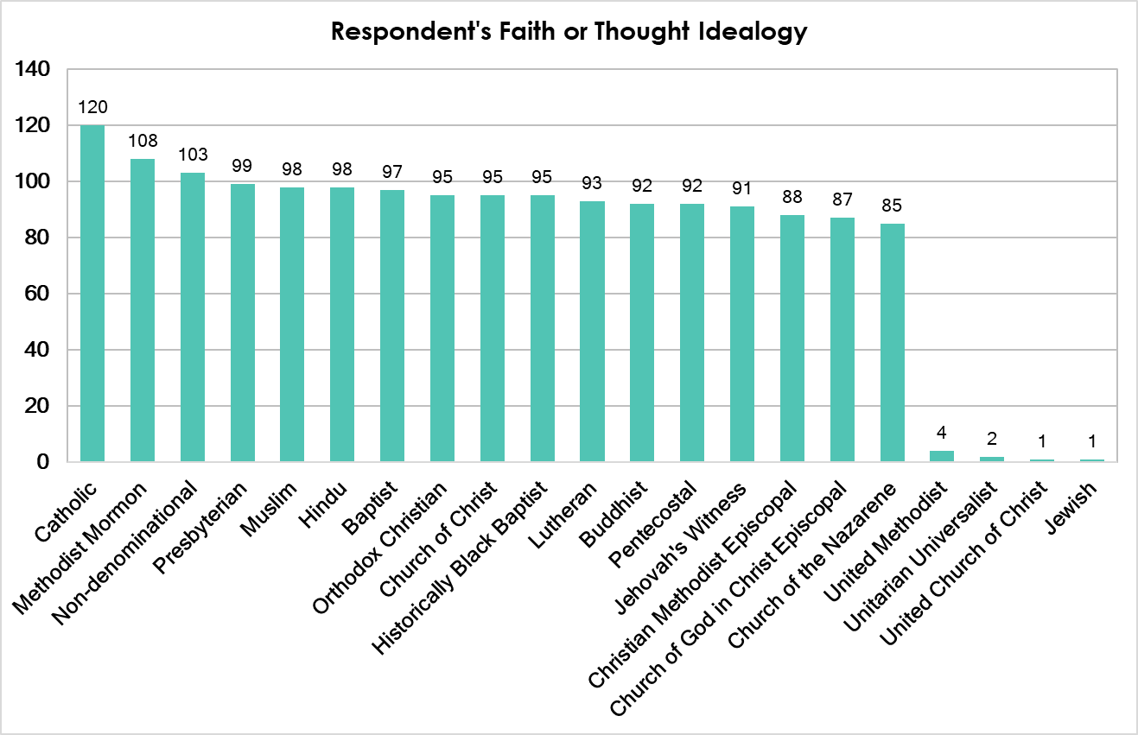

Nearly all respondents (93%) identified as being affiliated with a faith or organized thought ideology with the highest numbered affiliation being Catholic. Ninety-nine respondents also identified as being a faith member and 1% identified as being a faith leader such as a pastor, priest, rabbi, youth leader. It should also be noted that 6% (n=100) of the caregivers who responded selected they were unaffiliated (atheist or agnostic).

Only 2% of respondents identified as working or volunteering at a youth-serving community-based organization. Of those respondents, the majority (n=26) worked either indirect or support service organizations with the main role of the respondent being a direct service provider (e.g., educator, counselor, nurse, or other roles directly working with clients).

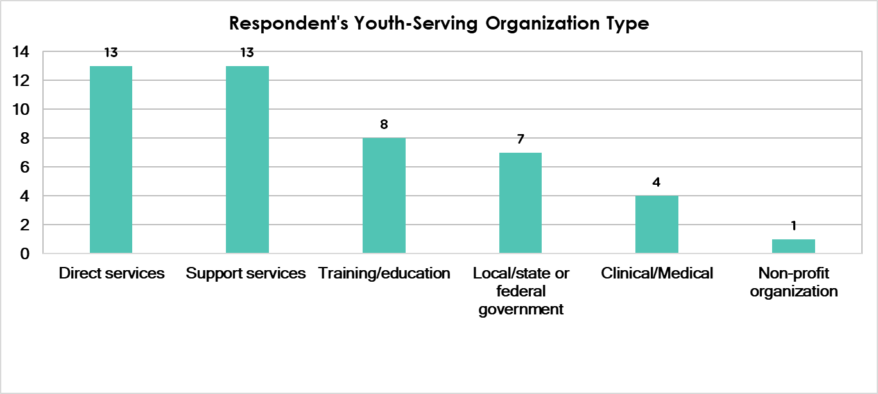
Note: this question was a multiple-choice selection.

Age Appropriateness for Sexual Health Topics
This section was built in direct response to the first iteration of the community assessment. In the previous assessment, participants were asked if they were confident talking to youths in their lives regarding sexual health; the majority of the 350 respondents said they were confident. However, only 22% of the respondents had talked to their children. When asked for the reason they hadn’t talked to their youth in their lives, 74% of respondents said because the topics were not age appropriate. This led to the question of “when do our community members think it is appropriate to have these conversations?” This information will help support meeting the community where they are while also assisting in integrating public health best practices.

For all the topics, most respondents felt that the earliest age to discuss these topics was grade school (ages 6-11 years old). However, when looking at the average age group for all topics, 33% of caregivers said that sexual health information should be presented to youth around the age of 15-19.

Age Appropriateness for Sexual Health Topics
 | Baby  (0-11 months) | Toddler (1-3 years) | Preschool (4-5 years) | Grade-schoolers (6-11 years) | Preteen (12-14 years) | Teen  (15-19 years) | Adult  (20+ years) | Did not respond
2SLGBTQ+ Information | 0.2% | 0.5% | 0.3% | 31.8% | 34.0% | 33.2% | 0.1% | -
Abstinence | 0.1% | 0.2% | 0.3% | 32.1% | 34.8% | 32.3% | 0.1% | 0.2%
Access to Affordable Reproductive Healthcare | - | 0.1% | 0.1% | 33.2% | 34.2% | 32.3% | 0.1% | -
Anatomy | 0.5% | 0.7% | 0.3% | 30.6% | 33.3% | 34.5% | 0.2% | -
Healthy relationships and consent | 0.3% | 0.5% | 0.4% | 33.0% | 33.1% | 32.6% | 0.1% | -
Parent-Child Communication | 0.8% | 0.4% | 0.3% | 31.9% | 33.4% | 33.1% | 0.1% | -
Peer Pressure | 0.1% | 0.3% | 0.8% | 32.1% | 33.1% | 33.6% | 0.1% | -
Puberty and reproduction | 0.1% | 0.1% | 0.2% | 33.7% | 32.2% | 33.7% | 0.1% | -
Sexual Transmitted Infections | - | 0.1% | 0.1% | 31.9% | 33.9% | 33.8% | 0.1% | 0.1%
Skills for communication strategies with a romantic partner | - | 0.1% | 0.2% | 31.6% | 34.2% | 33.5% | 0.5% | -
Where to get and how to use birth control and condoms | - | 0.1% | 0.2% | 32.7% | 33.2% | 33.7% | 0.2% | -

Discrepancies in Caregivers’ Perceived Age-Appropriateness and Expert Recommendations
Generally, respondents’ perceptions of age-appropriate sexual health topics were older than what experts recommend for young people’s sexual health knowledge. Many experts recommend starting sexual health conversations in childhood using age-appropriate language and examples. As this assessment found, many caregivers feel that conversations about the majority of sexual health conversations should happen in the preteen and teen years.

Age Appropriateness for Sexual Health Topics: Caregivers and Experts
 | Relevant Recommendations* | Caregiver’s Highest Respondent Categories
 |  | Grade-schoolers (6-11 years) | Preteen (12-14 years) | Teen  (15-19 years)
2SLGBTQ+ Information | 3rd - 5th graders (8-11-year-olds) may be taught to “define sexual orientation as the romantic attraction of an individual to someone of the same gender or a different gender”* | 31.8% | 34.0% | 33.2%
Abstinence | 6th - 8th graders (11-14-year-olds) may be taught to “define sexual abstinence as it relates to pregnancy prevention”* | 32.1% | 34.8% | 32.3%
Anatomy | K - 2nd graders (5-8-year-olds) may be taught to “use proper names for body parts, including male and female anatomy.”* | 30.6% | 33.3% | 34.5%
Healthy relationships and consent | K - 2nd graders (5-8-year-olds) may be taught to, “explain that all people, including children, have the right to tell others not to touch their body when they do not want to be touched,” and “identify healthy ways for friends to express feelings to each other”* | 33.0% | 33.1% | 32.6%
Puberty and reproduction | 3rd - 5th graders (8-11-year-olds) may be taught to “explain the physical, social and emotional changes that occur during puberty and adolescence” and “explain ways to manage the physical and emotional changes associated with puberty”*  Additionally, “the onset of puberty…typically occurs between ages 8 and 13 for girls and ages 9 and 14 for boys.” ⁺ | 33.7% | 32.2% | 33.7%
Sexual Transmitted Infections | 6th - 8th graders (11-14-year-olds) may be taught to “define STDs, including HIV, and how they are and are not transmitted”* | 31.9% | 33.9% | 33.8%
*Identified as the most relevant National Sexuality Education Standards, but is not a comprehensive list of all relevant standards
⁺Based on information from the National Institute of Child Health and Human Development

Caregivers Requested Resources
Nearly one-third (27%) of caregivers who responded to the survey requested additional information for skills for communication strategies with a romantic partner. Other highly sought-after resources include information on where to get and how to use birth control and condoms and anatomy.

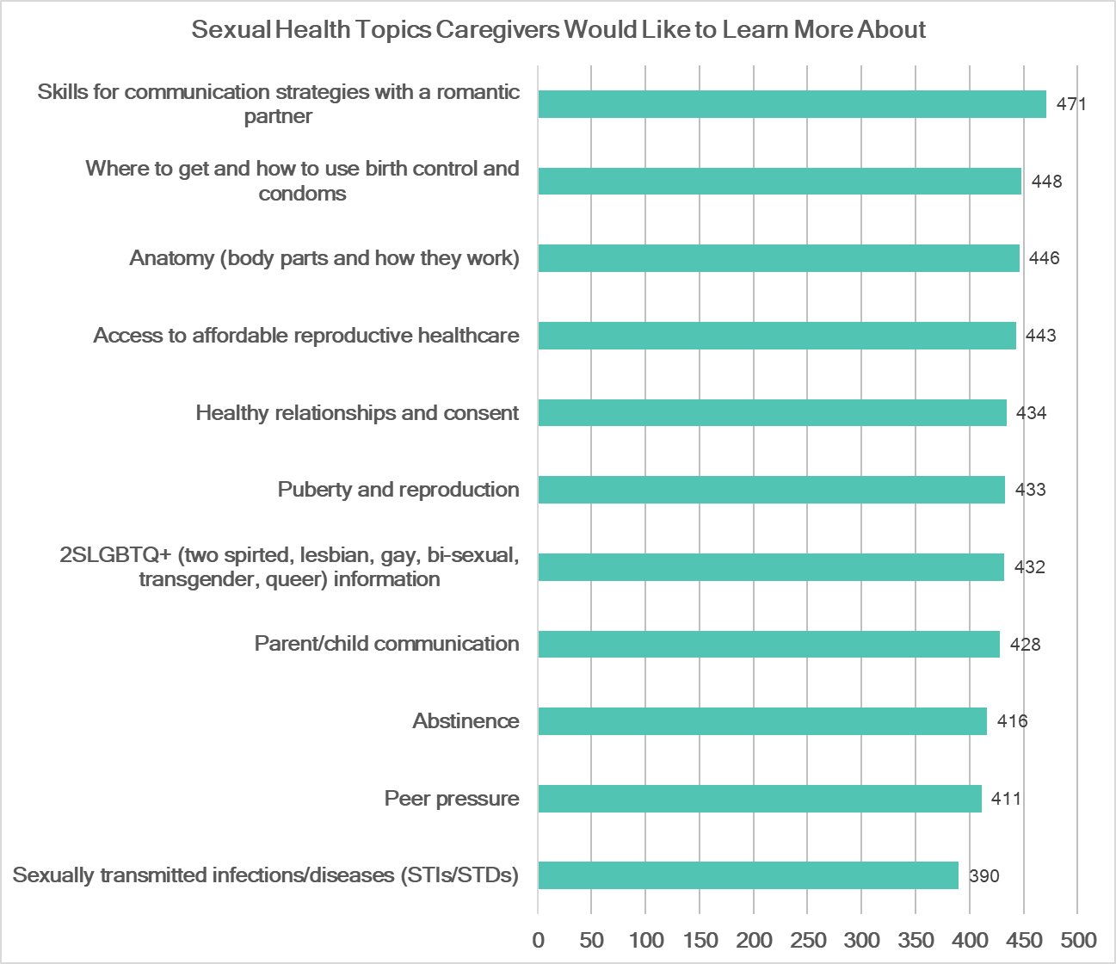
This question was formatted as a “check all that apply”

Thrive also asked caregivers how they would like to receive these resources. Many responses requested information through websites, educational programming, and books. This was highly similar to the results of the previous community assessment with the top request for delivery of information being through websites. Many caregivers reported in the last assessment that having access to online information was pivotal because of the lack of time many caregivers faced and the need to access information on command at various times during the day.

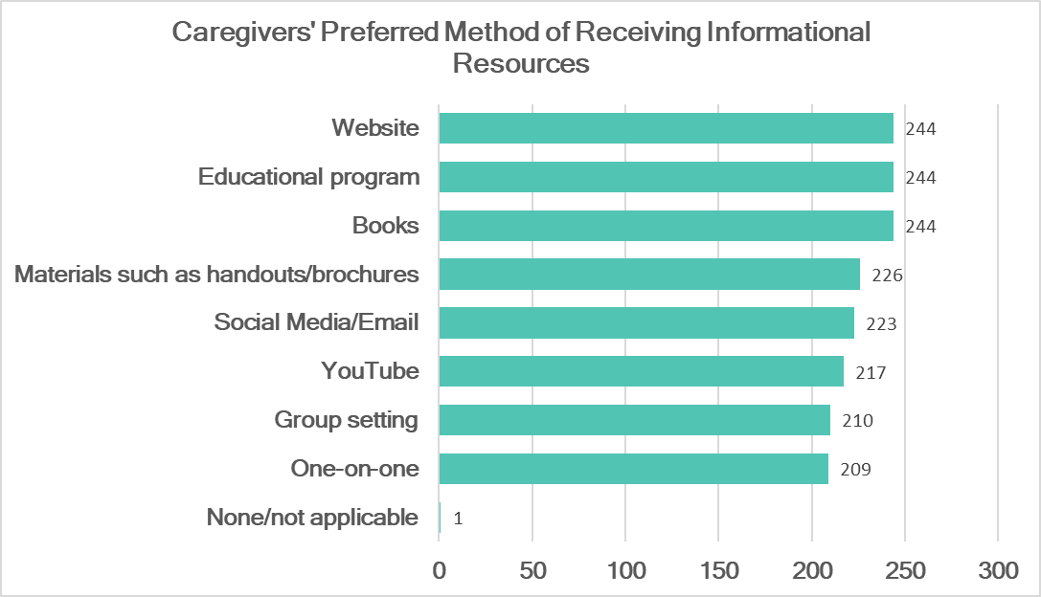
This question was formatted as a “check all that apply”

Caregivers were also asked how they currently access information about sexual health. Sixty percent of caregivers reported utilizing social media (such as Facebook, Twitter, Tik Tok, Instagram, etc.) and friends and family as the top resources for information.

How Caregivers Currently Access Sexual Health Information
Delivery Method | Percent of Responses
Social media (e.g., Facebook, Twitter, Instagram, etc.) | 31%
Friends and/or family | 29%
Medical providers | 14%
Internet/website | 14%
Books, articles or blogs | 9%
Programming | 1%
Other | 1%
Percentages based on 233 responses

Caregivers Reported Barriers
Caregivers were also asked to select from a list of barriers that kept them from receiving the resources they needed to talk to the youth in their lives about sexual health. Nearly one-fourth (24%) of caregivers said that they did not know a trained educator or presenter. Other top barriers included needing additional training/information to have the conversation and judgment from others.

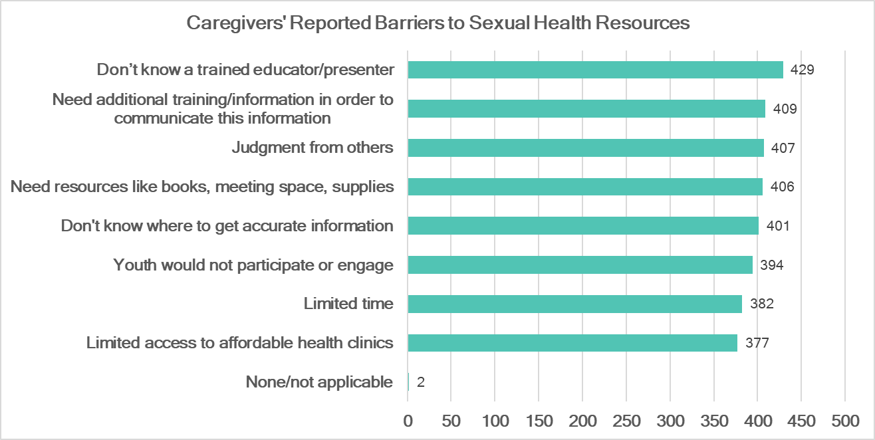This question was formatted as a “check all that apply”

Caregivers were also given an opportunity to answer two open-response questions to provide additional barriers not listed in the previous question. The first question specifically asked about barriers they experience when talking to youth about sexual health and the second question asked about barriers they have experienced or have seen in accessing sexual health services (e.g., birth control, pap smears, STI testing, etc.) for themselves or their family.

Talking to Youth About Sexual Health
The most common barriers reported for the open response question regarding barriers in talking to youth included lack of knowledge or comfortability, lack of time and not knowing the appropriate age to talk to their children about sexual health topics.
“The topic can become very sensitive very quickly for many youth, and not knowing how to adjust the approach for their needs prevents the conversation from starting.”
“I honestly don't know specific things to talk about.”

As indicated in the previous section of age-appropriate sexual health topic, many parents either do not know or assume topics should be discussed with children at an older age. Additional themes included embarrassment and lack of support.

Caregivers' Reported Barriers When Talking to Youth about Sexual Health
Theme | Percent of Responses
Lack of knowledge or comfortability | 34%
Lack of time | 19%
Age appropriateness | 15%
Embarrassing | 13%
Lack of support or approval | 7%
Child(ren) doesn't want to talk about it | 4%
Other | 4%
Religious Stigma | 3%
Percentages based on 67 responses

Accessing Sexual Health Services
Caregivers also gave additional information on barriers they were facing when trying to access sexual health medical services for themselves or their family. Over one-third of respondents (36%) reported having distrust in providers or the clinic. Some of the respondents shared that provider and clinic
implicit bias, lack of expertise, disparities with clinics presented challenges. Other top barriers included the cost of services or lack of insurance and lack of support to access the services.
“Being queer has been a barrier for getting proper access to services in the past- not knowing how to advocate for myself in certain situations.”
Again lack of support appeared as a theme indicated that although a caregiver may want to connect youth to sexual health medical services or have conversations about sexual health, they may feel they don’t have the resources or another caregiver in their life may disapprove. In the previous assessment, a barrier noted across all types of caregivers was a concern of disapproval or even in some instances repercussion of discussing sexual health. One youth-serving staff member was quoted saying “that's [having conversations about sexual health] just not something that we're allowed to do…It's just not something that they [organization’s board] view as appropriate.” Four percent of parents in the last assessment also reported that a barrier they faced was that their partner or family member wouldn’t approve. Lastly, some participants also expressed a concern that providers and clinics may not have age-appropriate information or teen friendly services.

Caregivers' Reported Barriers Accessing Sexual Health Services
Theme | Percent of Responses
Distrust in providers and clinics | 36%
Cost of services and/or insurance | 28%
Lack of support | 16%
Lack of knowledge on how to access services | 12%
No age-appropriate services and information | 8%
Percentages based on 25 responses

Limitations and Pivots
A limitation was noted while data collection was in process. This was an incentivized survey with respondents being entered in a drawing to win $25. The survey was distributed through Thrive’s social media, Collaboration partners through their social media and email as well as through paid targeted social media ads. A high number of responses were collected through social media, but many were identified as spam. Previously, multiple responses were left on so caregivers from the same household could take the survey, but due to the number of repetitive responses that option was turned off and duplicative answers were deleted. Additionally, the criteria for inclusion for survey completeness was increased and duplicate IP addresses were extensively reviewed for repetition in responses, completeness and survey response quality. As opposed to the previous caregiver assessment, Collaboration responses were lower. This could be due to Thrive engaging partners for competing deliverables for the SPARK Innovation OKC grant during this time as well as explained by professionals’ limited capacity due to the COVID-19 pandemic. In the past, onsite surveying was conducted at partner organizations to increase responses; however, due to safety concerns in light of the COVID-19 pandemic, Thrive staff did not conduct any onsite surveying.

Recommendations
Overall, this assessment shows that there is still work to do. Caregivers need resources, connection to support and access to professionals that can help provide high-quality sexual health information or medical services. Also comparing the previous assessment to this assessment, many of the same themes appeared. It is evident that there is still a stigma in Oklahoma’s culture around sexual health that is a barrier in discussing sexual health in general even when a caregiver has a desire to do so. Caregivers are still in need of consistent and easy ways to access information that reflects best practices that will help them feel more prepared for conversations about love, sex, and relationships with the young people in their lives.

Recommendations from this report would include helping caregivers learn age-appropriate ways to talk to their children about sexual health at a young age. Although not all conversations are relevant to children of all ages, it is important to have age-appropriate and open communication with children so caregivers can build trust with the youths in their lives. Additionally, many sexual health topics, such as consent and anatomy, are relevant for children at a very young age. By understanding where our community is currently at compared to best-practices, health professionals should work on creating content and learning opportunities to help bridge the disconnect between the community’s readiness and sexual health best-practices.

Other recommendations would be to build out and connect websites that have high-quality research-based sexual health information for quicker and easier access for caregivers. Another option would be to utilize social media to give out information about sexual health as that is where many caregivers reported already getting their information. It is important to note that the information should be “bite-sized”, easy to understand, and high-quality information. Since this is the second time that caregivers have identified websites and social media accounts as sources of information for sexual health, it is important to review Thrive’s current website and social media practices to see if they are effectively connecting caregivers to the resources they need. In addition, Thrive should consider launching social media informational campaigns that connect caregivers with multiple trusted informational sources such as Collaboration partners and local sexual health experts.

Another important opportunity for improvement would be to train healthcare providers in the Collaboration and the community at large to provide person-centered care and educate them on implicit bias and systematic barriers for equitable medical access. Once these providers have been identified, it will be equally as important to help connect community members to these providers. However, providing high-quality services is only one step that was identified in this assessment; it will also be important to connect community members to low-cost or no-cost healthcare resources and, if that is not available, look at ways to lower the cost of care for our community members through grants or donations. This barrier was a new insight from our community that was not noted in our previous assessment. This shift could be due to impacts on the healthcare system due to COVID-19 or could be due to new issues in accessing affordable healthcare. Further research should be done to understand additional context to these barriers to better address them.

Because research shows that caregivers greatly impact youth’s choices around sexual health, it is pivotal to equip them with the resources they need. Overall, this assessment showed us reoccurring themes from the previous assessment conducted in 2018. Some of the recommendations and requests from caregivers are complex like changing cultural norms and increasing foundational knowledge of caregivers; however, many of them are small adjustments that can be prioritized to help equip caregivers to positively impact the sexual health of the young people in their lives.

